

One Video Core Unicast (OMI Integration)

HE 4.3 BE Release

Design Specification

|  |  |
| --- | --- |
| Version | 0.1 |
| Author | Bhawani Singh Shekhawat |
| Contributors | Rajesh Karna, Paiker, Rajesh Kumar, Surendra, Saurabh Singh and Yunus |

Copyright © 2015 Accenture

All rights reserved.

Confidential and Proprietary.

The reproduction, transmission or use of this code/document or its contents

is not permitted without prior express written consent of Accenture.

Offenders will be liable for damages. All rights, including but not

limited to rights created by patent grant or registration of a utility

model or design, are reserved.

Accenture reserves the right to modify technical specifications and features.

Technical specifications and features are binding only insofar as they

are specifically and expressly agreed upon in a written contract.

0 General Information 6

0.1 History 6

0.2 References 6

0.3 Glossary and Abbreviations 6

0.4 List of Figures and Tables 7

1 Introduction 10

1.1 Document organization 10

1.2 Document Overview 11

2 Related FR 12

2.1 One Video Core Unicast (OMI Integration) 12

2.1.1 Scope 12

2.1.2 Requirements Overview 12

2.2 Assumptions and Restrictions 12

2.2.1 Assumptions 12

2.2.2 Restrictions 13

2.2.3 Backwards compatibility 13

2.2.4 Performance Requirements 13

3 Overview 14

3.1 Component Interaction 14

3.2 High Level Architecture 14

4 Object Model 15

4.1 Use Case Modeling 15

4.1.1.1 Activate Subscriber 15

4.1.1.2 Deactivate Subscriber 16

4.1.1.3 Create Subscriber 17

4.1.1.4 Delete Subscriber 18

4.1.1.5 Update Subscriber 19

4.1.1.6 Create Device 20

4.1.1.7 Subscriber STB Assignment 21

4.1.1.8 Subscriber STB Unassignment 23

4.1.1.9 Create Package 24

4.1.1.10 Delete Package 25

4.1.1.11 Create Bundle 26

4.1.1.12 Activate Bundle 27

4.1.1.13 Deactivate Bundle 28

4.1.1.14 Delete Bundle 29

4.1.1.15 Assign items to Package 30

4.1.1.16 Remove items from Package 31

4.1.1.17 Activate Channel 33

4.1.1.18 Deactivate Channel 34

4.1.1.19 Activate VoD Content 35

4.1.1.20 Deactivate VoD Content 36

4.1.1.21 Package Assignment 37

4.1.1.22 Package Unassignment 38

4.1.1.23 Package Mass Assignment 39

4.1.1.24 Package Mass Unassignment 40

4.1.1.25 Vod Rental 41

4.1.1.26 Bundle Rental 42

4.1.1.27 Activate PPV Channel 43

4.1.1.28 Deactivate PPV Channel 44

4.1.1.29 PPV Rental 45

4.1.1.30 Cancel Rental 46

4.1.1.31 Add a Recording 48

4.1.1.32 Deleting a Recording 49

4.1.1.33 Package subscription modification 50

4.1.1.34 Add stream to channel 51

4.1.1.35 Delete stream from channel 52

4.1.1.36 Add asset to VoD 53

4.1.1.37 Remove asset from VoD 54

4.2 Class Diagrams 55

4.2.1 TM GUI Class Diagram 55

4.2.2 OMI Client Class Diagram 56

5 Implementation 58

5.1 TM GUI changes for Migration 58

5.1.1 Use Case Modeling 58

5.1.1.1 Synchronization of Entities 58

5.1.1.2 Synchronization of Associations 59

5.1.1.3 Synchronization of Transactions 60

5.1.1.4 Synchronization of All Items 61

5.1.1.5 Stop Sync All 61

5.1.2 Flow Diagram 63

5.1.2.1 Flow diagram for Entities 63

5.1.2.2 Flow diagram for Associations 64

5.1.2.3 Flow diagram for Transactions 65

5.1.2.4 Flow diagram for All process 66

5.1.2.5 Flow diagram for Stop sync all 67

5.1.2.6 Flow diagram for Batch size value 68

5.1.3 Sequesnce Diagram 69

5.1.3.1 Entities 69

5.1.3.2 Association 69

5.1.3.3 Transaction 70

5.1.3.4 Sync All Entities 71

5.1.3.5 Sync All Associations 72

5.1.3.6 Sync All Transactions 72

5.1.3.7 Stop Sync All 73

5.2 OMI Client Changes 74

5.2.1 Flow Diagram 74

5.2.1.1 OMI Sync Request Flow Diagram 74

5.2.1.2 OMI ASync Request Flow Diagram 75

5.2.2 Sequence Diagram 76

5.2.2.1 OMI AsyncRequest Sequence diagram 76

5.2.2.2 OMI HttpRequest Sequence diagram 77

5.2.2.3 OMI SyncRequest Sequence diagram 78

5.2.3 Business Logic 78

5.2.3.1 OMI Client Objects 78

5.3 TM / URH / OPA Changes 88

5.3.1 Flow Diagram 88

5.3.1.1 Deactivate Bundle 88

5.3.1.2 Assign Items to Package 89

5.3.1.3 Remove Items from Package 90

5.3.1.4 Activate Channel 91

5.3.1.5 Deactivate Channel 92

5.3.1.6 Activate VoD Content 93

5.3.1.7 Deactivate VoD Content 94

5.3.1.8 Package Assignment 95

5.3.1.9 Package Unasssignment 96

5.3.2 Sequence Diagram 97

5.3.3 Business Logic 97

5.3.4 Exceptions 179

5.3.5 Error messages 180

6 Exported Interfaces 181

6.1 Entity-Subscriber: 181

6.2 Entity –STB 182

6.3 Entity-Device 183

6.4 Entity-Package 184

6.5 Entity-VOD 185

6.6 Entity-Bundle 186

6.7 Entity-Channel 187

6.8 Entity-NPVR 188

6.9 Association : Subscriber-STB 189

6.10 Association : Subscriber-Devices 190

6.11 Association : Subscriber-Packages 191

6.12 Associations: package-VOD 192

6.13 Associations: Package-Channels 193

6.14 Transactions-VOD 194

6.15 Transactions –Bundle 195

6.16 Transaction-PPV 196

6.17 Sync All 197

6.18 ODS for OMI Integrator 198

6.19 Adding Device Type for OPA Devices: 199

6.20 Mandatory movieVCASID 200

6.21 Adding Stream Id to Channel Stream 200

7 Configuration 201

7.1 Deployment Guide 201

8 Imported Interfaces 202

9 Database Changes 203

9.1 Database Patch 203

10 Unit Tests 204

11 Design Specification Reviewers List & Template 205

# General Information

## History

|  |  |  |
| --- | --- | --- |
| **Version** | **Date** | **Reason for Changes** |
| 0.1 | 16-01-2015 | Initial Draft |
| 0.2 | 25-08-2015 |  |
|  |  |  |

Table 1: History

## References

|  |  |
| --- | --- |
| [1] | FSpec_IPTV6.0 One Video Core Unicast (OMI Integration) |
| [2] | RSpec_IPTV6.0 One Video Core Unicast (OMI Integration) |
|  |  |

|  |  |
| --- | --- |
| **Type of documents** | |
| FR | Feature Request |
| FS | Functional Specification |
| DS | Design Specification |
| IS | Interface Specification |
| TS | Test Specification |
| UD | User Documentation |

Table 2: Type of documents

## Glossary and Abbreviations

|  |  |
| --- | --- |
|  | **Description** |
| API | Application Programming Interface |
| SE | System Engineering |
| STB | Set Top Box |
| TM | Total Manage |
| OPI | Open Portal Interface |
| OCI | Open Client Interface |
| BE | Back End |
| VMX | Verimatrix |
| OMI | Operator Management Interface |
|  |  |

Table 3: Abbreviations

## List of Figures and Tables

Figure 1: Document Overview 11

Figure 2: Component Interaction Diagram 14

Figure 3: High Level Architecture 14

Figure 4: Activate Subscriber 15

Figure 5 : Deactivate Subscriber 16

Figure 6: Create Subscriber 17

Figure 7: Delete Subscriber 18

Figure 8: Modify Subscriber 19

Figure 9: Create Device 20

Figure 10: Subscriber STB Assignment 22

Figure 11 : Subscriber STB Unassignment 23

Figure 12: Create Package 24

Figure 13 : Delete Package 25

Figure 14 : Create Bundle 26

Figure 15: Activate Bundle 27

Figure 16: Deactivate Bundle 28

Figure 17: Delete Bundle 29

Figure 18: Assign Item to Package 30

Figure 19 : Remove items from package 32

Figure 20: Activate Channel 33

Figure 21: Deactivate Channel 34

Figure 22: Activate VoD Content 35

Figure 23: Deactivate VoD Content 36

Figure 24: Package Assignment 37

Figure 25: Package Unassignment 38

Figure 26: Package Mass Assignment 39

Figure 27: Package Mass Unassignment 40

Figure 28: Vod Rental 41

Figure 29: Bundle Rental 42

Figure 30: Activate PPV Channel 43

Figure 31 : Deactivate PPV Channel 44

Figure 32: PPV Rental 45

Figure 33: Cancel Rental 47

Figure 34: Add a Recording 48

Figure 35: Deleting a Recording 49

Figure 36: Package Subscription Modification 50

Figure 37: Add stream to channel 51

Figure 38: Delete stream from channel 52

Figure 39: Add asset to VoD 53

Figure 40: Remove asset from VoD 54

Figure 41: TM GUI Class Diagram 55

Figure 42: OMI Client Class Diagram 1 56

Figure 43: OMI Client Class Diagram 2 57

Figure 44: Synchronization of Entities 58

Figure 45: Synchronization of Associations 59

Figure 46: Synchronization of Transactions 60

Figure 47: Synchronization of All Items 61

Figure 48: Stop Sync All 62

Figure 49: Flow diagram for Entities 63

Figure 50: Flow diagram for Associations 64

Figure 51: Flow diagram for Transactions 65

Figure 52: Flow diagram for All process 66

Figure 53: Flow diagram for Stop sync all 67

Figure 54: Flow diagram for Batch size value 68

Figure 55: Sequesnce Diagram - Entities 69

Figure 56: Sequesnce Diagram - Association 69

Figure 57: Sequesnce Diagram - Transaction 70

Figure 58: Sequesnce Diagram – Sync All Entities 71

Figure 59: Sequesnce Diagram - Sync All Entities 72

Figure 60: Sequesnce Diagram - Sync All Entities 72

Figure 61: Sequesnce Diagram - Stop Sync All 73

Figure 62: OMI Sync Request Flow Diagram 74

Figure 63 : OMI ASync Request Flow Diagram 75

Figure 64: OMI AsyncRequest Sequence diagram 76

Figure 65: OMI HttpRequest Sequence diagram 77

Figure 66: OMI SyncRequest Sequence diagram 78

Figure 67 : Deactivate Bundle Flow Diagram 89

Figure 68 :Assign Items to Package Flow Diagram 90

Figure 69 : Remove Items from Package Flow Diagram 91

Figure 70: Activate Channel Flow Diagram 92

Figure 71: Deactivate Channel Flow Diagram 93

Figure 72 : Activate VoD Content Flow Diagram 94

Figure 73 : Deactivate VoD Content Flow Diagram 95

Figure 74 : Package Assignment Flow Diagram 96

Figure 75: Package Unasssignment Flow Diagram 97

Table 1: History 6

Table 2: Type of documents 6

Table 3: Abbreviations 6

Table 4: Activate Subscriber 16

Table 5 : Deactivate Subscriber 17

Table 6: Create Subscriber 18

Table 7: Delete Subscriber 19

Table 8: Modify Subscriber 20

Table 9: Create Device 21

Table 10: Subscriber STB Assignment 22

Table 11: Subscriber STB Unassignment 24

Table 12: Create Package 25

Table 13: Delete Package 26

Table 14: Create Bundle 27

Table 15: Activate Bundle 28

Table 16: Deactivate Bundle 29

Table 17: Delete Bundle 30

Table 18: Assign Items to Package 31

Table 19: Remove Items from Package 32

Table 20: Activate Channel 34

Table 21: Deactivate Channel 35

Table 22: Activate VoD Content 36

Table 23: Deactivate VoD Content 37

Table 24: Package Assignment 38

Table 25: Package Unassignment 39

Table 26: Package Mass Assignment 40

Table 27: Package Mass Unassignment 41

Table 28: VoD Rental 42

Table 29: Bundle Rental 43

Table 30: Activate PPV Channel 44

Table 31: Deactivate PPV Channel 45

Table 32: PPV Rental 46

Table 33: Cancel Rental 47

Table 34: Add a Recording 49

Table 35: Delete a Recording 50

Table 36: Package Subscription Modification 51

Table 37: Add stream to channel 52

Table 38: Delete stream from channel 53

Table 39: Add asset to VoD 53

Table 40: Remove asset from VoD 54

Table 41: Synchronization of Entities Table 59

Table 42 : Synchronization of Associations Table 60

Table 43 : Synchronization of Transactions Table 61

Table 44 : Synchronization of All Items Table 61

Table 45 : Stop Sync All Table 62

# Introduction

This document is the "System Design Specification" for project IPTV 6.0 and it joins all feature design contributions from “One Video Core Unicast (OMI Integration)”.

See document chapters "History" and "Document Organization" for more information.

For this project the basis standard software for specific subsystems will be IPTV 6.0.

## Document organization

The feature requirements expected by the development will be restricted to include the project RS and FS (See References [1]).

Regarding the document contributions it is expected from development that the features to be realized be distributed considering the design phase:

- Analysis, consisting in the "Functional Specification Level 1 version IUS1.1" contributions, meaning chapters:  
 General Information  
 Introduction  
 Related FR  
 Object Model (excluding only the Use Cases subchapter Class Diagram)  
 Exported Interfaces  
 Imported Interfaces  
  
- Design , consisting in the remaining "Design Specification" contributions, meaning chapters:  
 Object Model (only the Use Cases subchapter Class Diagram)  
 Implementation  
 Configuration  
 Database Migration/Upgrade  
 Installation  
  
See document chapter "History" for more information.

## Document Overview

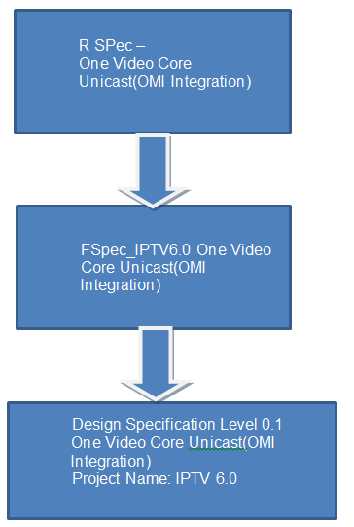

Figure 1: Document Overview

# Related FR

## One Video Core Unicast (OMI Integration)

### Scope

This document defines the Detailed Design for the requirements and use cases defined in the Functional Spec for “One video core unicast (OMI Integration)”.

We have to implement push entitlement mode based on the Operator Management Interface (OMI), OMI is a set of SOAP web services. IPTV6.0 BE will call these web services to push all the entitlement data to the Verimatrix and there will be a migration process also, which would be managed through TM GUI, to migrate all the entitlement data to the Verimatrix through OMI web services.

### Requirements Overview

Implement push entitlement mode based on the Operator Management Interface (OMI).

More Details: [References [1, 2].]

## Assumptions and Restrictions

### Assumptions

1. Integration with OMI is based on Verimatrix 3.6 version and available web services of OMI.
2. The integration of Verimatrix Pre-Processor (VPP) Web Service is out of scope for IPTV Back End, so the VoD provided via the Content Apis are already encrypted.
3. It is in charge to the Service Provider to check that the Encoders are compatible to Verimatrix 3.6 with OMI mode activated.
4. During ‘Sync All’ scenario thorugh the TM GUI, it is operator’s responsibility to set the Entitlement criteria to either ‘OFF’ or ‘PULL’.
5. Any operation which involves more than one step, then all the previous steps should be calls in Synchronized manner (No need to check request type, direct call SYNC method of OMI Client).
6. We assume for activating Bundles, it will always have VOD assets with movieVCAS id.  The call AddItemsToPackage to OMI is made only for VOD assets which have a movieVCAS id. If no assets have movieVCAS id then no call is made to OMI.
7. We assume for inactive VODs, Channels, and Bundles are in sync status in DB(by using DB Script) 2. In case of channel and VODs if any of the content creation status of asset/stream will fail than no other call (create package and add items to package) will be sent.
8. In case of Add / Remove item to packages :

* If no stream is found for channel then omi call is avoided for vmx provisioning.
* If no movieVCASId is found for VoD item then then omi call is avoided for vmx provisioning

1. In case of deactivating Bundles, it will always have VOD assets with movieVCAS id. The call RemoveItemsFromPackage to OMI is made only for VOD assets which have a movieVCAS id. If no assets have movieVCAS id then no call is made to OMI.
2. During activation/deactivation if movie vCAS Id is not present, then content will be ignored. No call will go to VMX.
3. If VoD new request is coming from API having status as “Inactive”, then call will not go to VMX.
4. Global Packages is out of scope.
5. Help is out of scope.

### Restrictions

NONE

### Backwards compatibility

Entitlement data will continue to be stored in the BE as before to still support the pull entitlement mode through exisiting Entitlement APIs.

### Performance Requirements

* As the OMI performance is not known yet, the performance OMI Integrator will only be assessed after evaluating the OMI performance.
* There will be definitely impacts on the performance of OCI, OPI TM APIs where the entitlement data is pushed to the Verimatrix through OMI Integrator. But ‘how much’ will depend upon the OMI performance.

# Overview

## Component Interaction



Figure 2: Component Interaction Diagram

## High Level Architecture

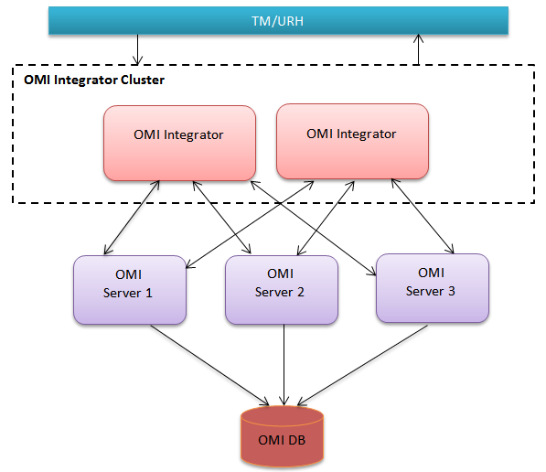

Figure 3: High Level Architecture

# Object Model

## Use Case Modeling

#### Activate Subscriber

This use case describes how the subscriber is activated in VMX by calling the integrator when activated in TM. Multiple subscribers can be activated in a single call to integrator.

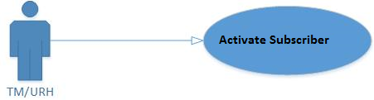

Figure 4: Activate Subscriber

|  |  |
| --- | --- |
| **Actor** | TM/URH |
| **Operation Name** | Activate Subscriber |
| **Pre-condition** | 1. TM is up and running. 2. TM DB is up and running. 3. Integrator is up and running. 4. OMI Integrator is defined in TM and is in Active state. 5. Subscriber is already provisioned in VMX. 6. Devices assigned to the subscriber are already provisioned in VMX. 7. Devices are already assigned to the subscriber in the VMX. 8. Assigned packages are already provisioned in the VMX. |
| **Flow of events** | 1. TM receives the request from GUI/subscriber API (SubscriberActivation) for subscriber activation. 2. Do all the processing and validations, as before, for the subscriber activation. 3. If packages are assigned to the subscriber then call the operation “ActivateSubscriber” of the Integrator (through integrator client) to add entitlement for the subscriber in the VMX. 4. Update the subscriber in TM DB. |
| **Post condition** | 1. Subscriber is activated successfully. 2. Success status is saved in the TM DB (SubscriberPackages) indicating that the subscriber – package association is in ‘sync with VMX. 3. Success status is saved in the TM DB |
| **Alternative flow of events** | 1. If the operations are to be called asynchronously then their immediate responses are assumed to be failure and TM DB tables (as mentioned in the post condition) will be updated with ‘not sync’ status The tables will be updated with ‘sync’ mark if the actual response from the operation is success. |
| **Exceptional flow** | 1. If any of the synchronous Integrator call fails then no further call to Integrator will be made and existing error message for GUI or subscriber API will be displayed/sent. 2. Calls to VMX are successfull but system error occurs in TM while activating the subscriberthen existing error message for GUI or subscriber API will be displayed/sent. |
| **Reference** |  |

Table 4: Activate Subscriber

#### Deactivate Subscriber

This use case describes how the subscriber is de-activated in VMX by calling the integrator when deactivated in TM. Multiple subscribers can be deactivated in a single call to integrator.

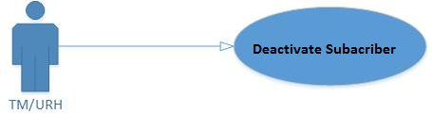

Figure 5 : Deactivate Subscriber

|  |  |
| --- | --- |
| **Actor** | TM/URH |
| **Operation Name** | Deactivate Subscriber |
| **Pre-condition** | 1. TM is up and running. 2. TM DB is up and running. 3. Integrator is up and running. 4. OMI Integrator is defined in TM and is in Active state. |
| **Flow of events** | 1. TM receives the request from TM GUI/ Subscriber API deactivation(SubscriberDeactivation for subscriber deactivation. 2. Do all the processing and validations, as before, for subscriber deactivation. 3. If packages are assigned to the subscriber then call the operation “DeactivateSubscriber” with sub tag ‘RemoveEntitlement ’ of the Integrator (through integrator client) to remove entitlement for the subscriber in the VMX. 4. Update the subscriber in database. |
| **Post condition** | 1. Subscriber is deactivated in TM. 2. Success status will be saved in the TM DB (SubscriberPackages Table) to indicate that the subscriber is in ‘sync’ with VMX. 3. Success status is saved in the TM DB |
| **Alternative flow of events** | 1. If the operations are to be called asynchronously then their immediate responses are assumed to be failure and TM DB tables (as mentioned in the post condition) will be updated with ‘not sync’ status The tables will be updated with ‘sync’ mark if the actual response from the operation is success. |
| **Exceptional flow** | 1. If any of the synchronous Integrator call fails then no further call to Integrator will be made and existing failure message for GUI or subscriber API will be displayed/sent. 2. If error comes while deactivating the subscriber in TM then call the operation ‘AddEntitlement’ of the Integrator to reveret back the VMX operation. |
| **Reference** |  |

Table 5 : Deactivate Subscriber

#### Create Subscriber

This use case describes how the subscriber is provisioned in VMX by calling the integrator when created in TM. Multiple subscribers can be deprovisioned in a single call to integrator.

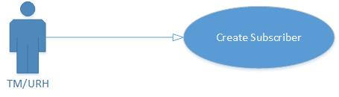

Figure 6: Create Subscriber

|  |  |
| --- | --- |
| **Actor** | TM/URH |
| **Operation Name** | Create Subscriber |
| **Pre-condition** | 1. TM is up and running. 2. TM DB is up and running. 3. Integrator is up and running. 4. OMI Integrator is defined in TM and is in Active state. |
| **Flow of events** | 1. TM receives the request from TM GUI/ Subscriber API (SubscriberCreate) for subscriber creation. 2. Do all the processing and validations, as before, for subscriber creation. 3. Call the operation ‘CreateSubscriber’ of the Integrator ( through integrator client) to provision in VMX. 4. Create the subscriber in database. |
| **Post condition** | 1. Subscriber is created in TM. 2. Subscriber is provisioned in the VMX successfully. 3. The TM DB(Subscribers) is updated to indicate that the subscriber is in ‘sync’ with VMX. |
| **Alternative flow of events** | If the operations are to be called asynchronously then their immediate responses are assumed to be failure and TM DB tables (as mentioned in the post condition) will be updated with ‘not sync’ status The tables will be updated with ‘sync’ mark if the actual response from the operation is success. |
| **Exceptional flow** | 1. If error comes while creating the subscriber in TM then no call will be made to the integrator for subscriber provisioning in VMX.   *Synchronous*   1. Failure message for GUI or subscriber API will be displayed/sent. |
| **Reference** |  |

Table 6: Create Subscriber

#### Delete Subscriber

This use case describes how the subscriber is de-provisioned in VMX by calling the integrator when deleted in TM. Multiple subscribers can be deprovisioned in a single call to integrator.

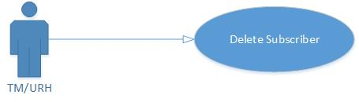

Figure 7: Delete Subscriber

|  |  |
| --- | --- |
| **Actor** | TM/URH |
| **Operation Name** | Delete Subsciber |
| **Pre-condition** | 1. TM is up and running. 2. TM DB is up and running. 3. Integrator is up and running. 4. OMI Integrator is defined in TM and is in Active state. 5. Subscriber is already deactivated in TM. |
| **Flow of events** | 1. TM receives the request from TM GUI/ Subscriber API (SubscriberDelete) for subscriber deletion. 2. Do all the processing and validations, as before, for subscriber deletion. 3. Call the operation ‘DeleteSubscriber’ of the Integrator (Through integrator client) to deprovision in VMX. 4. Delete the subscriber in database. |
| **Post condition** | 1. Subscriber is deleted in TM. 2. Subscriber is deprovisioned in the VMX successfully. |
| **Alternative flow of events** | 1. None |
| **Exceptional flow** | 1. If error comes while deactivating the subscriber in TM then no call will be made to the integrator for subscriber deprovisioning in VMX.   *Asynchronous*  None  *Synchronous*  Failure message for GUI or subscriber API will be displayed/sent. |
| **Reference** |  |

Table 7: Delete Subscriber

#### Update Subscriber

This use case describes how the ‘maxDevices’ of the subscriber will be updated in VMX while updating the max devices in TM. Multiple subscribers can be modified for max devices in a single call to the integrator. No call will be made to integrator if maxdevice is not updated.

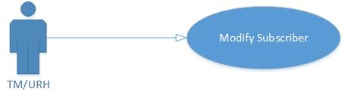

Figure 8: Modify Subscriber

|  |  |
| --- | --- |
| **Actor** | TM/URH |
| **Operation Name** | Modify Subscriber |
| **Pre-condition** | 1. TM is up and running. 2. TM DB is up and running. 3. Integratoris up and running. 4. OMI Integrator is defined in TM and is in Active state. |
| **Flow of events** | 1. TM receives the request from GUI/Subscriber API (subscriberUpdate) for subscriber modification of ‘maxDevices’. 2. Do all the processing and validations, as before, for subscriber modification. 3. Call the operation ‘ModifySubscriber’ of Integrator (through integrator client) to modify the maxDevices of subscriber in the VMX. 4. Update the subscriber in database. |
| **Post condition** | 1. Subscriber is modified in TM. 2. Subscriber’s max devices are updated in the VMX successfully.   Success status will be saved in the TM DB(Subscribers Table) to indicate that the subscriber is in ‘sync’ with VMX |
| **Alternative flow of events** | 1. If the operations are to be called asynchronously then their immediate responses are assumed to be failure and TM DB tables (as mentioned in the post condition) will be updated with ‘not sync’ status The tables will be updated with ‘sync’ mark if the actual response from the operation is success. |
| **Exceptional flow** | 1. If error comes while modifying the subscriber in TM then no call will be made to the integrator for subscriber modification in VMX.   *Synchronous*   1. Error message for GUI or subscriber API will be displayed/sent. |
| **Reference** |  |

Table 8: Modify Subscriber

#### Create Device

This use case describes how the device/STB will be provisioned in VMX while creating the in TM. Multiple devices/STBs can be provisioned in a single call.

.

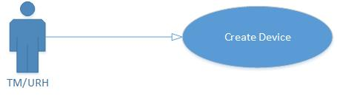

Figure 9: Create Device

|  |  |
| --- | --- |
| **Actor** | TM/URH |
| **Operation Name** | Create Device |
| **Pre-condition** | 1. TM is up and running. 2. TM DB is up and running. 3. Integrator is up and running. 4. OMI Integrator is defined in TM and is in Active state. |
| **Flow of events** | 1. TM receives the request from GUI to create a device/STB. 2. Do all the processing and validations, as before, for creation of a device/STB. 3. Call operation ‘CreateDevice’ of Integrator (Thorugh integrator client) to provision the device/STB in the VMX. 4. Create the device/STB in TM DB. |
| **Post condition** | 1. Device/STB is created in TM. 2. Device/STB is provisioned in the VMX.   Success status is saved in the TM DB (Settopboxes and SubscribersItvDevices) to indicate that the device/STB and its association with subscriber is in ‘sync’ with VMX. |
| **Alternative flow of events** | 1. If the operation is to be called asynchronously then its immediate response is assumed to be failure and TM DB tables (as mentioned in the post condition) will be updated with ‘not sync’ status. However, ‘in sync’ status will be stored for device/STB association with the subscriber. The tables will be updated with ‘sync’ mark if the actual response from the operation is success. |
| **Exceptional flow** | 1. If error occurs in TM while creating the device/STB then no call to the integrator will be made for provisioning in the VMX.   *Synchronous*   1. Error will be shown on GUI. |
| **Reference** |  |

Table 9: Create Device

#### Subscriber STB Assignment

This use case describes how the device/STB is assigned to a subscriber in VMX by calling the integrator while assigning the device/STB to a subscriber in TM. Multiple devices/STBs can be assigned in a single call.

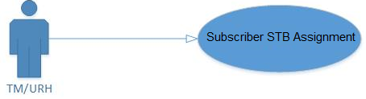

Figure 10: Subscriber STB Assignment

|  |  |
| --- | --- |
| **Actor** | TM/URH |
| **Operation Name** | Subscriber STB Assignment |
| **Pre-condition** | 1. TM is up and running. 2. TM DB is up and running. 3. Integrator is up and running. 4. OMI Integrator is defined in TM and is in Active state. |
| **Flow of events** | 1. TM receives the request from GUI/ subscriber API (SubscriberSTBAssign, SubcriberUpdate)/autoConfig (OCI)/autoInstall(OCI)/registerOTTDevice(OPI)/registerManagedDevice(OPI). to assign a device/STB to the subscriber. 2. Do all the processing and validations,as before, to assign a device/STB to the subscriber. 3. Call operation ‘AddAndAssignDevice’ of Integrator (through integrator client) to add and assign the device/STB to the subscriber in VMX. 4. Save the data in TM DB. |
| **Post condition** | 1. Device/STB is assigned to the subscriber in TM successfully. 2. Device/STB is enabled and assigned to the subscriber in VMX successfully. 3. Success status of the device/STB assignment is saved in TM DB (Settopboxes and SubscriberItvDevices) to indicate that subscriber – device/STB association is in ‘sync’ with VMXand they are sync with VMX with respect to assignment. |
| **Alternative flow of events** | 1. If the operations are to be called asynchronously then their immediate responses are assumed to be failure and TM DB tables (as mentioned in the post condition) will be updated with ‘not sync’ status The tables will be updated with ‘sync’ mark if the actual response from the operation is success. |
| **Exceptional flow** | 1. If any of the synchronous Integrator call fails then no further call to Integrator will be made and exisiting error message for GUI or OPI/OCI will be displayed/sent. 2. If an error occurs in TM while assigning device/STB to the subscriber then exisiting error message for GUI or OPI/OCI will be displayed/sent. |
| **Reference** |  |

Table 10: Subscriber STB Assignment

#### Subscriber STB Unassignment

This use case describes how the device/STB is unassigned froom a subscriber in VMX by calling the integrator while unassigning the device/STB from a subscriber in TM. Multiple devices/STBs can be unassigned in a single call.

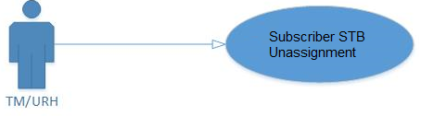

Figure 11 : Subscriber STB Unassignment

|  |  |
| --- | --- |
| **Actor** | TM/URH |
| **Operation Name** | Subscriber STB Unassignment |
| **Pre-condition** | 1. TM is up and running. 2. TM DB is up and running. 3. Integrator is up and running. 4. OMI Integrator is defined in TM and is in Active state. |
| **Flow of events** | 1. TM receives the request from GUI/ from subscriber API(SubscriberSTBUnassign, SubscriberSTBDeletion)/unassignSTB(OCI)/unregisterDevice(OPI) to unassign a device/STB from the subscriber. 2. Do all the processing and validations,as before, to unassign a device/STB to the subscriber. 3. Call operation ‘RemoveAndUnassignDevice’ of Integrator(through integrator client) to remove the device/STB to the subscriber in VMX. 4. Save the data in TM DB. |
| **Post condition** | 1. Device/STB is unassigned to the subscriber in TM successfully. 2. Device/STB is disabled and unassigned to the subscriber in VMX successfully. 3. Success status of the device unassignment is saved in TM DB (Settopboxes and SubscriberItvDevices) to indicate that subscriber – device/STB association is in ‘sync’ with VMX and they are not sync with VMX with respect to unassignment. |
| **Alternative flow of events** | 1. If the operations are to be called asynchronously then their immediate responses are assumed to be failure and TM DB tables (as mentioned in the post condition) will be updated with ‘not sync’ status The tables will be updated with ‘sync’ mark if the actual response from the operation is success. |
| **Exceptional flow** | 1. If any of the synchronous Integrator call fails then no further call to Integrator will be made and exisiting error message for GUI or OPI/OCI will be displayed/sent. 2. If an error occurs in TM while unassigning device/STB to the subscriber then exisiting error message for GUI or OPI/OCI will be displayed/sent and call operation ‘AddAndAssignDevice’ of Integrator to revert back the VMX operation. |
| **Reference** |  |

Table 11: Subscriber STB Unassignment

#### Create Package

This use case describes how a package is provisioned in VMX by calling the Integrator when a package is created in TM.

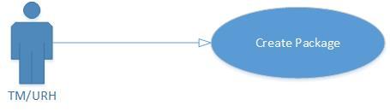

Figure 12: Create Package

|  |  |
| --- | --- |
| **Actor** | TM/URH |
| **Operation Name** | Create Package |
| **Pre-condition** | 1. TM is up and running. 2. TM DB is up and running. 3. Integrator is up and running. 4. OMI Integrator is defined in TM and is in Active state. |
| **Flow of events** | 1. TM receives the request from TM GUI to create a package. 2. Do all the processing, as before, for the creation of a package. 3. Call operation ‘CreatePackage’ of the Integrator (through integrator client) to provision the package in the VMX. 4. Package data is saved in the TM DB. |
| **Post condition** | 1. Package is created in TM successfully. 2. Package is provisioned in VMX successfully. 3. Success status of the package ceation is saved in TM DB (Packages table) to indicate that package is in ‘sync’ with VMX. |
| **Alternative flow of events** | 1. If the operations are to be called asynchronously then their immediate responses are assumed to be failure and TM DB tables (as mentioned in the post condition) will be updated with ‘not sync’ status The tables will be updated with ‘sync’ mark if the actual response from the operation is success. |
| **Exceptional flow** | 1. If any of the synchronous Integrator call fails then no further call to Integrator will be made and exisiting error will be shown on GUI. 2. If an error occurs in TM while creating the package then exisiting error will be shown on GUI. |
| **Reference** |  |

Table 12: Create Package

#### Delete Package

This use case describes how a package will be deprovisioned in the VMX when deleted in TM. Only packageId of package, as part of packageList, is required.

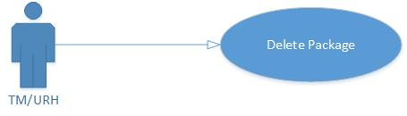

Figure 13 : Delete Package

|  |  |
| --- | --- |
| **Actor** | TM/URH |
| **Operation Name** | Delete Package |
| **Pre-condition** | 1. TM is up and running. 2. TM DB is up and running. 3. Integrator is up and running. 4. OMI Integrator is defined in TM and is in Active state. |
| **Flow of events** | 1. TM receives the request from TM GUI to delete a package. 2. Do all the processing, as before, for the deletion of a package. 3. Call operation ‘DeletePackage’ of the Integrator to provision the package in the VMX. 4. Package is deleted in the TM DB. |
| **Post condition** | 1. Package is deleted in TM successfully. 2. Package is deprovisioned in VMX successfully. |
| **Alternative flow of events** | None |
| **Exceptional flow** | 1. If any of the synchronous Integrator call fails then no further call to Integrator will be made and an exisiting error will be shown on GUI. 2. If an error occurs in TM while creating the package then an exisiting error will be shown on GUI and call operation ‘CreatePackage’ of the Integrator to revert back the VMX operation. |
| **Reference** |  |

Table 13: Delete Package

#### Create Bundle

This use case describes how a bundle is created in VMX in the form of a package by calling the Integrator when a bundle is created in TM.

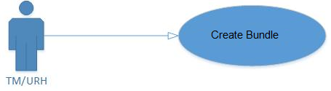

Figure 14 : Create Bundle

|  |  |
| --- | --- |
| **Actor** | TM/URH |
| **Operation Name** | Create Bundle |
| **Pre-condition** | 1. TM is up and running. 2. TM DB is up and running. 3. Integrator is up and running. 4. OMI Integrator is defined in TM and is in Active state. |
| **Flow of events** | 1. TM receives the request from TM GUI to create a bundle. 2. Do all the processing, as before, for the creating a bundle. 3. Call operation ‘CreatePackage’ of the Integrator to provision the bundle in the form of package (that represents a bundle and package id will be the bundle id) in the VMX. 4. Bundle is creating and data is saved in the TM DB. |
| **Post condition** | 1. Bundle is created in TM successfully. 2. Package (that represents the bundle) provisioned in the VMX successfully. 3. Success status of the bundle creation is saved in TM DB (Bundles Table) to indicate that bundle is in ‘sync’ with VMX. |
| **Alternative flow of events** | 1. If the operations are to be called asynchronously then their immediate responses are assumed to be failure and TM DB tables (as mentioned in the post condition) will be updated with ‘not sync’ status The tables will be updated with ‘sync’ mark if the actual response from the operation is success. |
| **Exceptional flow** | 1. If any of the synchronous Integrator call fails then no further call to Integrator will be made and exisiting error will be shown on GUI/content API.. 2. If an error occurs in TM while creating the bundle then exisiting error will be shown on GUI/content API. |
| **Reference** |  |

Table 14: Create Bundle

#### Activate Bundle

This use case describes how a bundle is activated in VMX in the form of a package by calling the Integrator when a bundle is activated in TM.

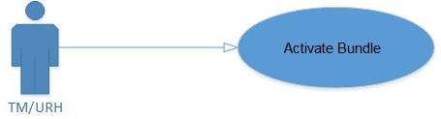

Figure 15: Activate Bundle

|  |  |
| --- | --- |
| **Actor** | TM/URH |
| **Operation Name** | Activate Bundle |
| **Pre-condition** | 1. TM is up and running. 2. TM DB is up and running. 3. Integrator is up and running. 4. OMI Integrator is defined in TM and is in Active state. 5. VoD assets are already provisioned in the VMX. 6. Package that represents the bundle (with bundle id) is already provisioned in the VMX. |
| **Flow of events** | 1. TM receives the request from TM GUI to activate a bundle. 2. Do all the processing, as before, for the activating a bundle. 3. Call operation ‘AddItemsToPackage’ of the Integrator to add the VoDs (VoD Assets) (in the bundle) to the package (that represents a bundle and package id will be the bundle id) in the VMX. 4. Bundle is activated and data is saved in the TM DB. |
| **Post condition** | 1. Bundle is activated in TM successfully. 2. Items (each asset of a VoD) are assigned to the package (which represents a bundle) in VMX successfully. 3. Success status of the bundle activation is saved in TM DB (Bundles Table) to indicate that bundle is in ‘sync’ with VMX. |
| **Alternative flow of events** | 1. If the operations are to be called asynchronously then their immediate responses are assumed to be failure and TM DB tables (as mentioned in the post condition) will be updated with ‘not sync’ status The tables will be updated with ‘sync’ mark if the actual response from the operation is success. |
| **Exceptional flow** | 1. If any of the synchronous Integrator call fails then no further call to Integrator will be made and exisiting error will be shown on GUI/content API.. 2. If an error occurs in TM while creating the package then no call to the integrator will be made. |
| **Reference** |  |

Table 15: Activate Bundle

#### Deactivate Bundle

This use case describes how a bundle is deactivated in VMX in the form of a package by calling the Integrator when a bundle is deactivated in TM.

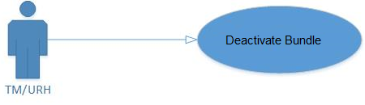

Figure 16: Deactivate Bundle

|  |  |
| --- | --- |
| **Actor** | TM/URH |
| **Operation Name** | Deactivate Bundle |
| **Pre-condition** | 1. TM is up and running. 2. TM DB is up and running. 3. Integrator is up and running. 4. OMI Integrator is defined in TM and is in Active state. |
| **Flow of events** | 1. TM receives the request from TM GUI to deactivate a bundle. 2. Do all the processing, as before,for the deactivating a bundle. 3. Call operation ‘RemoveItemsFromPackage’ of Integrator to remove items from package in the VMX. Here the package id would be the bundle id of the bundle. 4. Bundle is deactivated and data is saved in the TM DB. |
| **Post condition** | 1. Bundle is deactivated in TM successfully. 2. Items (each asset of a VoD) are unassigned from the package (which represents a bundle) in VMX successfully. 3. Success status of the bundle deactivation is saved in TM DB(Bundles Table) to indicate that bundle is in ‘sync’ with VMX. |
| **Alternative flow of events** | 1. If the operations are to be called asynchronously then their immediate responses are assumed to be failure and TM DB tables (as mentioned in the post condition) will be updated with ‘not sync’ status The tables will be updated with ‘sync’ mark if the actual response from the operation is success. |
| **Exceptional flow** | 1. If any of the synchronous Integrator call fails then no further call to Integrator will be made and an exisiting error message will be shown for GUI/Content API. 2. If an error occurs in TM while deactivating the bundle then an exisiting error message will be shown for GUI/Content API and call operation ‘AddItemsToPackage’ of the Integrator revert back the VMX operation. |
| **Reference** |  |

Table 16: Deactivate Bundle

#### Delete Bundle

This use case describes how a bundle is de-provisioned in VMX in the form of a package by calling the Integrator when a bundle is deleted in TM.

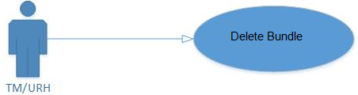

Figure 17: Delete Bundle

|  |  |
| --- | --- |
| **Actor** | TM/URH |
| **Operation Name** | Delete Bundle |
| **Pre-condition** | 1. TM is up and running. 2. TM DB is up and running. 3. Integrator is up and running. 4. OMI Integrator is defined in TM and is in Active state. |
| **Flow of events** | 1. TM receives the request from TM GUI to delete a bundle. 2. Do all the processing, as before,for the deleting a bundle. 3. Call operation ‘DeletePackage’ of the Integrator to deprovision the bundle,in the form of a package, in the VMX. The packageId in the call would be the bundle id. 4. Bundle is deleted in the TM DB. |
| **Post condition** | 1. Bundle is deleted in TM successfully. 2. Bundle is deprovisioned (in the form of a package) in VMX successfully. |
| **Alternative flow of events** |  |
| **Exceptional flow** | 1. If any of the synchronous Integrator call fails then no further call to Integrator will be made and exisiting error message will be shown for GUI/Content API.. 2. If an error occurs in TM while deleting the bundle then exisiting error message will be shown for GUI/Content API and call operation ‘CreatePackage’ to revert back the VMX operation. |
| **Reference** |  |

Table 17: Delete Bundle

#### Assign items to Package

This use case describes how content will be added to the package in the VMX on addition of item in package in TM by making a call to Integrator. Multiple items can be added to the package in a single call. Likewise, single content can be added to multiple packages in the single call. Each channel stream of a channel or each asset of the VoD (only FoD) will be added to package in the VMX. Please note, PPV channels and and bundled contents will not be added to Packages in VMX.

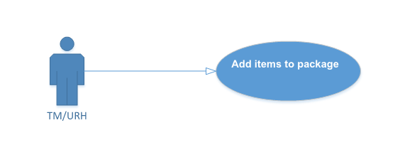

Figure 18: Assign Item to Package

|  |  |
| --- | --- |
| **Actor** | TM/URH |
| **Operation Name** | Assign Items to Package |
| **Pre-condition** | 1. TM is up and running. 2. TM DB is up and running. 3. Integrator is up and running. 4. OMI Integrator is defined in TM and is in Active state. 5. The contents (VoD assets/Channel streams) are already provisioned in VMX. |
| **Flow of events** | 1. TM receives the request from TM GUI/Content API to add items in a package. 2. Do all the processing and validations, as before, to assign items to package. 3. Call operation ‘AddItemsToPackage’ of Integrator to add items to package in the VMX. 4. Save the data in TM DB. |
| **Post condition** | 1. Items are assigned to the package in TM successfully. 2. Items (each channel stream of a channel or each asset of a VoD) are assigned to the package in VMX successfully. 3. Success status of the item (each channel stream of a channel or each asset of a VoD (other than FoD and even those VoDs which are part of bundle) to package assignment is stored in the TM DB (PackageItems Table) indicating the item-package association is in ‘sync’ with VMX. |
| **Alternative flow of events** | 1. If the operations are to be called asynchronously then their immediate responses are assumed to be failure and TM DB tables (as mentioned in the post condition) will be updated with ‘not sync’ status The tables will be updated with ‘sync’ mark if the actual response from the operation is success. |
| **Exceptional flow** | 1. If any of the synchronous Integrator call fails then no further call to Integrator will be made and exisiting error will be shown on GUI/Content API.. 2. If an error occurs in TM /Content API while assigning item to package exisiting error will be shown on GUI/Content API. |
| **Reference** |  |

Table 18: Assign Items to Package

#### Remove items from Package

This use case describes how a item will be removed from the package in the VMX on removal of item from package in TM by making a call to Integrator. Multiple items can be removed from the package in a single call. Likewise, single content can be removed from multiple packages in the single call.Each channel stream of a channel or each asset of the VoD will be removed from package in the VMX. In case of bundle removal or assigned bundle deactivation, each item in the bundle will be removed from the package in the VMX.

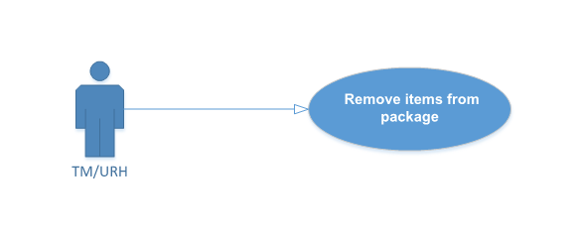

Figure 19 : Remove items from package

|  |  |
| --- | --- |
| **Actor** | TM/URH |
| **Operation Name** | Remove Items from Package |
| **Pre-condition** | 1. TM is up and running. 2. TM DB is up and running. 3. Integrator is up and running. 4. OMI Integrator is defined in TM and is in Active state. |
| **Flow of events** | 1. TM receives the request from TM GUI/Content API to remove items from a package. 2. Do all the processing and validations, as before, to unassign items from package. 3. Call operation ‘RemoveItemsFromPackage’ of Integrator to remove items from package in the VMX. 4. Save the data in TM DB. |
| **Post condition** | 1. Items are unassigned from the package in TM successfully. 2. Items (each channel stream of a channel or each asset of a VoD) are unassigned from the package in VMX successfully. 3. Success status of the item (each channel stream of a channel or each asset of a VoD) for package unassignment is stored in the TM DB indicating the item-package association is in ‘sync’ with VMX. |
| **Alternative flow of events** |  |
| **Exceptional flow** | 1. If any of the synchronous Integrator call fails then no further call to Integrator will be made and an exisiting error will be shown on GUI/Content API. 2. If an error occurs in TM/Content API while unassigning item from package then an exisiting error will be shown on GUI/Content API and call operation ‘AddItemsToPackage’ of Integrator to revert back the VMX operation. |
| **Reference** |  |

Table 19: Remove Items from Package

#### Activate Channel

This use case describes how all the channel streams of a channel would be provisioned in the VMX by calling the integrator interface when the channel is activated in TM. Multiple channel streams can be provisioned in a single call to integrator. This use case doesn’t apply to the PPV channels.

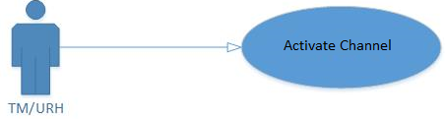

Figure 20: Activate Channel

|  |  |
| --- | --- |
| **Actor** | TM/URH |
| **Operation Name** | Activate Channel |
| **Pre-condition** | 1. TM is up and running. 2. TM DB is up and running. 3. Integrator is up and running. 4. OMI Integrator is defined in TM and is in Active state. |
| **Flow of events** | 1. Go to Products->DTV Channels 2. All the processing for activating a channel which is in place currently would be done as before. 3. Call the operation ActivateChannel including ‘CreateContent’, ‘CreatePackage’, ‘AddItemsToPackage’ of the Integrator to provision the entire channel streams in VMX. 4. Channel is activated and saved. |
| **Post condition** | 1. All the channel streams are provisioned successfully in the VMX by the integrator. 2. Success status is saved in the TM DB (DtvChannels Table) indicating that the channel is in ‘sync with VMX. 3. Package that represents the channel for the nPVR purpose is provisioned in the VMX successfully. |
| **Alternative flow of events** | 1. If the operations are to be called asynchronously then their immediate responses are assumed to be failure and TM DB tables (as mentioned in the post condition) will be updated with ‘not sync’ status The tables will be updated with ‘sync’ mark if the actual response from the operation is success. |
| **Exceptional flow** | 1. No call to the Integrator would be made if there are no streams attached to the channel. 2. If any of the synchronous Integrator call fails then no further call to Integrator will be made and exisiting error will be shown on GUI. 3. If any error comes during the channel activation then exisiting error will be shown on GUI. |
| **Reference** |  |

Table 20: Activate Channel

#### Deactivate Channel

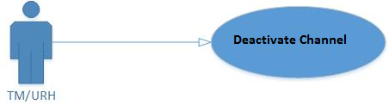

Figure 21: Deactivate Channel

|  |  |
| --- | --- |
| **Actor** | TM |
| **Operation Name** | Deactivate Channel |
| **Pre-condition** | 1. TM is up and running. 2. TM DB is up and running. 3. Integrator is up and running. 4. OMI Integrator is defined in TM and is in Active state. |
| **Flow of events** | 1. Go to Setup->DTV 2. All the processing for deactivating a channel which is in place currently would be done as before. 3. Call the operation ‘DactivateChannel’ of the Integrator to de-provision all the channel streams in VMX. 4. Channel is deactivated and saved. |
| **Post condition** | 1. The channel streams are de-provisioned successfully in the VMX by the integrator. 2. Success status is saved in the TM DB(DtvChannels Table) indicating that the channel is in ‘sync with VMX. 3. Package that represents the channel(for npvr recording entitlement) is de-provisioned in the VMX successfully. |
| **Alternative flow of events** | 1. If the operations are to be called asynchronously then their immediate responses are assumed to be failure and TM DB tables (as mentioned in the post condition) will be updated with ‘not sync’ status The tables will be updated with ‘sync’ mark if the actual response from the operation is success. |
| **Exceptional flow** | 1. If there is no stream attached to the channel, being deactivated, then no call will be sent to the integrator. 2. If any of the synchronous Integrator call fails then no further call to Integrator will be made and exisiting error will be shown on GUI. 3. If any error comes during the channel de-activation then exisiting error will be shown on GUI and call operation ‘CreateContent’ and ‘CreatePackage’ of the Integrator to revert back the VMX operation. |
| **Reference** |  |

Table 21: Deactivate Channel

#### Activate VoD Content

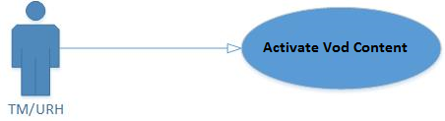

Figure 22: Activate VoD Content

|  |  |
| --- | --- |
| **Actor** | TM GUI/Content API |
| **Operation Name** | Activate VoD Content |
| **Pre-condition** | 1. TM is up and running. 2. TM DB is up and running. 3. Integrator is up and running. 4. OMI Integrator is defined in TM and is in Active state. |
| **Flow of events** | 1. VoD is activated through TM GUI/Content API. 2. All the processing for activating a VoD which is in place currently would be done as before. 3. Call operation ‘ActivateVod’ of the Integrator to provision all the VoD assets in VMX. Movie VCASID will be used as contentId. 4. If the VoD is not FoD then add sub tag ‘CreatePackage’ of the Integrator to provision a package to represent the VoD content with VoD external Id as package Id in the VMX. 5. If the VoD is not FoD then add sub tag operation ‘AddItemsToPackage’ of the Integrator to assign the content (created in step 4) to the package created in step 5 in the VMX. 6. VoD is activated and data is saved TM DB. |
| **Post condition** | 1. All the VoD assets are provisioned successfully in the VMX by the integrator. 2. If the VoD is not FoD then Package, to represent the VoD content, provisioned successfully in the VMX by the integrator. 3. If the VoD is not FoD then all the VoD Content assets are assigned to the package (which represents the VoD Content) 4. Success status is saved in the TM DB (ContentItems Table) indicating that the VoD is in ‘sync with VMX. |
| **Alternative flow of events** | 1. If the operations are to be called asynchronously then their immediate responses are assumed to be failure and TM DB tables (as mentioned in the post condition) will be updated with ‘not sync’ status The tables will be updated with ‘sync’ mark if the actual response from the operation is success. |
| **Exceptional flow** | 1. If any of the synchronous Integrator call fails then no further call to Integrator will be made and an exisiting error will be shown for GUI/Content API. 2. If any error comes during the VoD activation in TM then an exisiting error will be shown for GUI/Content API. |
| **Reference** |  |

Table 22: Activate VoD Content

#### Deactivate VoD Content

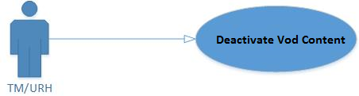

Figure 23: Deactivate VoD Content

|  |  |
| --- | --- |
| **Actor** | TM GUI/Content API |
| **Operation Name** | Deactivate VoD Content |
| **Pre-condition** | 1. TM is up and running. 2. TM DB is up and running. 3. Integrator is up and running. 4. OMI Integrator is defined in TM and is in Active state. |
| **Flow of events** | 1. VoD deactivation is done in TM GUI/Content API. 2. All the processing for deactivating a VoD which is in place currently would be done as before. 3. If the content is not FoD then call operation ‘DeletePackage’of the Integrator to de-provision the package (that represents a VoD and containing the VoD assets) the VoD assets in VMX (external Id of the VoD will be used as packageId). 4. VoD is deactivated and data saved in TM DB. |
| **Post condition** | 1. VoD is deactivated in TM successfully. 2. All the VoD assets are de-provisioned successfully in the VMX by the integrator. 3. If it is not FoD then the package, to represent the VoD content, de-provisioned successfully in the VMX by the integrator. 4. Success status is saved in the TM DB(ContentItems Table) indicating that the VoD is in ‘sync with VMX. |
| **Alternative flow of events** | 1. If the operations are to be called asynchronously then their immediate responses are assumed to be failure and TM DB tables (as mentioned in the post condition) will be updated with ‘not sync’ status The tables will be updated with ‘sync’ mark if the actual response from the operation is success. |
| **Exceptional flow** | 1. If any of the synchronous Integrator call fails then no further call to Integrator will be made and an exisiting error message will be shown on GUI/content API 2. If any error comes during the VoD de-activation in TM then an exisiting error message will be shown on GUI/content API AND call operation ‘CreateContent’, ‘CreatePackage’and ‘AddItemsToPackage’ of the Integrator revert back the VMX operation. |
| **Reference** |  |

Table 23: Deactivate VoD Content

#### Package Assignment

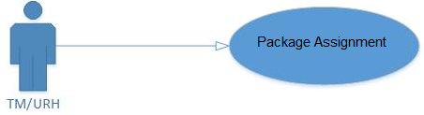

Figure 24: Package Assignment

|  |  |
| --- | --- |
| **Actor** | TM GUI/Subscriber API/ Package subscription API |
| **Operation Name** | Package Assignment |
| **Pre-condition** | 1. TM is up and running. 2. TM DB is up and running. 3. Integrator is up and running. 4. OMI Integrator is defined in TM and is in Active state. |
| **Flow of events** | 1. Package assignment is done in TM GUI/ from Subscriber API (SubscriberPackageAssign, SubscriberPackageUnlock,SubcriberUpdate) or Package subscription API (SubscriberPackageAssign,SubscriberPackageUnlock). 2. All the processing for assigning package to a subscriber is done as before. 3. Call the operation ‘AddEntitlement’of the Integrator to perform entitlement in VMX. 4. Package assignment is saved in TM DB. |
| **Post condition** | 1. Subscriber package assigned/unlocked in TM successfully. 2. Package entitlement is done successfully in the VMX by the integrator. 3. Success status is saved in the TM DB(SubscriberPackages) indicating that subscriber-package association is in ‘sync with VMX. |
| **Alternative flow of events** | 1. If the operations are to be called asynchronously then their immediate responses are assumed to be failure and TM DB tables (as mentioned in the post condition) will be updated with ‘not sync’ status The tables will be updated with ‘sync’ mark if the actual response from the operation is success. |
| **Exceptional flow** | 1. If any of the synchronous Integrator call fails then no further call to Integrator will be made and an exisiting error will be shown on GUI. 2. If an error occurs in TM while creating the package then an exisiting error will be shown on GUI and call operation ‘CreatePackage’ of the Integrator to revert back the VMX operation. |
| **Reference** |  |

Table 24: Package Assignment

#### Package Unassignment

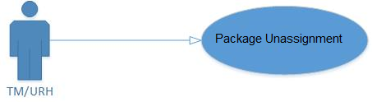

Figure 25: Package Unassignment

|  |  |
| --- | --- |
| **Actor** | TM GUI/Subscriber API/ Package subscription API |
| **Operation Name** | Package Unassignment |
| **Pre-condition** | 1. TM is up and running. 2. TM DB is up and running. 3. Integrator is up and running. 4. OMI Integrator is defined in TM and is in Active state. |
| **Flow of events** | 1. Package unassignment is done in TM GUI/ Subscriber API (subscriber package unassign,subscriber package lock) or Package subscription API ((subscriber package unassign,subscriber package lock). 2. All the processing for unassigning package to a subscriber is done as before. 3. Call operation ‘RemoveEntitlement’ of the Integrator to perform entitlement removal in VMX. 4. Package unassignment is saved in TM DB. |
| **Post condition** | 1. Subscriber package unassigned/locked in TM successfully. 2. Package entitlement is removed successfully in the VMX by the integrator. 3. Success status is saved in the TM DB indicating that subscriber-package association is in ‘sync with VMX. |
| **Alternative flow of events** | 1. If the operations are to be called asynchronously then their immediate responses are assumed to be failure and TM DB tables (as mentioned in the post condition) will be updated with ‘not sync’ status The tables will be updated with ‘sync’ mark if the actual response from the operation is success. |
| **Exceptional flow** | 1. If any of the synchronous Integrator call fails then no further call to Integrator will be made and an exisiting error will be shown for GUI/Subscriber API/Package Subscription API.. 2. If any error comes in package unassignment/lock in TM then an exisiting error will be shown for GUI/Subscriber API/Package Subscription API AND call the operation ‘AddEntitlement’of the Integrator to revert back the VMX operation. |
| **Reference** |  |

Table 25: Package Unassignment

#### Package Mass Assignment

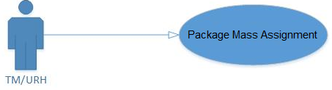

Figure 26: Package Mass Assignment

|  |  |
| --- | --- |
| **Actor** | Package Subscription API/Subscriber API |
| **Operation Name** | Package Mass Assignment |
| **Pre-condition** | 1. Package mass assignment is done TM through Package Subscription API/Subscriber API. 2. Mass package assignment is carried out as before. 3. Call the operation ‘AddEntitlement of the Integrator to perform the entitlement in VMX for subscribers without blocking the already going on mass assignment process. 4. Save the package assignment in TM TB. |
| **Flow of events** | 1. TM receives the request from TM GUI to delete a package. 2. Do all the processing, as before, for the deletion of a package. 3. Call operation ‘DeletePackage’ of the Integrator to provision the package in the VMX. 4. Package is deleted in the TM DB. |
| **Post condition** | 1. Mass package assignment is done in TM. 2. Mass package entitlement is done successfully in the VMX by the integrator. 3. Success status is saved in the TM DB indicating that subscriber-package(SubscriberPackages) associations are in ‘sync’ with VMX. |
| **Alternative flow of events** | 1. If the operations are to be called asynchronously then their immediate responses are assumed to be failure and TM DB tables (as mentioned in the post condition) will be updated with ‘not sync’ status The tables will be updated with ‘sync’ mark if the actual response from the operation is success. |
| **Exceptional flow** | 1. If any of the synchronous Integrator call fails then no further call to Integrator will be made and an exisiting error will be returned for Package Subcription API/Subscriber API.. |
| **Reference** |  |

Table 26: Package Mass Assignment

#### Package Mass Unassignment

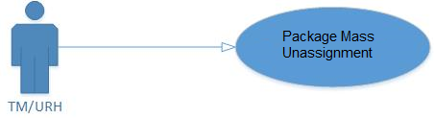

Figure 27: Package Mass Unassignment

|  |  |
| --- | --- |
| **Actor** | Package Subscription API/Subscriber API |
| **Operation Name** | Package Mass Unassignment |
| **Pre-condition** | 1. TM is up and running. 2. TM DB is up and running. 3. Integrator is up and running. 4. OMI Integrator is defined in TM and is in Active state. |
| **Flow of events** | 1. Package mass assignment is done TM through Package Subscription API/Subscriber API. 2. Mass package assignment is carried out as before. 3. Call the operation ‘RemoveEntitlement’ of the Integrator to perform the entitlement in VMX for subscribers without blocking the already going on mass unassignment process. 4. Save the package unassignment in TM DB. |
| **Post condition** | 1. Mass package unassignment is done in TM. 2. Mass package entitlement removal is done successfully in the VMX by the integrator. 3. Success status is saved in the TM DB (SubscriberPackages) indicating that subscriber-package associations are in ‘sync’ with VMX. |
| **Alternative flow of events** | 1. If the operations are to be called asynchronously then their immediate responses are assumed to be failure and TM DB tables (as mentioned in the post condition) will be updated with ‘not sync’ status The tables will be updated with ‘sync’ mark if the actual response from the operation is success. |
| **Exceptional flow** | 1. If any of the synchronous Integrator call fails then no further call to Integrator will be made and an exisiting error will be returned for Package Subcription API/Subscriber API AND callthe operation ‘AddEntitlement’of the Integrator to revert back the VMX operation. |
| **Reference** |  |

Table 27: Package Mass Unassignment

#### Vod Rental

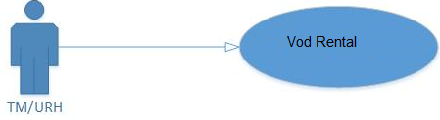

Figure 28: Vod Rental

|  |  |
| --- | --- |
| **Actor** | TM |
| **Operation Name** | VoD Rental |
| **Pre-condition** | 1. TM and URH are up and running. 2. TM DB is up and running. 3. Integrator is up and running. 4. OMI Integrator is defined in TM and is in Active state. |
| **Flow of events** | 1. VoD rental is done in TM through existing OCI(itemRental)/OPI(rentItems) calls. 2. All the processing for renting is, as before, is done in TM/URH. 3. Call the operation ‘AddEntitlement’ of the Integrator to perform entitlement in VMX. The entitlementId in the call would be Id that represents transaction in TM and packageId in the call would be externalId of the VoD (because in VMX the VoD (not FoD) is represented as Package whose package Id is the externalId of the VoD). 4. Item is rented successfully and data is saved in TM DB |
| **Post condition** | 1. VoD is rented in TM successfully. 2. VoD is entitled to subscriber successfully in the VMX by the integrator. 3. Success status is saved in the TM DB (Transactions Table) indicating that the VoD renting transaction is in ‘sync with VMX. |
| **Alternative flow of events** | 1. If the operations are to be called asynchronously then their immediate responses are assumed to be failure and TM DB tables (as mentioned in the post condition) will be updated with ‘not sync’ status The tables will be updated with ‘sync’ mark if the actual response from the operation is success. |
| **Exceptional flow** | 1. If any of the synchronous Integrator call fails then no further call to Integrator will be made and an exisiting error will be shown for OPI/OCI. 2. If any error comes in VoD renting in TM then an exisiting error will be shown for OPI/OCI. |
| **Reference** |  |

Table 28: VoD Rental

#### Bundle Rental

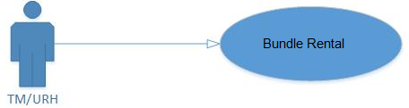

Figure 29: Bundle Rental

|  |  |
| --- | --- |
| **Actor** | TM/URH |
| **Operation Name** | Bundle Rental |
| **Pre-condition** | 1. TM and URH are up and running. 2. TM DB is up and running. 3. Integrator is up and running. 4. OMI Integrator is defined in TM and is in Active state. |
| **Flow of events** | 1. Bundle rental is done in TM through existing OCI(itemRental)/OPI(rentBundle) calls. 2. All the processing for renting is, as before, is done in TM/URH. 3. Call operation ‘AddEntitlement’ of the Integrator to perform entitlement of bundle in the VMX. The entitlementId in the call would be Id that represents transaction in TM and packageId in the call would be bundle Id (because in VMX the bundle provisioned as Package). 4. Item is rented successfully and data is saved in TM DB. |
| **Post condition** | 1. Bundle is rented in TM successfully. 2. Bundled entitled to subscriber successfully in the VMX by the integrator. 3. Success status is saved in the TM DB(Transactions Table) indicating that the bundle renting transaction is in ‘sync with VMX. |
| **Alternative flow of events** | 1. If the operations are to be called asynchronously then their immediate responses are assumed to be failure and TM DB tables (as mentioned in the post condition) will be updated with ‘not sync’ status The tables will be updated with ‘sync’ mark if the actual response from the operation is success. |
| **Exceptional flow** | 1. If any of the synchronous Integrator call fails then no further call to Integrator will be made and an exisiting error will be shown for OPI/OCI. 2. If any error comes in Bundle renting in TM then an exisiting error will be shown for OPI/OCI. |
| **Reference** |  |

Table 29: Bundle Rental

#### Activate PPV Channel

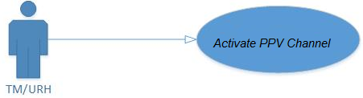

Figure 30: Activate PPV Channel

|  |  |
| --- | --- |
| **Actor** | TM |
| **Operation Name** | Activate PPV Channel |
| **Pre-condition** | 1. TM is up and running. 2. TM DB is up and running. 3. Integrator is up and running. 4. OMI Integrator is defined in TM and is in Active state. |
| **Flow of events** | 1. PPV is activated through TM GUI. 2. All the processing for activating a PPV which is in place currently would be done as before. 3. Call the operation ‘ActiatePPVChannel’ of the Integrator to provision all the PPV channel streams in VMX. 4. PPV is activated and data is saved TM DB. |
| **Post condition** | 1. All the PPV streams are provisioned successfully in the VMX by the integrator. 2. Package, to represent the PPV Channel , provisioned successfully in the VMX by the integrator. 3. PPV Channel streams are assigned to the package (which represents the PPV channel) 4. Success status is saved in the TM DB (DTVChannels Table) indicating that the PPV is in ‘sync with VMX. |
| **Alternative flow of events** | 1. If the operations are to be called asynchronously then their immediate responses are assumed to be failure and TM DB tables (as mentioned in the post condition) will be updated with ‘not sync’ status The tables will be updated with ‘sync’ mark if the actual response from the operation is success. |
| **Exceptional flow** | 1. If any of the synchronous Integrator call fails then no further call to Integrator will be made and an exisiting error will be shown. 2. If any error comes during the PPV channel activation in TM then no call will be sent to integrator. |
| **Reference** |  |

Table 30: Activate PPV Channel

#### Deactivate PPV Channel

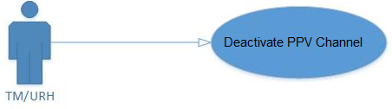

Figure 31 : Deactivate PPV Channel

|  |  |
| --- | --- |
| **Actor** | TM |
| **Operation Name** | Deactivate PPV Channel |
| **Pre-condition** | 1. TM is up and running. 2. TM DB is up and running. 3. Integrator is up and running. 4. OMI Integrator is defined in TM and is in Active state. |
| **Flow of events** | 1. PPV channel deactivation is done in TM GUI. 2. All the processing for deactivating a PPV channel which is in place currently would be done as before. 3. Call theoperation of the Integrator to de-provision all the PPV assets in VMX. 4. Call the operation ‘DeactivatePPVChannel’ of the Integrator to de-provision the package (that represents a PPV channel and containing the channel streams) the channel streams in VMX (channel id of the channel will be used as packageId). 5. PPV is deactivated and data saved in TM DB. |
| **Post condition** | 1. PPV Channel is deactivated in TM successfully. 2. All the PPV channel are de-provisioned successfully in the VMX by the integrator. 3. The package, to represent the channel streams, de-provisioned successfully in the VMX by the integrator. 4. Success status is saved in the TM DB(DTVChannels Table) indicating that the PPV is in ‘sync with VMX. |
| **Alternative flow of events** | 1. If the operations are to be called asynchronously then their immediate responses are assumed to be failure and TM DB tables (as mentioned in the post condition) will be updated with ‘not sync’ status The tables will be updated with ‘sync’ mark if the actual response from the operation is success. |
| **Exceptional flow** | 1. If any of the synchronous Integrator call fails then no further call to Integrator will be made and an exisiting error will be shown. 2. If any error comes during the PPV de-activation in TM then an exisiting error will be shown. AND call the operation ‘ActivatePPVChannel’ of the Integrator to revert back the VMX operations. |
| **Reference** |  |

Table 31: Deactivate PPV Channel

#### PPV Rental

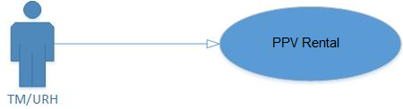

Figure 32: PPV Rental

|  |  |
| --- | --- |
| **Actor** | TM/URH |
| **Operation Name** | PPV Rental |
| **Pre-condition** | 1. TM and URH are up and running. 2. TM DB is up and running. 3. Integrator is up and running. 4. OMI Integrator is defined in TM and is in Active state. |
| **Flow of events** | 1. PPV rental is done in TM through existing OCI(itemRental)/OPI(rentItem) calls. 2. All the processing for renting is, as before, is done in TM/URH. 3. Call the operation ‘AddEntitlement’ of the Integrator to perform entitlement in VMX. The entitlementId in the call would be Id that represents transaction in TM and packageId in the call would be Channel id of the PPV (because in VMX the PPV Channel is represented as Package whose package Id is the ChannelId of the PPV Channel). 4. Item is rented successfully and data is saved in TM DB. |
| **Post condition** | 1. PPV is rented in TM successfully. 2. PPV is entitled to subscriber successfully in the VMX by the integrator. 3. Success status is saved in the TM DB (Transactions Table) indicating that the PPV renting transaction is in ‘sync with VMX. |
| **Alternative flow of events** | 1. If the operations are to be called asynchronously then their immediate responses are assumed to be failure and TM DB tables (as mentioned in the post condition) will be updated with ‘not sync’ status The tables will be updated with ‘sync’ mark if the actual response from the operation is success. |
| **Exceptional flow** | 1. If any of the synchronous Integrator call fails then no further call to Integrator will be made and an exisiting error will be shown for OPI/OCI. 2. If any error comes in PPV renting in TM then an exisiting error will be shown for OPI/OCI. |
| **Reference** |  |

Table 32: PPV Rental

#### Cancel Rental

This use case describes how an item entitlement to a subscriber in the VMX would be removed by calling the integrator interface when the rental is cancelled in TM through OCI/OPI or TM UI. Multiple entitlements can be removed in a single call to integrator.

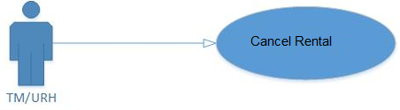

Figure 33: Cancel Rental

|  |  |
| --- | --- |
| **Actor** | TM/URH |
| **Operation Name** | Cancel Rental |
| **Pre-condition** | 1. TM and URH are up and running. 2. TM DB is up and running. 3. Integrator is up and running. 4. OMI Integrator is defined in TM and is in Active state. |
| **Flow of events** | 1. Item rental is cancelled in TM through existing OCI(cancelPPVRental)/OPI(cancelPPVRental)/TM UI calls. 2. All the processing for renting cancellation, as before, is done in TM/URH. 3. Call the operation ‘RemoveEntitlement’ of the Integrator to perform entitlement removal in VMX. The entitlementId in the call would be Id that represents transaction in TM. 4. Item renting is cancelled successfully and data is saved in TM DB. |
| **Post condition** | 1. Item rental cancellation in TM is done successfully. 2. Itementitlement removed to subscriber successfully in the VMX by the integrator. 3. Success status is saved in the TM DB (Transactions Table) indicating that the item rental cancellation transaction is in ‘sync with VMX. |
| **Alternative flow of events** | 1. If the operations are to be called asynchronously then their immediate responses are assumed to be failure and TM DB tables (as mentioned in the post condition) will be updated with ‘not sync’ status The tables will be updated with ‘sync’ mark if the actual response from the operation is success. |
| **Exceptional flow** | 1. If any of the synchronous Integrator call fails then no further call to Integrator will be made and and an exiting error will be shown for OCI/OPI/TM UI. 2. If any error comes in item rental cancellation in TM then an exiting error will be shown for OCI/OPI/TM UI AND call ‘AddEntitlement’ operation of the Integrator to revert back the VMX operation. |
| **Reference** |  |

Table 33: Cancel Rental

#### Add a Recording

This use case describes how recording assets would be provisioned and entitled to the user in the VMX. This use case applies to invidual recording as well as series recording OCI and OPI requests. This case will only be executed when the system recording is not created in the system.

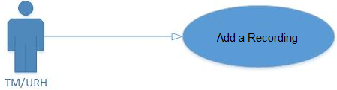

Figure 34: Add a Recording

|  |  |
| --- | --- |
| **Actor** | URH |
| **Operation Name** | Add Recording |
| **Pre-condition** | 1. TM is up and running. 2. TM DB is up and running. 3. Integrator is up and running. 4. OMI Integrator is defined in TM and is in Active state. |
| **Flow of events** | 1. URH receives the add recording OCI/OPI request. 2. TM/URH will ask for the ContentId from the OMI Integrator Client which in turn would call OMI Integrator by calling a URL provided by OMI Integrator (which is currently generated by nPVR Mediator. But now onwards it will use the ContentId generated by the OMI Integrator rather generating that on its own), please refer to the section 3.1.2.2.2.23 for the same. 3. TM/URH will store the ContentId in the SystemNPVRRecording table in TM. 4. TM/URH sends one additional parameter i.e. ContentId in the request to the nPVR mediator. 5. All the processing for adding the recording which is in place currently would be done as before. 6. When the TM/URH receives the response from the nPVR Mediator and ff the system recording is created in this add recording request then call operation ‘AddRecording’ of the Integrator (through the integrator client) to provision one asset in VMX (with content id as the content Id generated in the step 2). . |
| **Post condition** | 1. Content Id is successfully retrieved by the TM/URH through OMI integrator client. 2. Request to Mediator is sent successfully along with the generated content Id. 3. Recording request processed successfully. 4. The recording asset is provisioned successfully (with the content id retrieved in #1) in the VMX by the integrator after receiving the response from nPVR mediator 5. The recording asset is assigned to the package (which represents the channel) after receiving the response from nPVR mediator. 6. Success status is saved in the TM DB (SystemNPVRRecording Table) indicating that the asset is in ‘sync with VMX. Which actually indicates that the recording asset is successfully assigned to the package representing the channel. |
| **Alternative flow of events** | 1. If the operations are to be called asynchronously then their immediate responses are assumed to be failure and TM DB tables (as mentioned in the post condition) will be updated with ‘not sync’ status The tables will be updated with ‘sync’ mark if the actual response from the operation is success. |
| **Exceptional flow** | 1. If content Id from the client is not retrieved successfully then the recording request for add recording will be failed and an exisiting OPI/OCI error message will be shown. |
| **Reference** |  |

Table 34: Add a Recording

#### Deleting a Recording

This use case describes how recording assets would be de-provisioned and entitlement removal from the user in the VMX. This use case applies to invidual recording as well as series recording deletion OCI and OPI requests. Please note, if the recordings are deleted through exisiting batch process then the VMX interaction should not block the batch process. This use case will only be executed when system recording is to be deleted.

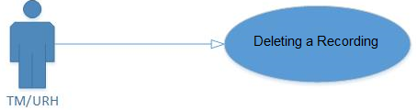

Figure 35: Deleting a Recording

|  |  |
| --- | --- |
| **Actor** | URH |
| **Operation Name** | Delete Recording |
| **Pre-condition** | 1. TM is up and running. 2. TM DB is up and running. 3. Integrator is up and running. 4. OMI Integrator is defined in TM and is in Active state. |
| **Flow of events** | 1. URH receives the delete recording OCI/OPI requests or during the exisiting batch processes. 2. All the processing for deleting the recording which is in place currently would be done as before. 3. If system recording is to be deleted then call the operation ‘DeleteContent’ of the Integrator to de-provision asset in VMX. The content Id will be the content Id which was generated and saved while sending the recording request. |
| **Post condition** | 1. Recording is deleted in the TM successfully. 2. If system recording is deleted then all the recording assets are de-provisioned successfully in the VMX by the integrator. |
| **Alternative flow of events** | 1. If the operations are to be called asynchronously then their immediate responses are assumed to be failure and TM DB tables (as mentioned in the post condition) will be updated with ‘not sync’ status The tables will be updated with ‘sync’ mark if the actual response from the operation is success. |
| **Exceptional flow** | 1. If any of the synchronous Integrator call fails then no further call to Integrator will be made and an exisiting error will be shown for OCI/OPI. 2. If any error comes during the recording deletion in TM then an exisiting error will be shown for OCI/OPI. AND call operation ‘CreateContent’ to revert back the VMX operation. |
| **Reference** |  |

Table 35: Delete a Recording

#### Package subscription modification

This use case describes how a package subscription would be modified in the VMX by calling the integrator interface when the subscription is modified in TM through GUI. Multiple subscriptions can be modified in a single call to integrator.

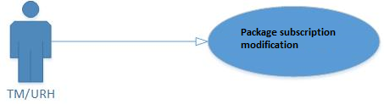

Figure 36: Package Subscription Modification

|  |  |
| --- | --- |
| **Actor** | TM/URH |
| **Operation Name** | Package Subscription Modification |
| **Pre-condition** | 1. TM is up and running. 2. TM DB is up and running. 3. Integrator is up and running. 4. OMI Integrator is defined in TM and is in Active state. |
| **Flow of events** | 1. Call the operation ‘ModifyEntitlement’of the Integrator to perform entitlement in VMX. 2. Subscription modification is done successfully and data is saved in TM DB. |
| **Post condition** | 1. Subscription is modified in TM successfully. 2. Entitlement is modified successfully in the VMX by the integrator. 3. Success status is saved in the TM DB (SubscriberPackages) indicating that subscriber-package association is in ‘sync with VMX. |
| **Alternative flow of events** | 1. If the operation is to be called asynchronously then its immediate response is assumed to be failure and TM DB tables (as mentioned in the post condition) will be updated with ‘not sync’ status The tables will be updated with ‘sync’ mark if the actual response from the operation is success. |
| **Exceptional flow** | 1. If the synchronous Integrator call fails then an exisiting error message will be shown on GUI. 2. If any error comes in modifying the package subscription in TM then an exisiting error message will be shown on GUI. |
| **Reference** |  |

Table 36: Package Subscription Modification

#### Add stream to channel

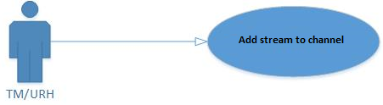

Figure 37: Add stream to channel

|  |  |
| --- | --- |
| **Actor** | TM |
| **Operation Name** | Add stream to channel |
| **Pre-condition** | 1. TM is up and running. 2. TM DB is up and running. 3. Integrator is up and running. 4. OMI Integrator is defined in TM and is in Active state. 5. Channel is activated and in sync with VMX. |
| **Flow of events** | 1. Call the operation ‘AddStreamToChannel’ the Integrator with sub tags ‘CreateContent’ and ‘AddItemsToPackage’. 2. Stream is added and data is saved in DB. |
| **Post condition** | 1. Channel streams are provisioned successfully in the VMX by the integrator. 2. Success status is saved in the TM DB (DtvChannels Table) indicating that the channel is in ‘sync with VMX. |
| **Alternative flow of events** | 1. If the operation is to be called asynchronously then its immediate response is assumed to be failure and TM DB tables (as mentioned in the post condition) will be updated with ‘not sync’ status The tables will be updated with ‘sync’ mark if the actual response from the operation is success. |
| **Exceptional flow** | 1. If the synchronous Integrator call fails then exisiting error will be shown on GUI. 2. If any error comes during the stream addition then exisiting error will be shown on GUI. |
| **Reference** |  |

Table 37: Add stream to channel

#### Delete stream from channel

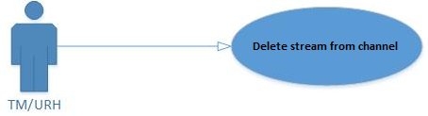

Figure 38: Delete stream from channel

|  |  |
| --- | --- |
| **Actor** | TM |
| **Operation Name** | Delete stream from channel |
| **Pre-condition** | 1. TM is up and running. 2. TM DB is up and running. 3. Integrator is up and running. 4. OMI Integrator is defined in TM and is in Active state. 5. Channel is activated and in sync with VMX. |
| **Flow of events** | 1. Call the operation ‘DeleteStreamFromChannel’ of the integrator. 2. Stream is removed and data is saved in DB. |
| **Post condition** | 1. Channel streams are removed successfully in the VMX by the integrator. 2. Success status is saved in the TM DB (DtvChannels Table) indicating that the channel is in ‘sync with VMX. |
| **Alternative flow of events** | 1. If the operation is to be called asynchronously then its immediate response is assumed to be failure and TM DB tables (as mentioned in the post condition) will be updated with ‘not sync’ status The tables will be updated with ‘sync’ mark if the actual response from the operation is success. |
| **Exceptional flow** | 1. If the synchronous Integrator call fails then exisiting error will be shown on GUI. 2. If any error comes during the asset addition then exisiting error will be shown on GUI. |
| **Reference** |  |

Table 38: Delete stream from channel

#### Add asset to VoD

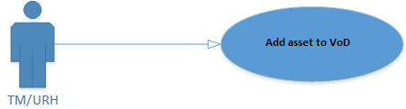

Figure 39: Add asset to VoD

|  |  |
| --- | --- |
| **Actor** | TM |
| **Operation Name** | Add asset to VoD |
| **Pre-condition** | 1. TM is up and running. 2. TM DB is up and running. 3. Integrator is up and running. 4. OMI Integrator is defined in TM and is in Active state. 5. VoD is activated and in sync with VMX. |
| **Flow of events** | 1. Call the operation ‘AddAssetToVoD’ of the integrator with sub tag ‘CreateContent’ and ‘AddItemsToPackage’. 2. Asset is added and data is saved in DB. |
| **Post condition** | 1. Asset is provisioned successfully in the VMX by the integrator. 2. Success status is saved in the TM DB (ContentItems Table) indicating that the VoD is in ‘sync with VMX. |
| **Alternative flow of events** | 1. If the operation is to be called asynchronously then its immediate response is assumed to be failure and TM DB tables (as mentioned in the post condition) will be updated with ‘not sync’ status The tables will be updated with ‘sync’ mark if the actual response from the operation is success. |
| **Exceptional flow** | 1. If the synchronous Integrator call fails then exisiting error will be shown on GUI. 2. If any error comes during the asset addition then exisiting error will be shown on GUI. |
| **Reference** |  |

Table 39: Add asset to VoD

#### Remove asset from VoD

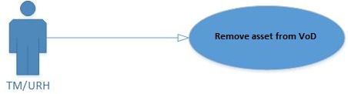

Figure 40: Remove asset from VoD

|  |  |
| --- | --- |
| **Actor** | TM |
| **Operation Name** | Remove asset from VoD |
| **Pre-condition** | 1. TM is up and running. 2. TM DB is up and running. 3. Integrator is up and running. 4. OMI Integrator is defined in TM and is in Active state. 5. VoD is activated and in sync with VMX. |
| **Flow of events** | 1. Call the operation ‘DeleteAssetFromVoD’ of the integrator. 2. Asset is removed to VoD on TM UI. 3. Asset is added and data is saved in DB. |
| **Post condition** | 1. Asset is removed successfully in the VMX by the integrator. 2. Success status is saved in the TM DB (ContentItems Table) indicating that the VoD is in ‘sync with VMX. |
| **Alternative flow of events** | 1. If the operation is to be called asynchronously then its immediate response is assumed to be failure and TM DB tables (as mentioned in the post condition) will be updated with ‘not sync’ status The tables will be updated with ‘sync’ mark if the actual response from the operation is success. |
| **Exceptional flow** | 1. If the synchronous Integrator call fails then exisiting error will be shown on GUI. 2. If any error comes during the asset addition then exisiting error will be shown on GUI. |
| **Reference** |  |

Table 40: Remove asset from VoD

## Class Diagrams

### TM GUI Class Diagram

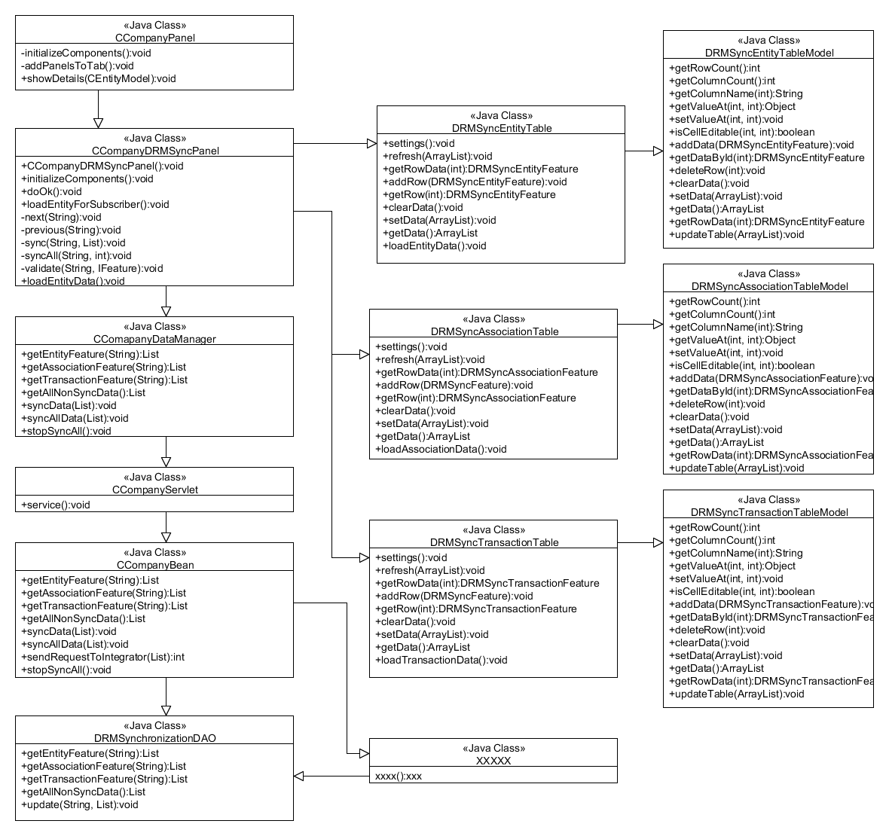

Figure 41: TM GUI Class Diagram

### OMI Client Class Diagram

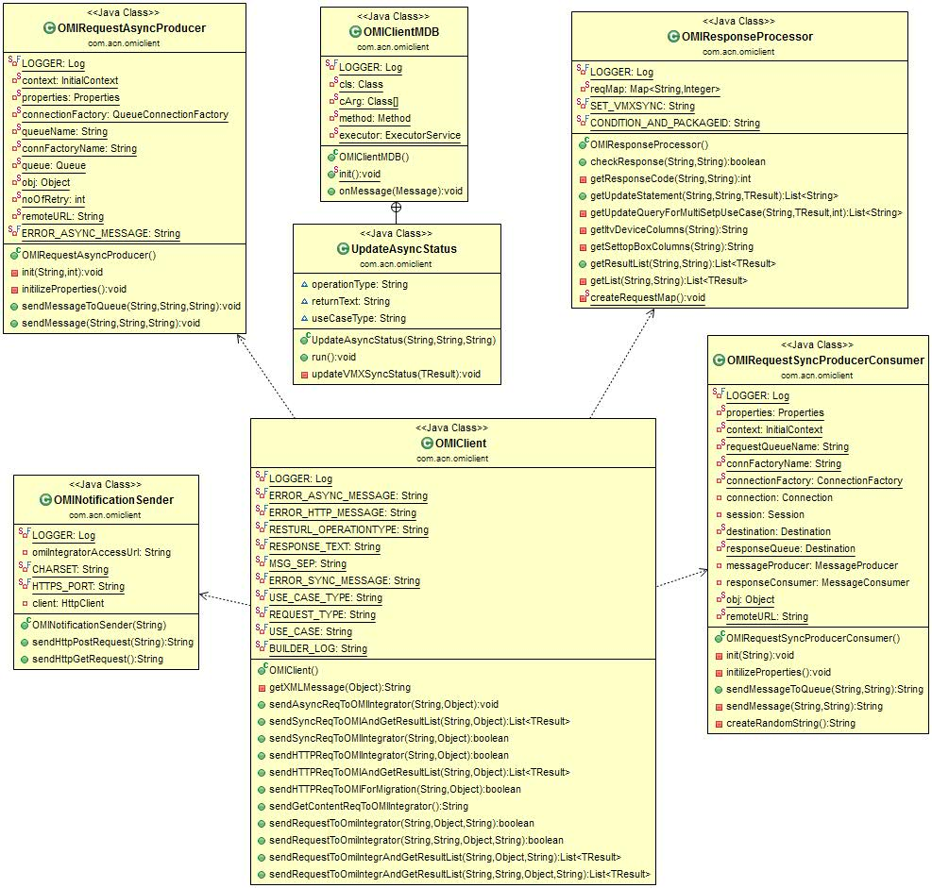

Figure 42: OMI Client Class Diagram 1

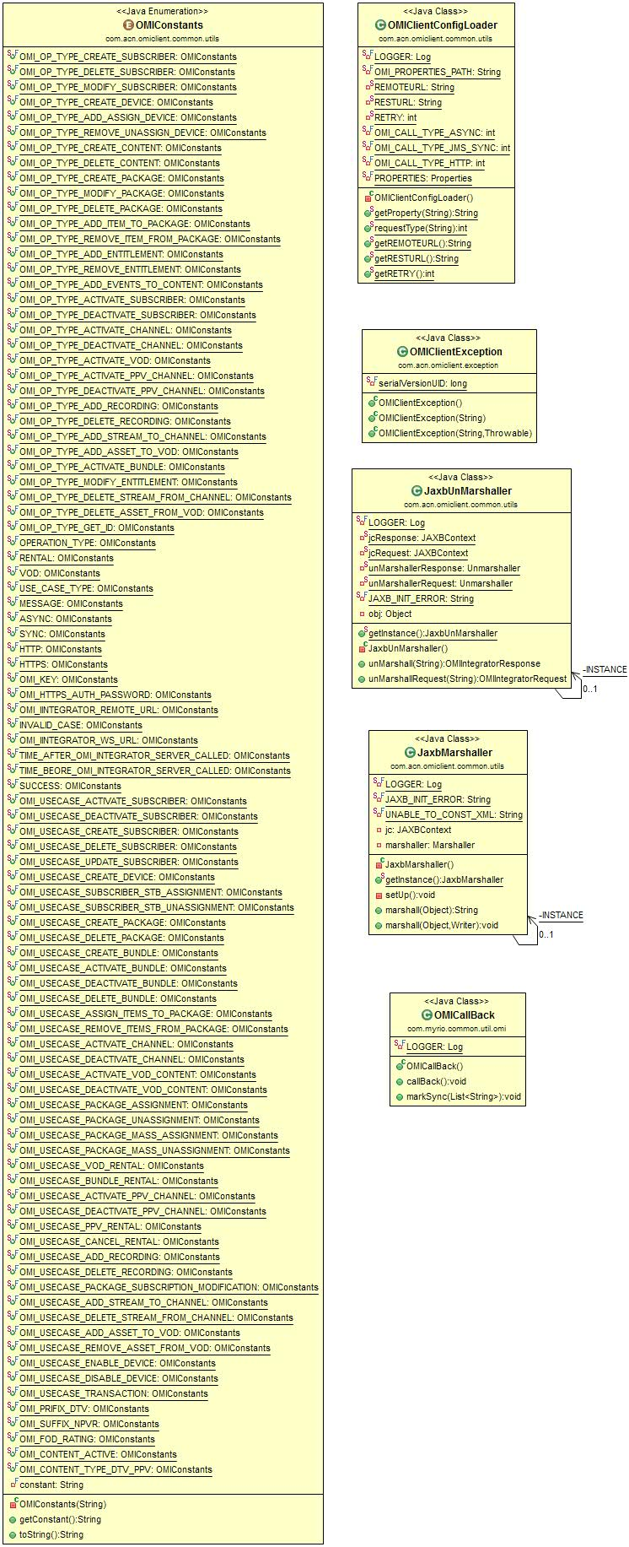

Figure 43: OMI Client Class Diagram 2

# Implementation

## TM GUI changes for Migration

### Use Case Modeling

#### Synchronization of Entities

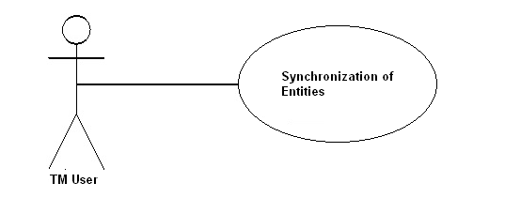

Figure 44: Synchronization of Entities

|  |  |
| --- | --- |
| **Actor** | TM User |
| **Information** | Fetching the list of non-sync Entities from DB and forward it on OMI Integrator for synchronization. |
| **Pre-condition** | 1. TM is up and running. 2. TM DB is up and running. 3. OMI Integrator is up and running. |
| **Flow of events** | 1. Login to TM 2. Select Setup -> Company -> DRM Synchronization 3. Select Entities RadioButton 4. Select entity type from combo-box 5. According to selected entity type Non-Sync Items table will be loaded. 6. Synchronization:    1. Selected items synchronization:       1. Select item from Non-Sync Items table       2. Click on Sync button.    2. All items synchronization:       1. Enter batch size from 1 to 1000 in batch text box       2. Click in Sync all button |
| **Post condition** | 1. Selected items/all (for selected type) entities will be forwarded to OMI Integrator for synchronization. 2. The status of VMXSYNC column in TM DB will be updated according to OMI response. |
| **Alternative flow of events** | None. |
| **Exception** | 1. Click on Sync button without selecting items from “Non-Sync Items table” then message should be shown “Please select item(s) to sync”. |
| **Reference** |  |

Table 41: Synchronization of Entities Table

#### Synchronization of Associations

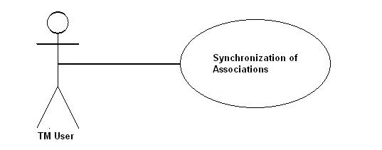

Figure 45: Synchronization of Associations

|  |  |
| --- | --- |
| **Actor** | TM User |
| **Information** | Fetching the list of non-sync Entities from DB and forward it on OMI Integrator for synchronization. |
| **Pre-condition** | 1. TM is up and running. 2. TM DB is up and running. 3. OMI Integrator is up and running. |
| **Flow of events** | 1. Login to TM 2. Select Setup -> Company -> DRM Synchronization 3. Select Associations RadioButton 4. Select association type from combo-box 5. According to selected association type Non-Sync Items table will be loaded. 6. Synchronization:    1. Selected items synchronization:       1. Select item from Non-Sync Items table       2. Click on Sync button.    2. All items synchronization:       1. Enter batch size from 1 to 1000 in batch text box       2. Click in Sync all button |
| **Post condition** | 1. Selected items/all (for selected type) associations will be forwarded to OMI Integrator for synchronization. 2. The status of VMXSYNC column in TM DB will be updated according to OMI response. |
| **Alternative flow of events** | None. |
| **Exception** | 1. Click on Sync button without selecting items from “Non-Sync Items table” then message should be shown “Please select item(s) to sync”. |
| **Reference** |  |

Table 42 : Synchronization of Associations Table

#### Synchronization of Transactions

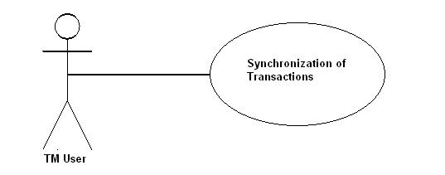

Figure 46: Synchronization of Transactions

|  |  |
| --- | --- |
| **Actor** | TM User |
| **Information** | Fetching the list of non-sync Transactions from DB and forward it on OMI Integrator for synchronization. |
| **Pre-condition** | 1. TM is up and running. 2. TM DB is up and running. 3. OMI Integrator is up and running. |
| **Flow of events** | 1. Login to TM 2. Select Setup -> Company -> DRM Synchronization 3. Select Transactions RadioButton 4. Select transaction type from combo-box 5. According to selected transaction type Non-Sync Items table will be loaded. 6. Synchronization:    1. Selected items synchronization:       1. Select item from Non-Sync Items table       2. Click on Sync button.    2. All items synchronization:       1. Enter batch size from 1 to 1000 in batch text box       2. Click in Sync all button |
| **Post condition** | 1. Selected items/all (for selected type) entities will be forwarded to OMI Integrator for synchronization. 2. The status of VMXSYNC column in TM DB will be updated according to OMI response. |
| **Alternative flow of events** | None. |
| **Exception** | 1. Click on Sync button without selecting items from “Non-Sync Items table” then message should be shown “Please select item(s) to sync”. |
| **Reference** |  |

Table 43 : Synchronization of Transactions Table

#### Synchronization of All Items

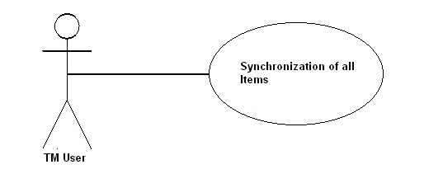

Figure 47: Synchronization of All Items

|  |  |
| --- | --- |
| **Actor** | TM User |
| **Information** | Fetching the list of all non-sync items from DB and forward it on OMI Integrator for synchronization. |
| **Pre-condition** | 1. TM is up and running. 2. TM DB is up and running. 3. OMI Integrator is up and running. |
| **Flow of events** | 1. Login to TM 2. Select Setup -> Company -> DRM Synchronization 3. Select All RadioButton 4. Synchronization:    1. All items synchronization:       1. Enter batch size from 1 to 1000 in batch text box       2. Click in Sync all button |
| **Post condition** | 1. All items will be forwarded to OMI Integrator for synchronization in pre-defined order. 2. The status of VMXSYNC column in TM DB will be updated according to OMI response. |
| **Alternative flow of events** | None. |
| **Exception** | None. |
| **Reference** |  |

Table 44 : Synchronization of All Items Table

#### Stop Sync All

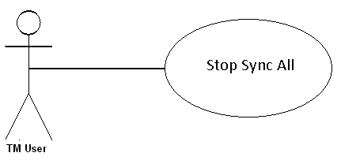

Figure 48: Stop Sync All

|  |  |
| --- | --- |
| **Actor** | TM User |
| **Information** | To stop the already going on sync all process. |
| **Pre-condition** | 1. TM is up and running. 2. TM DB is up and running. 3. OMI Integrator is up and running. |
| **Flow of events** | 1. Login to TM 2. Select Setup -> Company -> DRM Synchronization 3. Click in Stop button |
| **Post condition** | 1. Remaining going on Sync all process will be stop. 2. The status of VMXSYNC column in TM DB will be updated. |
| **Alternative flow of events** | None. |
| **Exception** | None. |
| **Reference** |  |

Table 45 : Stop Sync All Table

### Flow Diagram

#### Flow diagram for Entities

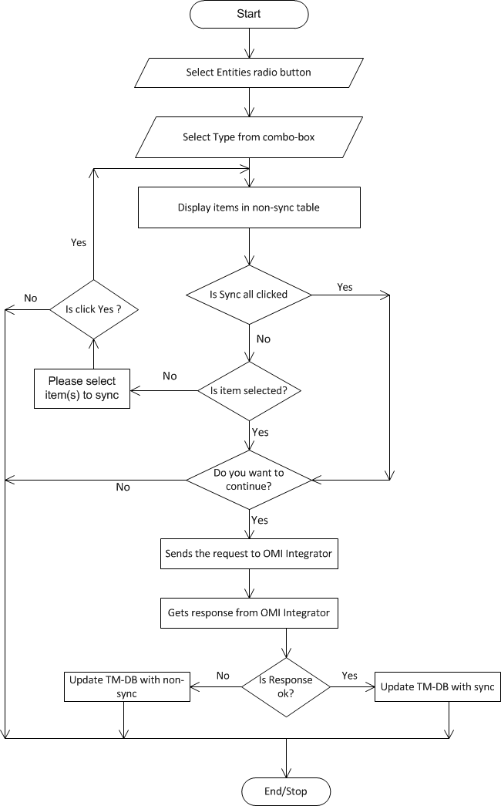

Figure 49: Flow diagram for Entities

#### Flow diagram for Associations

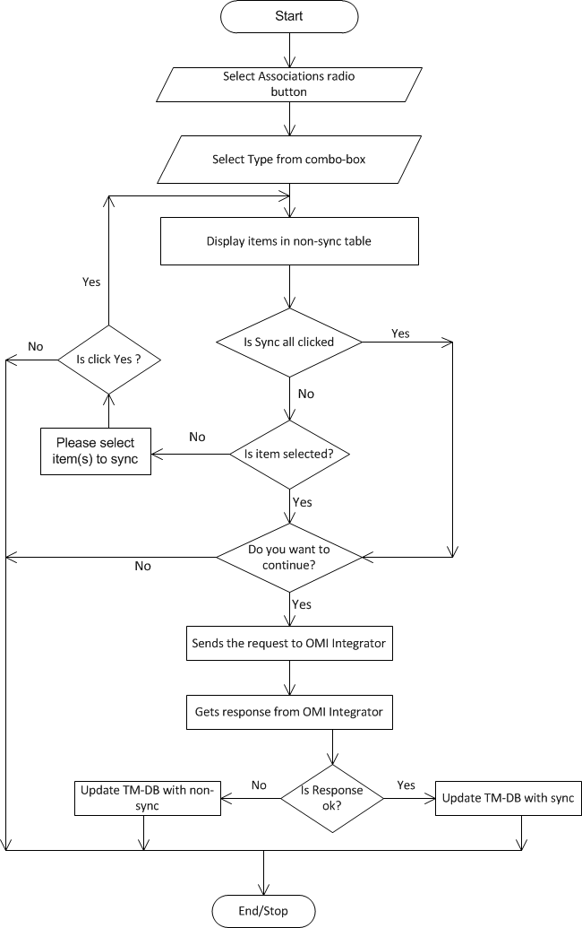

Figure 50: Flow diagram for Associations

#### Flow diagram for Transactions

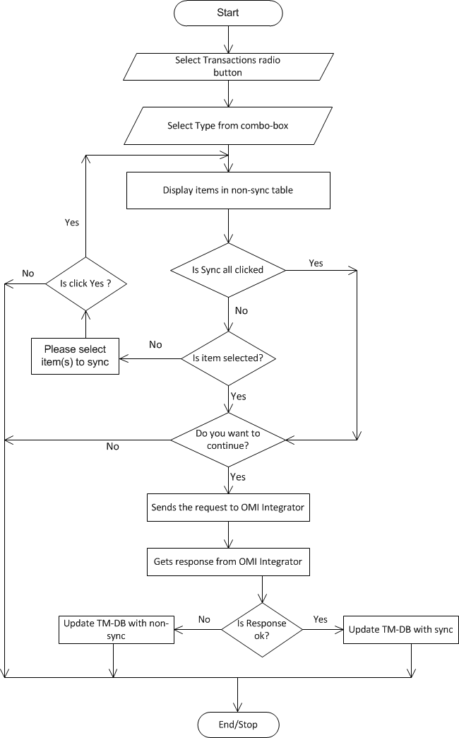

Figure 51: Flow diagram for Transactions

#### Flow diagram for All process

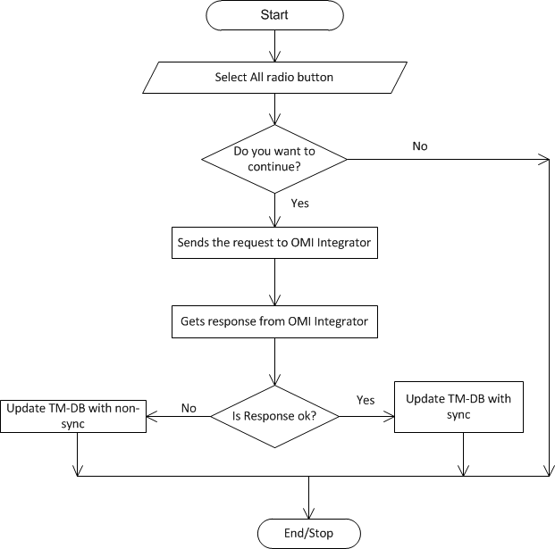

Figure 52: Flow diagram for All process

#### Flow diagram for Stop sync all

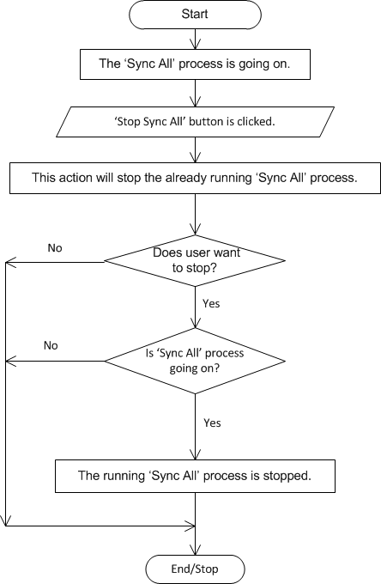

Figure 53: Flow diagram for Stop sync all

#### Flow diagram for Batch size value

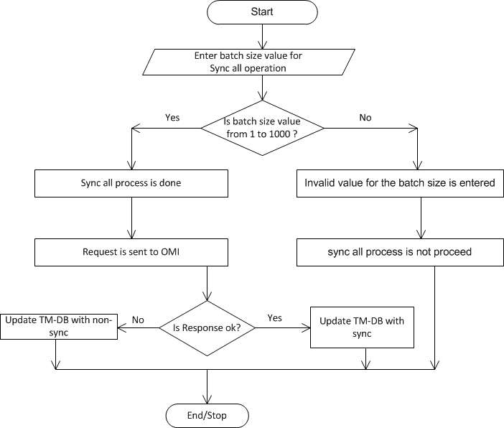

Figure 54: Flow diagram for Batch size value

### Sequesnce Diagram

#### Entities



Figure 55: Sequesnce Diagram - Entities

#### Association



Figure 56: Sequesnce Diagram - Association

#### Transaction



Figure 57: Sequesnce Diagram - Transaction

#### Sync All Entities



Figure 58: Sequesnce Diagram – Sync All Entities

#### Sync All Associations



Figure 59: Sequesnce Diagram - Sync All Entities

#### Sync All Transactions



Figure 60: Sequesnce Diagram - Sync All Entities

#### Stop Sync All



Figure 61: Sequesnce Diagram - Stop Sync All

## OMI Client Changes

### Flow Diagram

#### OMI Sync Request Flow Diagram

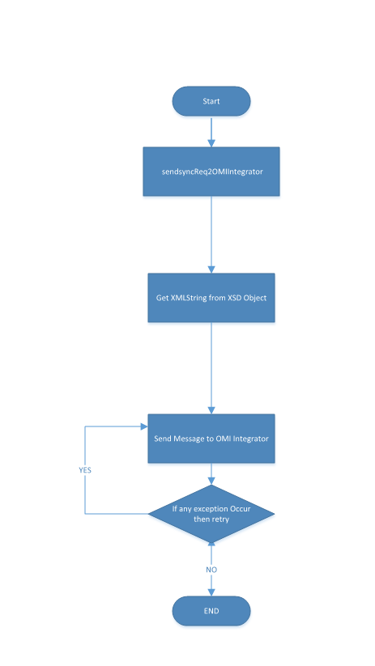

Figure 62: OMI Sync Request Flow Diagram

#### OMI ASync Request Flow Diagram

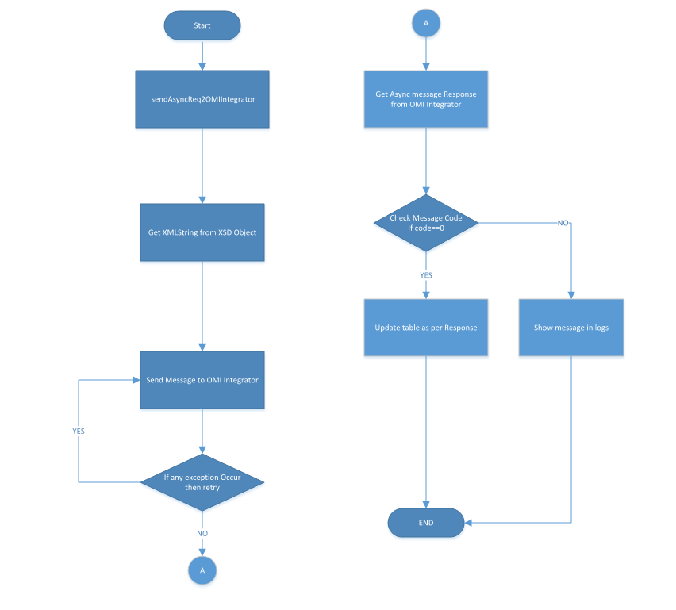

Figure 63 : OMI ASync Request Flow Diagram

### Sequence Diagram

#### OMI AsyncRequest Sequence diagram

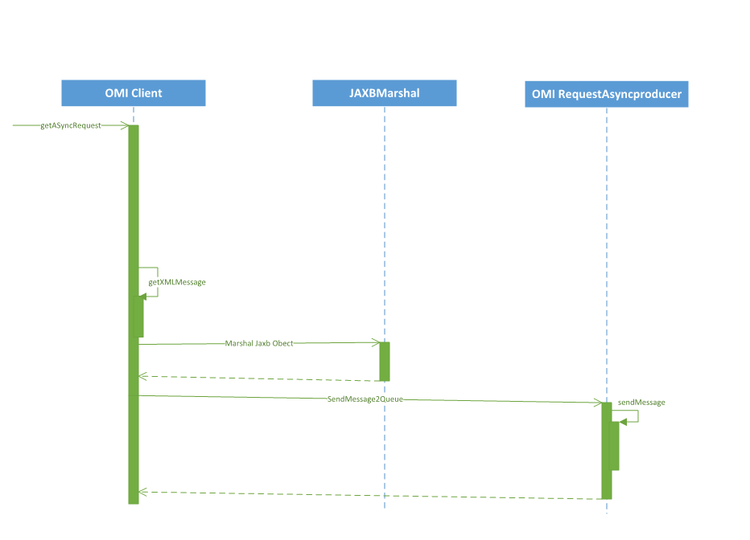

Figure 64: OMI AsyncRequest Sequence diagram

#### OMI HttpRequest Sequence diagram

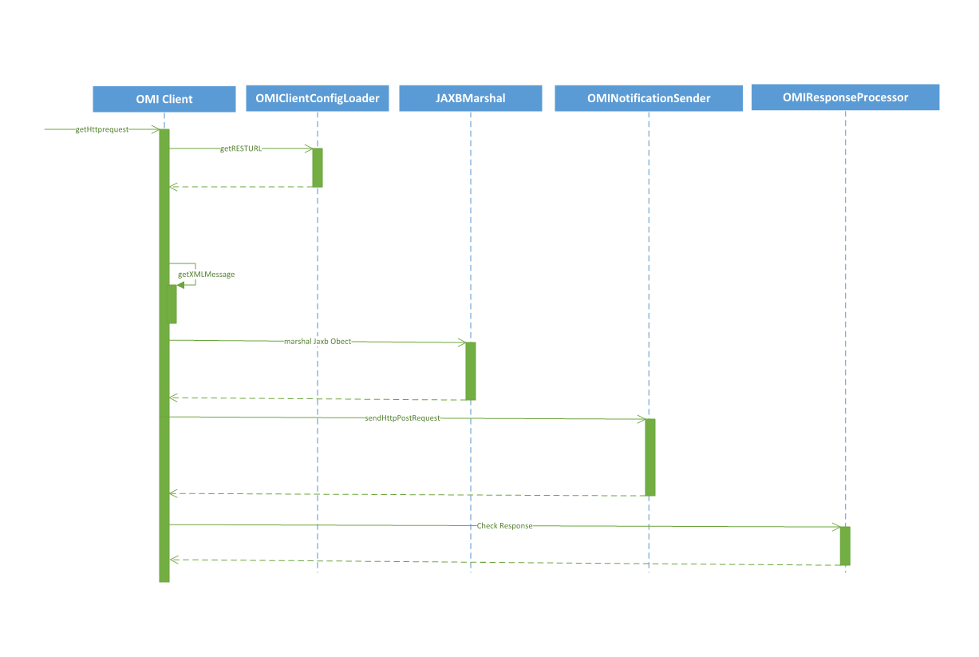

Figure 65: OMI HttpRequest Sequence diagram

#### OMI SyncRequest Sequence diagram

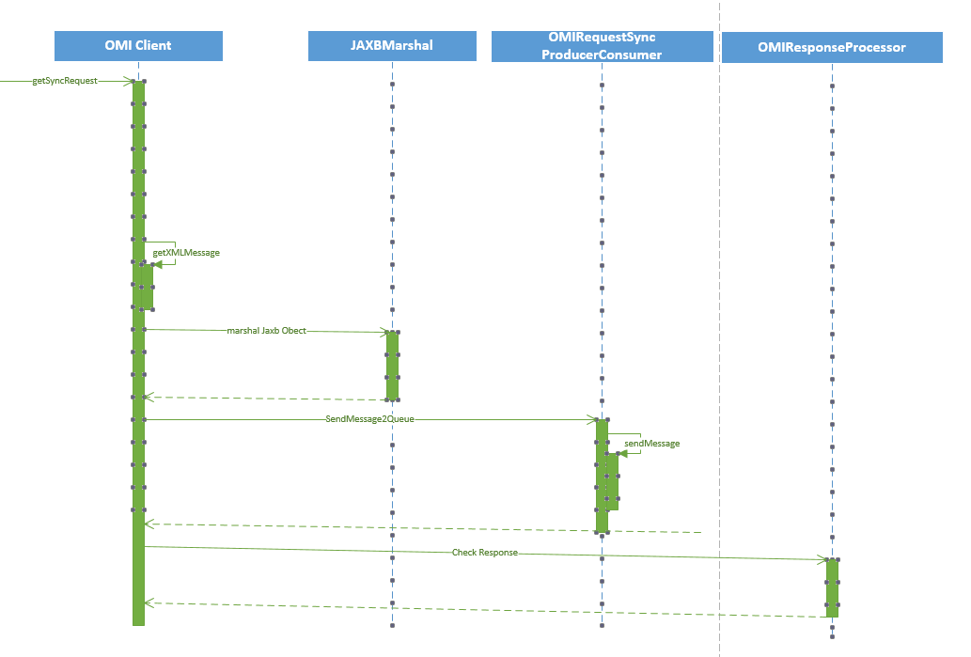

Figure 66: OMI SyncRequest Sequence diagram

### Business Logic

#### OMI Client Objects

* **com.myrio.common.util.omi.OMICallBack**

|  |  |  |
| --- | --- | --- |
| ***Creating Attributes*** | ***Attribute Type*** | ***Description*** |
| logger | private CElementNumber | Odp type id |

|  |  |  |
| --- | --- | --- |
| ***Creating Method*** | ***Description*** | ***Exception*** |
| public void markSync(String query) | To update sync status | None |

* **mclient.msgr.MessageTypes.java**

|  |  |  |
| --- | --- | --- |
| ***Creating Attributes*** | ***Attribute Type*** | ***Description*** |
| OMI_OP_TYPE_CREATE_SUBSCRIBER | Public String | OMI_OP_TYPE_CREATE_SUBSCRIBER |
| OMI_OP_TYPE_CREATE_DEVICE | Public String | OMI_OP_TYPE_CREATE_DEVICE |
| OMI_OP_TYPE_CREATE_PACKAGE | Public String | OMI_OP_TYPE_CREATE_PACKAG |
| OMI_OP_TYPE_ADD_ITEM_TO_PACKAGE | Public String | OMI_OP_TYPE_ADD_ITEM_TO_PACKAGE |
| OMI_OP_TYPE_CREATE_CONTENT | Public String | OMI_OP_TYPE_CREATE_CONTENT |
| OMI_OP_TYPE_DELETE_CONTENT | Public String | OMI_OP_TYPE_DELETE_CONTEN |
| OMI_OP_TYPE_DELETE_PACKAGE | Public String | OMI_OP_TYPE_DELETE_PACKAGE |
| OMI_OP_TYPE_DELETE_SUBSCRIBER | Public String | OMI_OP_TYPE_DELETE_SUBSCRIBER |
| OMI_OP_TYPE_MODIFY_SUBSCRIBER | Public String | OMI_OP_TYPE_MODIFY_SUBSCRIBER |
| OMI_OP_TYPE_ASSIGN_DEVICE | Public String | OMI_OP_TYPE_ASSIGN_DEVICE |
| OMI_OP_TYPE_UNASSIGN_DEVICE | Public String | OMI_OP_TYPE_UNASSIGN_DEVICE |
| OMI_OP_TYPE_ADD_ASSIGN_DEVICE | Public String | OMI_OP_TYPE_ADD_ASSIGN_DEVICE |
| OMI_OP_TYPE_REMOVE_UNASSIGN_DEVICE | Public String | OMI_OP_TYPE_REMOVE_UNASSIGN_DEVICE |
| OMI_OP_TYPE_MODIFY_PACKAG | Public String | OMI_OP_TYPE_MODIFY_PACKAG |
| OMI_OP_TYPE_REMOVE_ITEM_TO_PACKAGE | Public String | OMI_OP_TYPE_REMOVE_ITEM_TO_PACKAGE |
| OMI_OP_TYPE_ADD_ENTITLEMENT | Public String | OMI_OP_TYPE_ADD_ENTITLEMENT |
| OMI_OP_TYPE_MODIFY_ENTITLEMENT | Public String | OMI_OP_TYPE_MODIFY_ENTITLEMENT |
| OMI_OP_TYPE_REMOVE_ENTITLEMENT | Public String | OMI_OP_TYPE_REMOVE_ENTITLEMENT |
| OMI_OP_TYPE_ADD_EVENTS_TO_CONTEN | Public String | OMI_OP_TYPE_ADD_EVENTS_TO_CONTEN |
| OMI_SERVER_NAME | Public String | OMI_OP_TYPE_ADD_ITEM_TO_PKG |
| OMI_OP_TYPE_DEACTIVATE_SUBSCRIBER | Public String | OMI_OP_TYPE_DEACTIVATE_SUBSCRIBER |
| OMI_OP_TYPE_ACTIVATE_CHANNEL | Public String | OMI_OP_TYPE_ACTIVATE_CHANNEL |
| OMI_OP_TYPE_DEACTIVATE_CHANNEL | Public String | OMI_OP_TYPE_DEACTIVATE_CHANNEL |
| OMI_OP_TYPE_ACTIVATE_VOD | Public String | OMI_OP_TYPE_ACTIVATE_VOD |
| OMI_OP_TYPE_ACTIVATE_PPV_CHANNEL | Public String | OMI_OP_TYPE_ACTIVATE_PPV_CHANNEL |
| OMI_OP_TYPE_DEACTIVATE_PPV_CHANNEL | Public String | OMI_OP_TYPE_DEACTIVATE_PPV_CHANNEL |
| OMI_OP_TYPE_ADD_RECORDING | Public String | OMI_OP_TYPE_ADD_RECORDING |
| OMI_OP_TYPE_ADD_STREAM_TO_CHANNEL | Public String | OMI_OP_TYPE_ADD_STREAM_TO_CHANNEL |
| OMI_OP_TYPE_DELETE_STREAM_FROM_CHANNEL | Public String | OMI_OP_TYPE_DELETE_STREAM_FROM_CHANNEL |
| OMI_OP_TYPE_ADD_ASSET_TO_VOD | Public String | OMI_OP_TYPE_ADD_ASSET_TO_VOD |
| OMI_OP_TYPE_DELETE_ASSET_FROM_VOD | Public String | OMI_OP_TYPE_DELETE_ASSET_FROM_VOD |
| OMI_OP_TYPE_ACTIVATE_BUNDLE | Public String | OMI_OP_TYPE_ACTIVATE_BUNDLE |
| OMI_USECASE_ACTIVATE_SUBSCRIBER | Public String | OMI_USECASE_ACTIVATE_SUBSCRIBER |
| OMI_USECASE_DEACTIVATE_SUBSCRIBER | Public String | OMI_USECASE_DEACTIVATE_SUBSCRIBER |
| OMI_USECASE_CREATE_SUBSCRIBER | Public String | OMI_USECASE_CREATE_SUBSCRIBER |
| OMI_USECASE_DELETE_SUBSCRIBER | Public String | OMI_USECASE_DELETE_SUBSCRIBER |
| OMI_USECASE_UPDATE_SUBSCRIBER | Public String | OMI_USECASE_UPDATE_SUBSCRIBER |
| OMI_USECASE_CREATE_DEVICE | Public String | OMI_USECASE_CREATE_DEVICE |
| OMI_USECASE_SUBSCRIBER_STB_ASSIGNMENT | Public String | OMI_USECASE_SUBSCRIBER_STB_ASSIGNMENT |
| OMI_USECASE_SUBSCRIBER_STB_UNASSIGNMENT | Public String | OMI_USECASE_SUBSCRIBER_STB_UNASSIGNMENT |
| OMI_USECASE_CREATE_PACKAGE | Public String | OMI_USECASE_CREATE_PACKAGE |
| OMI_USECASE_DELETE_PACKAGE | Public String | OMI_USECASE_DELETE_PACKAGE |
| OMI_USECASE_CREATE_BUNDLE | Public String | OMI_USECASE_CREATE_BUNDLE |
| OMI_USECASE_ACTIVATE_BUNDLE | Public String | OMI_USECASE_ACTIVATE_BUNDLE |
| OMI_USECASE_DEACTIVATE_BUNDLE | Public String | OMI_USECASE_DEACTIVATE_BUNDLE |
| OMI_USECASE_DELETE_BUNDLE | Public String | OMI_USECASE_DELETE_BUNDLE |
| OMI_USECASE_ASSIGN_ITEMS_TO_PACKAGE | Public String | OMI_USECASE_ASSIGN_ITEMS_TO_PACKAGE |
| OMI_USECASE_REMOVE_ITEMS_FROM_PACKAGE | Public String | OMI_USECASE_REMOVE_ITEMS_FROM_PACKAGE |
| OMI_USECASE_ACTIVATE_CHANNEL | Public String | OMI_USECASE_ACTIVATE_CHANNEL |
| OMI_USECASE_DEACTIVATE_CHANNEL | Public String | OMI_USECASE_DEACTIVATE_CHANNEL |
| OMI_USECASE_ACTIVATE_VOD_CONTENT | Public String | OMI_USECASE_ACTIVATE_VOD_CONTENT |
| OMI_USECASE_DEACTIVATE_VOD_CONTENT | Public String | OMI_USECASE_DEACTIVATE_VOD_CONTENT |
| OMI_USECASE_PACKAGE_ASSIGNMENT | Public String | OMI_USECASE_PACKAGE_ASSIGNMENT |
| OMI_USECASE_PACKAGE_UNASSIGNMENT | Public String | OMI_USECASE_PACKAGE_UNASSIGNMENT |
| OMI_USECASE_PACKAGE_MASS_ASSIGNMENT | Public String | OMI_USECASE_PACKAGE_MASS_ASSIGNMENT |
| OMI_USECASE_PACKAGE_MASS_UNASSIGNMENT | Public String | OMI_USECASE_PACKAGE_MASS_UNASSIGNMENT |
| OMI_USECASE_VOD_RENTAL | Public String | OMI_USECASE_VOD_RENTAL |
| OMI_USECASE_BUNDLE_RENTAL | Public String | OMI_USECASE_BUNDLE_RENTAL |
| OMI_USECASE_ACTIVATE_PPV_CHANNEL | Public String | OMI_USECASE_ACTIVATE_PPV_CHANNEL |
| OMI_USECASE_DEACTIVATE_PPV_CHANNEL | Public String | OMI_USECASE_DEACTIVATE_PPV_CHANNEL |
| OMI_USECASE_PPV_RENTAL | Public String | OMI_USECASE_PPV_RENTAL |
| OMI_USECASE_CANCEL_RENTAL | Public String | OMI_USECASE_CANCEL_RENTAL |
| OMI_USECASE_ADD_RECORDING | Public String | OMI_USECASE_ADD_RECORDING |
| OMI_USECASE_DELETE_RECORDING | Public String | OMI_USECASE_DELETE_RECORDING |
| OMI_USECASE_PACKAGE_SUBSCRIPTION_MODIFICATION | Public String | OMI_USECASE_PACKAGE_SUBSCRIPTION_MODIFICATION |
| OMI_USECASE_ADD_STREAM_TO_CHANNEL | Public String | OMI_USECASE_ADD_STREAM_TO_CHANNEL |
| OMI_USECASE_DELETE_STREAM_FROM_CHANNEL | Public String | OMI_USECASE_DELETE_STREAM_FROM_CHANNEL |
| OMI_USECASE_ADD_ASSET_TO_VOD | Public String | OMI_USECASE_ADD_ASSET_TO_VOD |
| OMI_USECASE_REMOVE_ASSET_FROM_VOD | Public String | OMI_USECASE_REMOVE_ASSET_FROM_VOD |
| OMI_USECASE_TRANSACTION | Public String | OMI_USECASE_TRANSACTION |
| OMI_ASYNC | int | OMI_ASYNC |
| OMI_SYNC | int | OMI_SYNC |
| OMI_CALL_TYPE_ASYNC | int | OMI_CALL_TYPE_JMS |
| OMI_CALL_TYPE_JMS_SYNC | int | OMI_CALL_TYPE_JMS_SYNC |
| OMI_CALL_TYPE_HTTP | int | OMI_CALL_TYPE_HTTP |

* **com.acn.omiclient.OMIClient**

|  |  |  |
| --- | --- | --- |
| ***Creating Attributes*** | ***Attribute Type*** | ***Description*** |
| LOGGER | Public log | Logger instance. |
| ERROR_ASYNC_MESSAGE | private static final String | SET_VMXSYNC |
| ERROR_HTTP_MESSAGE | private static final String | Not able to send http request. : |
| RESTURL_OPERATIONTYPE | private String | SET_VMXSYNC |
| RESTURL_OPERATIONTYPE | private static final String | RESTURL + operationType = |
| RESPONSE_TEXT | private static final String | responseText = |
| MSG_SEP | private static final String | : |
| ERROR_SYNC_MESSAGE | private static final String | Not able to send JMS Sync request. |
| USE_CASE_TYPE | private static final String | , useCaseType = |
| REQUEST_TYPE | private static final String | , RequestType = |
| USE_CASE | private static final String | and useCase = |
| BUILDER_LOG | private static final String | builder = |

|  |  |  |
| --- | --- | --- |
| ***Creating Method*** | ***Change Description*** | ***Exception*** |
| private String getXMLMessage(Object jaxbObject) | Convert XSD object to string XML. | None |
| public void sendAsyncReq2OMIIntegrator(String operationType, Object jaxbObject) | Send Async request to OMI Integrator. |  |
| public List<TResult> sendSyncReq2OMIAndGetResultList(String operationType, Object jaxbObject) | Send Sync request to OMI Integrator and return tresult list |  |
| public boolean sendSyncReq2OMIIntegrator(String operationType, Object jaxbObject) | Send JMS Sync request to OMI Integrator |  |
| public boolean sendHTTPReq2OMIIntegrator(String operationType, Object jaxbObject) | Send HTTP request to OMI Integrator |  |
| public List<TResult> sendHTTPReq2OMIAndGetResultList(String operationType, Object jaxbObject) | Send Sync request to OMI Integrator and return tresult list |  |
| public void sendMassOperation2OMIIntegrator(String operationType, Object jaxbObject) | Send Mass Operation request to OMI Integrator |  |
| public String sendGetContentReq2OMIIntegrator() | Get content id for OMI Integrator |  |
| public boolean sendRequestToOmiIntegrator(String operation, Object requestObject) | Send request to VMX |  |
| public List<TResult> sendRequestToOmiIntegrAndGetResultList(String operation, Object requestObject) | Send request to VMX |  |
| public List<TResult> sendRequestToOmiIntegrAndGetResultList(String operation,String useCaseType , Object requestObject, String useCase) | Send request to VMX |  |
| public List<TResult> sendRequestToOmiIntegrAndGetResultList(String operation,Object requestObject, String useCase) | Send request to VMX |  |

* **com.acn.omiclient.OMIResponseProcessor**

|  |  |  |
| --- | --- | --- |
| ***Creating Attributes*** | ***Attribute Type*** | ***Description*** |
| LOGGER | Public log | Logger instance |
| reqMap | Private HashMap<String, Integer> | for all request |
| SET_VMXSYNC | Private string | SET_VMXSYNC |
| CONDITION_AND_PACKAGEID | Private string | CONDITION_AND_PACKAGEID |

|  |  |  |
| --- | --- | --- |
| ***Creating Method*** | ***Change Description*** | ***Exception*** |
| public static boolean checkResponse(String operationType, String responseText) | Check response | none |
| private static int getResponseCode(String operationType, String responseText) | Get response code | none |
| public static String getUpdateStatement(String operationType, TResult result) | Get update statement for db update | none |
| private static String getItvDeviceColumns(String operationType, String columnNameValues) |  | none |
| private static String getSettopBoxColumns(String operationType, String columnNameValues) |  | none |
| public static List<TResult> getResultList(String operationType, String responseText) | Get result list from response | none |
| private static List<TResult> getList(String operationType, String responseText) | Get result list from response | none |
| private List<String> getUpdateQueryForMultiSetpUseCase(String operationType, TResult result, int val) | Get result list from response | none |
| private static void createRequestMap() | Get response type value | none |

* **com.acn.omiclient.OMIClientMDB**

|  |  |  |
| --- | --- | --- |
| ***Creating Attributes*** | ***Attribute Type*** | ***Description*** |
| LOGGER | Protected log | Logger instance |
| cls | Private Class | cls |
| cArg | Private Class[] | cArg |
| method | Private Method | method |
| executor | Private ExecutorService | executor reference |
| operationType | String | operationType |
| returnText | String | returnText |

|  |  |  |
| --- | --- | --- |
| ***Creating Method*** | ***Change Description*** | ***Exception*** |
| public static void init() | Initilize re conditions |  |
| public void onMessage(Message message) | MDB message listner method |  |
| public UpdateAsyncStatus(String operationType, String returnText) |  |  |
| public void run() | Process response |  |

* **com.acn.omiclient.OMINotificationSender**

|  |  |  |
| --- | --- | --- |
| ***Creating Attributes*** | ***Attribute Type*** | ***Description*** |
| LOGGER | Private log | Logger instance |
| omiIntegratorAccessUrl | Private string | 1UX BE Server Full URL |
| CHARSET | private static final String | UTF-8 |
| HTTPS_PORT | private static final String | 9002 |
| client | Private HttpClient | client |

|  |  |  |
| --- | --- | --- |
| ***Creating Method*** | ***Change Description*** | ***Exception*** |
| public OMINotificationSender(String omiIntegratorAccessUrl) |  |  |
| public String sendHttpPostRequest(String bodyData) | Make the HTTP POST call to the OMI Integrator | exception |
| public String sendHttpGetRequest() | Make the HTTP GET call to the OMI Integrator server | exception |

* **com.acn.omiclient.OMIRequestAsyncProducer**

|  |  |  |
| --- | --- | --- |
| ***Creating Attributes*** | ***Attribute Type*** | ***Description*** |
| Logger | Public log | Logger instance |
| context | Private InitialContext | context |
| properties | Private properties | properties |
| connectionFactory | Private QueueConnectionFactory | connectionFactory |
| queueName | Private String | queueName |
| connFactoryName | Private String | connFactoryName |
| queue | Private Queue | queue |
| obj | Private Object | obj |
| remoteURL | private static String | remoteURL |
| ERROR_ASYNC_MESSAGE | private static final String | Not able to send JMS ASync request. : |
| noOfRetry | Private Int | context |

|  |  |  |
| --- | --- | --- |
| ***Creating Method*** | ***Change Description*** | ***Exception*** |
| public static void init(String remoteURL, int retry) | Sets up prerequisite values |  |
| public void sendMessage2Queue(String operationType, String requestText) | Send message to queue | none |
| public void sendMessage(String operationType, String requestText) | Send message to JMS | JMSException |

* **com.acn.omiclient.OMIRequestSyncProducerConsumer**

|  |  |  |
| --- | --- | --- |
| ***Creating Attributes*** | ***Attribute Type*** | ***Description*** |
| LOGGER | Public Log | LOGGER |
| properties | Private properties | properties |
| context | Private InitialContext | context |
| requestQueueName | Private String | requestQueueName |
| connFactoryName | Private String | connFactoryName |
| connectionFactory | Private ConnectionFactory | connectionFactory |
| connection | Private Connection | connection |
| session | Private Session | session |
| destination | Private Destination | destination |
| responseQueue | Private Destination | responseQueue |
| messageProducer | Private MessageProducer | messageProducer |
| responseConsumer | private MessageConsumer | responseConsumer |
| obj | Private Object | object for synchronization |
| remoteURL | private static String | remoteURL |

|  |  |  |
| --- | --- | --- |
| ***Creating Method*** | ***Change Description*** | ***Exception*** |
| public static void init(String remoteURL) | Initilize per conditions | none |
| public String sendMessage2Queue(String operationType, String requestText) | Send message to queue | none |
| public OMIRequestSyncProducerConsumer() | constructor | none |
| private void initilizeProperties() | Initilize per conditions | none |
| private String sendMessage(String operationType,String requestText) | Send message to sync queue | RuntimeException |
| private String createRandomString() |  | none |

* **com.acn.omiclient.common.utils.JaxbMarshaller**

|  |  |  |
| --- | --- | --- |
| ***Creating Attributes*** | ***Attribute Type*** | ***Description*** |
| INSTANCE | Private JaxbMarshaller | Create JaxbMarshaller's instance class loading time |
| LOGGER | Public Log | log |
| JAXB_INIT_ERROR | private static final String | JAXB_INIT_ERROR |
| jc | private JAXBContext | jc |
| UNABLE_TO_CONST_XML | private static final String | UNABLE_TO_CONST_XML |
| marshaller | private Marshaller | marshaller |

|  |  |  |
| --- | --- | --- |
| ***Creating Method*** | ***Change Description*** | ***Exception*** |
| public static JaxbMarshaller getInstance() | Create JaxbMarshaller instance | None |
| private void setUp() | Sets up JAXB context and marshaller | None |
| public String marshall(Object jaxbObject) | Used for marshalling of XSD Object | None |
| public void marshall(Object jaxbObject, Writer writer) | (non-Javadoc) | None |

* **com.acn.omiclient.common.utils. JaxbUnMarshaller**

|  |  |  |
| --- | --- | --- |
| ***Creating Attributes*** | ***Attribute Type*** | ***Description*** |
| LOGGER | Public Log | Log |
| INSTANCE | Private JaxbUnMarshaller | Create JaxbMarshaller's instance class loading time |
| JAXB_ROOT | Private String | JAXB_ROOT |
| jc | private JAXBContext | jc |
| jcResponse | private static JAXBContext | jcResponse |
| jcRequest | private static JAXBContext | jcRequest |
| unMarshallerResponse | private static Unmarshaller | unMarshallerResponse |
| unMarshallerRequest | private static Unmarshaller | unMarshallerRequest |
| obj | private Object | Object |
| JAXB_INIT_ERROR | private static final String | JAXB initialization error. |

|  |  |  |
| --- | --- | --- |
| ***Creating Method*** | ***Change Description*** | ***Exception*** |
| public static JaxbUnMarshaller getInstance() | Create JaxbMarshaller instance | None |
| private void setUp() | Sets up JAXB context and unMarshaller | None |
| public OMIIntegratorResponse unMarshall(String responseXml) | Used for Unmarshalling | None |
| public OMIIntegratorRequest unMarshallRequest(String responseXml) | Used for Unmarshalling | None |

* **com.acn.omiclient.common.utils.OMIClientConfigLoader**

|  |  |  |
| --- | --- | --- |
| ***Creating Attributes*** | ***Attribute Type*** | ***Description*** |
| LOGGER | Protected Log | Logger |
| OMI_PROPERTIES_PATH | Private String | This final variable is used for OMI configuration |
| OMI_CALL_TYPE_ASYNC | Private String | This final variable is used for Asynchronous request |
| OMI_CALL_TYPE_JMS_SYNC | Private String | This final variable is used for Synchronous request |
| OMI_CALL_TYPE_HTTP | Private String | This final variable is used for Rest request |
| REMOTEURL | Private String | This final variable is used for remote URL |
| RESTURL | Private String | This final variable is used for HTTP URL |
| RETRY | Private int | This final variable is used for RETRY |
| PROPERTIES | Private Properties | Create properties reference to load Domain Name Servers property values |

|  |  |  |
| --- | --- | --- |
| ***Creating Method*** | ***Change Description*** | ***Exception*** |
| public static String getProperty(String propName) | Get property values | None |
| public static int requestType(String operationType) | get request type | None |
| public static String getREMOTEURL() |  | None |
| public static String getRESTURL() |  | None |
| public static int getRETRY() |  | None |

## TM / URH / OPA Changes

### Flow Diagram

#### Deactivate Bundle

This use case describes how a bundle is deactivated in VMX in the form of a package by calling the Integrator when a bundle is deactivated in TM.



Figure 67 : Deactivate Bundle Flow Diagram

#### Assign Items to Package

This use case describes how a content will be added to the package in the VMX on addition of item in package in TM by making a call to Integrator. Multiple items can be added to the package in a single call. Each channel stream of a channel or each asset of the VoD (only FoD and bundled contents will be excluded) will be added to package in the VMX. Please note, PPV channels will not be added to Packages in VMX.



Figure 68 :Assign Items to Package Flow Diagram

#### Remove Items from Package

This use case describes how a item will be removed from the package in the VMX on removal of item from package in TM by making a call to Integrator. Multiple items can be removed from the package in a single call. Each channel stream of a channel or each asset of the VoD will be removed from package in the VMX. In case of bundle removal or assigned bundle deactivation, each item in the bundle will be removed from the package in the VMX



Figure 69 : Remove Items from Package Flow Diagram

#### Activate Channel

This use case describes how all the channel streams of a channel would be provisioned in the VMX by calling the integrator interface when the channel is activated in TM. Multiple channel streams can be provisioned in a single call to integrator.



Figure 70: Activate Channel Flow Diagram

#### Deactivate Channel

This use case describes how channel streams would be de-provisioned in the VMX by calling the integrator interface when the channel is de-activated in TM. Multiple channel streams can be de-provisioned in a single call to integrator. This use case doesn’t apply to the PPV channels.



Figure 71: Deactivate Channel Flow Diagram

#### Activate VoD Content

This use case describes how all the VoD assets of a VoD would be provisioned in the VMX by calling the integrator interface when the VoD is activated in TM. Multiple VoD assets can be provisioned in a single call to integrator.



Figure 72 : Activate VoD Content Flow Diagram

#### Deactivate VoD Content

This use case describes how all the VoD assets of a VoD would be de-provisioned in the VMX by calling the integrator interface when the VoD is de-activated in TM. Multiple VoD assets can be de-provisioned in a single call to integrator.



Figure 73 : Deactivate VoD Content Flow Diagram

#### Package Assignment

This use case describes how a package would be assigned to a subscriber in the VMX by calling the integrator interface when the package assignment is done in TM. Multiple packages can be assigned in a single call to integrator. Please note, the package that represents each channel in the package will also be assigned to the subscriber and there the package Id would be <channelId>_npvr.



Figure 74 : Package Assignment Flow Diagram

#### Package Unasssignment

This use case describes how a package would be un-assigned from a subscriber in the VMX (package entitlement for a subscriber will be removed) by calling the integrator interface when the package unassignment is done in TM. Multiple packages can be unassigned in a single call to integrator. Please note, the package that represents each channel in the package will also be unassigned from the subscriber and there the package Id would be <channelId>_npvr.



Figure 75: Package Unasssignment Flow Diagram

### Sequence Diagram

None

### Business Logic

* **com.myrio.tm.company.db.CServerDAO**

|  |  |  |
| --- | --- | --- |
| ***Existing Method*** | ***Change Description*** | ***Exception*** |
| public static boolean isServerActive(String serverName) | Check server is active or not | None |

* **com.myrio.tm.content.a.CContentItemSessionBean**

|  |  |  |
| --- | --- | --- |
| ***Existing Method*** | ***Change Description*** | ***Exception*** |
| public void updateAssignedPackages(int movieID, String movieName, String movieType, HashMap updatePackageMap) | Update the packages that this DTVChannelItem is assigned to. (incuding add or delete) | CException |
| private void setChanges(List<String> assigned, List<String> unassigned, HashMap updatePackageMap) | Sets the assigned and unassigned | None |

* **com.myrio.tm.content.bundle.al.BundleSessionBean**

|  |  |  |
| --- | --- | --- |
| ***Creating Attributes*** | ***Attribute Type*** | ***Description*** |
| omiMgr | Private OMIManager | omiMgr |

|  |  |  |
| --- | --- | --- |
| ***Creating Method*** | ***Change Description*** | ***Exception*** |
| private void updateVMXSyncStatus(int vmxSyncStatus, int bundleId) | update VMX Sync Status | None |
| private List<String> getAssetsListByBundleId(int bundleID, String bType) | getAssetsListByBundleId | BundleException |
| private void createBundleRequestToOMI(int id) | Generated CreateBundle Request to send to OMI Client | CException |
| private void activateBundleRequestToOMI(int bundleID, List assetList) | Generates ActivateBundle Request to send to OMI Client | CException |
| private void setVMXStatus(int requestType, int id) | It sets the VMXSYNC Status based on the request type | None |

|  |  |  |
| --- | --- | --- |
| ***Existing Method*** | ***Change Description*** | ***Exception*** |
| public void ejbActivate() | called by the container on bean activation | None |
| public void ejbPassivate() | called by the container on bean passivation | None |
| public void ejbRemove() | called by the container while removing the bean. frees the resources | None |
| public void ejbCreate() | called by the container. Initialises the bean | CreateException, RemoteException, BundleException |
| public int addBundle(BundleDetailsFeature bundleDetails) | Create a new bundle using API | BundleException |
| public void activateBundle(int bundleID, String userId) | Activates a bundle | BundleException |
| public void deactivateBundle(int bundleID, String userId) | Deactivates a bundle | BundleException |
| public void deleteBundle(int bundleID, String userId) | Deletes a bundle | BundleException |
| public CEntityModel addProperties(CEntityModel model) | Add properties to a bundle | BundleException, CExternalIDException |

* **com.myrio.tm.omi.util.OMIManager**

|  |  |  |
| --- | --- | --- |
| ***Creating Attributes*** | ***Attribute Type*** | ***Description*** |
| HH_MM_SS_Z | private static final String | hh:mm:ssZ |
| YYYY_MM_DD | private static final String | yyyy-MM-dd |
| STRING_T | private static final String | T |
| REMOVE_ITEMS_FROM_PACKAGE | private static final String | RemoveItemsFromPackage |
| ADD_ITEMS_TO_PACKAGES | private static final String | AddItemsToPackages |
| CREATE_PACKAGE | private static final String | Create Package |
| DELETE_PACKAGE | private static final String | Delete Package |
| DTV_CHANNEL_DESCRIPTION | private static final String | DTV Channel Description |
| factory | private ObjectFactory |  |

|  |  |  |
| --- | --- | --- |
| ***Creating Method*** | ***Change Description*** | ***Exception*** |
| public OMIIntegratorRequest createRemoveEntitlementRequest(CSubscribedPackagesFeature subscribedPks, List<String> pkgs, int featureId) | createRemoveEntitlementRequest request |  |
| private boolean sentRequestToOMI(String operationType, OMIIntegratorRequest request, int reqType) | Send request to omi client | None |
| public boolean deleteBundle(int bundleId, int omiCallType) | Delete Bundle request | None |
| public boolean deletePackage(String[] pkgIds, int omiCallType) | Delete Package request | None |
| public boolean createBundle(String[] bundleIds) | Create Bundle request | None |
| public boolean createPackage(String[] pkgIds, int omiCallType) | Create Package request | None |
| public boolean createContent(int channelNumber, List<String> contentIDs, int omiCallType) | Create Content request | None |
| public boolean deleteContent(List<String> contentIDs, int omiCallType) | Delete Content request | None |
| private OMIIntegratorRequest getDeleteContentRequest(List<String> contentIDs ) | Get Delete Content request | None |
| private OMIIntegratorRequest getCreateContentRequest(int channelNumber, List<String> contentIDs ) | Create AddAssetsToPackage request | None |
| private OMIIntegratorRequest getDeletePackageRequest(TPackageType pkgType, String[] pkgIds) | Delete Package request | None |
| public boolean addAssetToPackages(List<String> pkgIDs, List<String> contentIDs, int omiCallType) | Add Items to package | None |
| public boolean removeAssetFromPackages(List<String> pkgIDs, List<String> contentIDs, int omiCallType) | remove Asset From Packages | None |
| private OMIIntegratorRequest getRemoveAssetFromPackagesRequest(List<String> unAssignedPkgID, List<String> unAssignedContentIDs ) | Create RemoveAssetsFromPackage request | None |
| public boolean addEntitlement(CSubscribedPackagesFeature subscribedPks, List<String> pkgs, int featureId) | AddEntitlement request | None |
| public boolean addEntitlement(CSubscriberDetailFeature subscriberDetail, List<String> pkgs, int featureId, CPackageDetailFeature packageDetail) | AddEntitlement request | None |
| public OMIIntegratorRequest createAddEntitlementRequest(CSubscribedPackagesFeature subscribedPks, List<String> pkgs, int featureId) | createAddEntitlementRequest request | None |
| public OMIIntegratorRequest createAddEntitlementRequest(CSubscriberDetailFeature subscribedPks, List<String> pkgs, int featureId, CPackageDetailFeature packageDetail) | createAddEntitlementRequest request | None |
| public boolean removeEntitlement(CSubscribedPackagesFeature subscribedPks, List<String> pkgs, int featureId) | remove entitlement request | None |
| public boolean removeEntitlement(CSubscriberDetailFeature subscribedPks, List<String> pkgs, int featureId, CPackageDetailFeature packageDetail) | remove entitlement request | None |
| public OMIIntegratorRequest createRemoveEntitlementRequest(CSubscriberDetailFeature subscribedPks, List<String> pkgs, int featureId, CPackageDetailFeature packageDetail) | createRemoveEntitlementRequest request | None |

* **com.myrio.tm.products.dtvchannelitem.a.CDTVChannelSessionBean**

|  |  |  |
| --- | --- | --- |
| ***Creating Attributes*** | ***Attribute Type*** | ***Description*** |
| omiMgr | Private OMIManager | OMIManager |

|  |  |  |
| --- | --- | --- |
| ***Creating Method*** | ***Change Description*** | ***Exception*** |
| private void updateVmxSynxStatus(int vmxSyncStatus, int channelId) | update VmxSynx Status | None |
|  |  |  |
| private void updateVmxSyncStatus(int vmxSyncStatus, int itemId, String pkgIds) | update VmxSync Status | None |
| private boolean prepareContentIDs(List<String> contentIDs,String itemid) | Prepare contentID /EventID for OMI request | CException |
| private boolean prepareContentIdForDTVItem(String itemId,List<String> contentIdList) | Prepare the content id for omi request, in case of DTV content id is multicast ip : port | CException |
| public String getCommaSepratedIDs(Vector pkgs) | getCommaSepratedIDs | None |

|  |  |  |
| --- | --- | --- |
| ***Existing Method*** | ***Change Description*** | ***Exception*** |
| public void ejbActivate() | Called by the container while Activating the Session bean | EJBException |
| public void ejbPassivate() | Called by the container while passivating the bean | EJBException |
| public void ejbRemove() | Called by the container while removing the bean | EJBException |
| public void ejbCreate() | called by the container when the bean is created | CreateException, EJBException |
| public CEntityModel activateDTVChannelItem(int id, String lastUpdateUserId) | Activates a DTVChannelItem | CException |
| public CEntityModel inactivateDTVChannelItem(int id, String lastUpdateUserId) |  | CException |
| public void updateAssignedPackages(int dtvid, HashMap updatePackageMap) | Update the packages that this DTVChannelItem is assigned to. (incuding add or delete)  * | CException |

* **com.myrio.tm.products.packages.al.CPackageSessionBean**

|  |  |  |
| --- | --- | --- |
| ***Creating Attributes*** | ***Attribute Type*** | ***Description*** |
| omiMgr | Private OMIManager | OMIManager |

|  |  |  |
| --- | --- | --- |
| ***Creating Method*** | ***Change Description*** | ***Exception*** |
| private void updateVmxSyncStatus(int vmxSyncStatus, int pkgId, String itemIds) | update VmxSync Status | None |
| public String getCommaSepratedIDs(Map<String, List<String>> idsMap) | getCommaSepratedIDs | None |
| private Map<String,List<String>> prepareContentIDs(List<String> contentIDs, List<String> itemIDs) | Prepare contentID /EventID for OMI request | CException |
| private List<String> prepareContentIdForVODItem(String itemId,List<String> contentIdList) | Prepare content ids for VOD items, in this case content id will be movies vcas id | CException |
| private List<String> prepareContentIdForDTVItem(String itemId,List<String> contentIdList) | Prepare the content id for omi request, in case of DTV content id is multicast ip : port | CException |
| public void setChanges(List<String> newAssigned, List<String> newUnassigned, ArrayList assigned, ArrayList oldAssigned, String sType) | Sets assigned and unassigned items | CException |
| private void setAssignedUnassignedIds(List<String> ids, int id, String sType) | set assigned and unassigned item ids | CException |
| private void createPackageRequestToOMI(int id) | Generates CreatePackage Request to send to OMI Client | CException |
| private void deletePackageRequestToOMI(int id) | Generates DeletePackage Request to send to OMI Client | CException |
| private void setVMXStatus(int requestType, int id) | It sets the VMXSYNC Status based on the request type | None |
| private void rollbackDelete(int requestType, int id) | Rolls back changes made by DeletePackage Request | None |

|  |  |  |
| --- | --- | --- |
| ***Existing Method*** | ***Change Description*** | ***Exception*** |
| public void ejbActivate() | Called by the container while Activating the Session bean | EJBException |
| public void ejbPassivate() | Called by the container while passivating the bean | EJBException |
| public void ejbRemove() | Called by the container while removing the bean | EJBException |
| public void ejbCreate() | called by the container when the bean is created | CreateException, EJBException |
| public CEntityModel insert(CEntityModel packageToBeInserted) | Inserts a Package into the data store through the CPackageEntityBean. The Entitymodel is validated by the DEscriptionSessionBean and then fresh ids are generated and then sent to the entitybean for insertion  * | FinderException, CreateException, CException |
| public void delete(int id, String userName) | Soft deletes a Package in the DataStore | CException |
| public void updatePackagesAllTypeItems(int packageId, HashMap assignedList, HashMap updatedItems, String packageType) |  | RemoteException, CException |

* **com.myrio.tm.products.packages.dba.CPackageAssignmentDAO**

|  |  |  |
| --- | --- | --- |
| ***Creating Method*** | ***Change Description*** | ***Exception*** |
| public static List<String> getAllPackagesIdAssignedToVoDItemId(int itemId) | get All PackagesId Assigned To VoD Itemid | Exception |

* **com.myrio.tm.products.packages.pkgapi.al.CPackageAPISessionBean**

|  |  |  |
| --- | --- | --- |
| ***Creating Attributes*** | ***Attribute Type*** | ***Description*** |
| omiMgr | Private OMIManager | omiMgr |

|  |  |  |
| --- | --- | --- |
| ***Creating Method*** | ***Change Description*** | ***Exception*** |
| private void updateVmxSyncStatus(int vmxSyncStatus, int featureId) | update VmxSync Status | None |

|  |  |  |
| --- | --- | --- |
| ***Existing Method*** | ***Change Description*** | ***Exception*** |
| public void ejbActivate() | Called by the container while Activating the Session bean | EJBException |
| public void ejbPassivate() | Called by the container while passivating the bean | EJBException |
| public void ejbRemove() | Called by the container while removing the bean | EJBException |
| public void ejbCreate() | called by the container when the bean is created | CreateException, EJBException |
| public PackageSubscriptionAPI subscriberPackageAssign(List<SubscriberPackageAssign> subscriberPackageAssign) | Assign a list of packages to given list of subscriber account numbers. | CException |
| public PackageSubscriptionAPI subscriberPackageUnAssign(List<SubscriberPackageUnassign> subscriberPackageUnassign) | Unassing list of packages from particular subscribers. | CException |
| public PackageSubscriptionAPI subscriberPackageLock(List<SubscriberPackageLock> subscriberPackageLock) | Lock a list of packages for particular given subscriber list. | CException |
| public PackageSubscriptionAPI subscriberPackageUnlock(List<SubscriberPackageUnlock> subscriberPackageUnlock) | Unlock the package assigned to subscriber. | CException |

* **com.myrio.tm.products.packages.pkgapi.dba.CPackageAPIDAO**

|  |  |  |
| --- | --- | --- |
| ***Creating Method*** | ***Change Description*** | ***Exception*** |
| public boolean updateSubscriberPackagesSync(Map<String, Integer> map) |  | CPackageAPIException |
| public boolean updateMassUnassignSync(int syncStatus, int id) | Update Sync status for data provisioning to VMX | CPackageAPIException |

|  |  |  |
| --- | --- | --- |
| ***Existing Method*** | ***Change Description*** | ***Exception*** |
| public boolean assignPackage(CPackageDetailFeature packageDetail, int subscriberID, Date  subscriptionStartDate, Date subscriptionEndDate, String packageRateCode, int featureId) | Insert a new subscriberpackages record using the data specified in the subscription object | CPackageAPIException |
| public int getNewFeatureId() throws SQLException | Get new feature ID | None |

* **com.myrio.tm.subscribers.dba.CSubscriberDAO**

|  |  |  |
| --- | --- | --- |
| ***Creating Method*** | ***Change Description*** | ***Exception*** |
| public void updateVmxSyncStatus(List<String> allQueries) | Update Vmx Sync Status in DB | None |
| public static List<String> getCustomizedPkgIdForNPVR(int packageId) | Returns the items which are assigned to the package with specified id | None |

* **com.myrio.tm.subscribers.dba.ISubscriberRemote**

|  |  |  |
| --- | --- | --- |
| ***Existing Method*** | ***Change Description*** | ***Exception*** |
| void assignToSubscriber(int packageId, int featureId, CAllSubscribedPackagesFeature allSubscribedPackagesFtr) | RemoteException, Exception | Called to assign a package to the subscriber |

* **com.myrio.tm.subscribers.opadevices.dba.COPADevicesAssignToSubscriberDAO**

|  |  |  |
| --- | --- | --- |
| ***Existing Method*** | ***Change Description*** | ***Exception*** |
| public Map<String, CSTBDetailsFeature> getAssignedOPADevicesForSubscriber(int subscriberId) | Gets the details features of the OPA Devices assigned to the specified subscriber | CException |

* **com.myrio.tm.subscribers.stb.dba.CSTBEntityBean**

|  |  |  |
| --- | --- | --- |
| ***Existing Method*** | ***Change Description*** | ***Exception*** |
| public CSTBEntityPK ejbCreate(CEntityModel setTopBox) | Creates a new STB and inserts the new data in the database | CreateException, CException |
| public void ejbLoad() | loads the data from the database to the bean | None |
| public void ejbStore() | Stores the data from Entitybean to DB | EJBException |

* **com.myrio.tm.subscribers.stb.util.CSTBDetailsFeature**

|  |  |  |
| --- | --- | --- |
| ***Creating Attributes*** | ***Attribute Type*** | ***Description*** |
| deviceId | Private CElementText | deviceId |
| stbVmxSync | Private CElementNumber | stbVmxSync |
| stbEnableVmxSync | Private CElementNumber |  |
| stbDisableVmxSync | Private CElementNumber |  |
| stbSubscriberVmxSync | Private CElementNumber |  |
| deviceType | Private CElementNumber | deviceType |

|  |  |  |
| --- | --- | --- |
| ***Creating Method*** | ***Change Description*** | ***Exception*** |
| public CElementNumber getStbVmxSync() | Returns $param.name$ | None |
| public void setStbVmxSync(CElementNumber stbVmxSync) | Sets the $param.name$ |  |
| public void setStbVmxSync(int stbVmxSync) |  |  |
| public CElementNumber getStbEnableVmxSync() | return the stbEnableVmxSync |  |
| public void setStbEnableVmxSync(CElementNumber stbEnableVmxSync) |  |  |
| public void setStbEnableVmxSync(int stbEnableVmxSync) |  |  |
| public CElementNumber getStbDisableVmxSync() |  |  |
| public void setStbDisableVmxSync(CElementNumber stbDisableVmxSync) |  |  |
| public void setStbDisableVmxSync(int stbDisableVmxSync) |  |  |
| public CElementNumber getStbSubscriberVmxSync() |  |  |
| public void setStbSubscriberVmxSync(CElementNumber stbSubscriberVmxSync) |  |  |
| public void setStbSubscriberVmxSync(int stbSubscriberVmxSync) |  |  |
| public CElementText getDeviceId() | Returns $param.name$ |  |
| public void setDeviceId(CElementText deviceId) | Sets $param.name$ |  |
| public void setDeviceId(String deviceId) | Sets the $param.name$ |  |
| public CElementNumber getDeviceType() |  |  |
| public void setDeviceType(CElementNumber deviceType) | Sets $param.name$ |  |
| public void setDeviceType(int deviceType) | Sets the $param.name$ |  |
|  |  |  |

* **com.myrio.tm.subscribers.stb.util.CSTBPagingFeature**

|  |  |  |
| --- | --- | --- |
| ***Creating Attributes*** | ***Attribute Type*** | ***Description*** |
| casDeviceId | Private String | casDeviceId |

|  |  |  |
| --- | --- | --- |
| ***Creating Method*** | ***Change Description*** | ***Exception*** |
| public String getCasDeviceId() | Gets the casDeviceId | None |
| public void setCasDeviceId(String casDeviceId) | Sets the casDeviceId | None |

* **com.myrio.tm.subscribers.util.CSubscriptionInformationFeature**

|  |  |  |
| --- | --- | --- |
| ***Creating Attributes*** | ***Attribute Type*** | ***Description*** |
| vmxSync | Private CElementNumber | vmxSync |

|  |  |  |
| --- | --- | --- |
| ***Creating Method*** | ***Change Description*** | ***Exception*** |
| public CElementNumber getVmxSync() | Returns $param.name$ | None |
| public void setVmxSync(CElementNumber vmxSync) | Sets the $param.name$ | None |

* **com.myrio.tm.subscribers.stb.al.CSTBSessionBean**

|  |  |  |
| --- | --- | --- |
| ***Creating Method*** | ***Change Description*** | ***Exception*** |
| private boolean addAndAssignDeviceDataToVMX( int subscriberId, CEntityModel cem) | Send stb assignment request to VMX | CException |
| private boolean removeAndUnassignDeviceDataToVMX(int subscriberId, CEntityModel cem) | Send Unassign STB request to VMX | CException |
| private void createDeviceRequestToOMI(CEntityModel stb) | Generates CreateDevice Request to send to OMI Client | CException |
| private void setVMXStatus(int requestType, int id) | It sets the VMXSYNC Status based on the request type | None |

|  |  |  |
| --- | --- | --- |
| ***Existing Method*** | ***Change Description*** | ***Exception*** |
| private void checkSTBModelValue(CEntityModel stb, Locale locale) |  | Exception |
| public CEntityModel insert_and_returnWithUDF(CEntityModel stb, Locale locale) |  | CException |
| public boolean updateSTBName(String MACAddress, String stbName) | updates the the new name for the STB | CException |
| public ArrayList getAllSTBs() | Gets all the stbs from the Entity Bean and packs it as an ArrayList and sends it back to the client | CException |
| public CEntityModel getByMacAddress(String macAddress) | Gets a STB using the mac address | CException |
| public void assignSTBToSubscriber(int subscriberId, int stbEquipmentId,  String stbName, String lastUpdateUserId, boolean fromSTB) | Assigns a STB to a subscriber | CException |
| public void unassignSTBFromSubscriber(int subscriberId, int stbEquipmentId,  String lastUpdateUserId) | Unassigns a stb from a subscriber | CException |

* **Com.myrio.tm.subscribers.dba.CSubscriberEntityBean**

|  |  |  |
| --- | --- | --- |
| ***Creating Attributes*** | ***Attribute Type*** | ***Description*** |
| createSubscriber | Private String | createSubscriber |
| featureId | Private int | featureId |

|  |  |  |
| --- | --- | --- |
| ***Existing Method*** | ***Change Description*** | ***Exception*** |
| public CSubscriberEntityPK ejbCreate(CEntityModel subscriber) | called by container to create a new entity bean | CreateException, CException |
| public void ejbStore() |  | None |
| private void loadSubscriberStbs() |  | SQLException |
| public void assignToSubscriber(int packageId, int featureId, CAllSubscribedPackagesFeature allSubscribedPackagesFtr) | Called to assign a package to the subscriber | Exception |
| private void insertSubscribedPackage(Connection conn, CSubscribedPackagesFeature subscription) | Insert a new subscriberpackages record using the data specified in the subscription object | SQLException,  CException |

* **Com.myrio.tm.subscribers.al.CSubscriberSessionBean**

|  |  |  |
| --- | --- | --- |
| ***Creating Attributes*** | ***Attribute Type*** | ***Description*** |
| SUBSCRIBER_STATUS_ACTIVE | Private String | SUBSCRIBER_STATUS_ACTIVE |
| SUBSCRIBER_STATUS_INACTIVE | Private String | SUBSCRIBER_STATUS_INACTIVE |
| deviceTypes | Private Map<Integer,TDeviceType> | deviceTypes |
| omiMgr | Private OMIManager | OMIManager |

|  |  |  |
| --- | --- | --- |
| ***Creating Method*** | ***Change Description*** | ***Exception*** |
| private boolean checkCallType(String operation) | Check request type |  |
| private boolean dataProvisioningToVMXForCreateSubscriber(CEntityModel subscriber) | Data provisioning in VMX server for create subscriber | Exception |
| private String convertDateToExpectedFormat(Date date) | Convert date |  |
| private boolean dataProvisioningToVMXForDeleteSubscriber(int subscriberId) | Send delete request to VMX | CException |
| private boolean dataProvisioningToVMXForActivateSubscriber(int subscriberId, ISubscriberRemote subscriberRemote, List<String> setTopBoxIdsForCASDeviceId , List<String> itvDeviceIdsForCASDeviceId,List<String> packageIds, List<String> setTopBoxIdsForMacAddress,List<String> itvDeviceIdsForDeviceId) | Send delete request to VMX | CException, RemoteException , Exception |
| private boolean dataProvisioningToVMXForDeActivateSubscriber(int subscriberId, ISubscriberRemote subscriberRemote, List<String> setTopBoxIdsForCASDeviceId , List<String> itvDeviceIdsForCASDeviceId , List<String> packageIds, List<String> setTopBoxIdsForMacAddress,List<String> itvDeviceIdsForDeviceId) | Send DeActivate Subscriber request to VMX | CException, RemoteException , Exception |
| private boolean dataProvisioningToVMXForEnableDevices(int subscriberId, ISubscriberRemote subscriberRemote, List<String> setTopBoxIdsForCASDeviceId , List<String> itvDeviceIdsForCASDeviceId, List<String> setTopBoxIdsForMacAddress,List<String> itvDeviceIdsForDeviceId) | Used for EnableDevices | CException, RemoteException |
| private boolean dataProvisioningToVMXForDisableDevice(int subscriberId, ISubscriberRemote subscriberRemote, List<String> setTopBoxIdsForCASDeviceId , List<String> itvDeviceIdsForCASDeviceId, List<String> setTopBoxIdsForMacAddress,List<String> itvDeviceIdsForDeviceId) | Used for DisableDevice | CException, RemoteException |
| private List<TDevice> getDeviceList(int subscriberId, ISubscriberRemote subscriberRemote, List<String> setTopBoxIdsForCASDeviceId , List<String> itvDeviceIdsForCASDeviceId,List<String> setTopBoxIdsForMacAddress, List<String> itvDeviceIdsForDeviceId) | Get all device list | CException, RemoteException |
| private boolean dataProvisioningToVMXForAddEntitlement(int subscriberId,ISubscriberRemote subscriberRemote, List<String> packageIds) | Used for AddEntitlement | Exception |
| private boolean dataProvisioningToVMXForRemoveEntitlement(int subscriberId,ISubscriberRemote subscriberRemote, List<String> packageIds) | Used for RemoveEntitlement | Exception |
| private List<TEntitlement> getEntitlementList(int subscriberId, HashMap allSubscribedPackages, boolean isAddEntitle, List<String> packageIds) | get Entitlement List |  |
| private void addEntitlementToList(String subscriberId, boolean isAddEntitle, List<TEntitlement> entitlement,CSubscribedPackagesFeature subs, String packageId) | Add entitlement to list |  |
| private void updateVmxSyncStatus(int vmxSyncStatus, int featureId) | update VmxSync Status |  |
| private void updateVmxSyncStatus(int subscriberId, List<String> setTopBoxIdsForCASDeviceId , List<String> itvDeviceIdsForCASDeviceId , List<String> packageIds,List<String> setTopBoxIdsForMacAddress, List<String> itvDeviceIdsForDeviceId, boolean isAddOperation) | Update subscriber vmx sync status in DB |  |
| private void generateUpdateQueriesForDevice(List<String> list, List<String> allQueries, String query, boolean isNumber) | Generate update queries for devices. |  |
| private void revertModifySubscriberFromVMX(boolean isTMDBOperationDone, boolean isOMICallSuccess, boolean isModify,String sStatus, int stbLimitOLD, int subscriberid) | Revert Modify Subscriber From VMX Server | CException |
| private boolean modifySubscriberToVMX(int subscriberId, int stbLimit) | Modify Subscriber To VMX Server | CException |
| private boolean dataProvisioningToVMXForModifySubscriber(int subscriberId, int stbLimitNew) | Data Provisioning to VXM Server for modify subscriber |  |
| private void updateVmxSyncStatusForSubs(ISubscriberRemote subscriberRemote, boolean isOMICallSuccess,boolean isOMIServerActive, boolean isCallSync) |  | RemoteException, CException |
| private void revertChgOfDelSubsInVMX(boolean isTMDBOperationDone, ISubscriberRemote subscriberRemote,boolean isOMICallSuccess) | Revert changes of delete subscriber in VMX | Exception |
| private void revertChangesInVMX(int subscriberId, ISubscriberRemote subscriberRemote, boolean isOMICallSuccess, boolean isTMDBOperationDone,List<String> setTopBoxIdsForCASDeviceId, List<String> itvDeviceIdsForCASDeviceId,List<String> setTopBoxIdsForMacAddress, List<String> itvDeviceIdsForDeviceId, List<String> packageIds) | Revert changes in VMX due to error |  |

|  |  |  |
| --- | --- | --- |
| ***Existing Method*** | ***Change Description*** | ***Exception*** |
| public void ejbCreate() |  | CreateException |
| public CEntityModel insert(CEntityModel subscriber) | Inserts a Subscriber into the store through the CSubscriberEntityBean. The Entitymodel is validated by the  DescriptionSessionBean and then fresh ids are generated and then sent to the entitybean for insertion | CException, UDFException, Exception |
| public CEntityModel insertAndPopulate(CEntityModel subscriber) | Creates (inserts) a new persistent subscriber record. In addition, a viewer and primary contact are automatically  created for this subscriber, using default values. | CException, UDFException, Exception |
| public CEntityModel update(CEntityModel subscriber, Boolean isNotify) | Updates a Subscriber in the DataStore. This method also validates the passed CEntityModel and then updates the  data in the DataStore through the CSubscriberEntityBean. | CException |
| private boolean isValidPhoneNumber(CEntityModel subscriber) | This method validates subscriber's phone number only home and secondary phone are validated as required by CID  service Any phone number has to be unique for all active subscribers Any phone number has to be 10 digits if it's  in US | CException |
| public CEntityModel deleteSubscriber(int subscriberId, String lastUpdateUserId, boolean isNotify) | Tags a subscriber as deleted | Exception |
| private CEntityModel activateSubscriber(CEntityModel cem, String lastUpdateUserId, boolean isNotify, boolean notifyTrigger) | Activates a Subscriber | Exception |
| private CEntityModel inactivateSubscriber(CEntityModel cem, String lastUpdateUserId,boolean isNotify, boolean notifyTrigger) | Inactivates a Subscriber | Exception |
| public HashMap assignPackageToSubscriber(CSubscribedPackagesFeature subscribedPackage, boolean isNotify, HashMap subscribedPackagestmp, boolean notifyTrigger) | This method assigns a package to subscriber | CMandatoryFieldNotFoundException, Exception |
| public HashMap maintainPackage(CSubscribedPackagesFeature subscribedPackage, boolean isNotify, HashMap subscribedPackagestmp, boolean notifyTrigger) | This method updates a package already assigned to a subscriber | CMandatoryFieldNotFoundException, Exception |
| public HashMap unassignPackageToSubscriber(CSubscribedPackagesFeature subscribedPackage, boolean isNotify, HashMap subscribedPackagestmp, boolean notifyTrigger) | This method unassigns a package to subscriber | Exception |

* **com.myrio.tm.products.packages.servlet.resources.packageservletresources**

|  |  |
| --- | --- |
| ***Key*** | ***Value*** |
| Operation_Failed | Operation Failed |
| OMI-001 | Sync call to OMI Failed |
| OMI-002 | Unable to rollback changes on OMI |
| OMI-003 | OMI Operation Failed |

* **com.myrio.tm.content.bundle.util.resources.bundleExceptions.properties**

|  |  |
| --- | --- |
| ***Key*** | ***Value*** |
| Operation_Failed | Operation Failed |
| OMI-001 | Sync call to OMI Failed |
| OMI-002 | Unable to rollback changes on OMI |
| OMI-003 | OMI Operation Failed |

* **com.myrio.tm.company.dba.CServerDAO**

|  |  |  |
| --- | --- | --- |
| Existing Method | Description | Exception |
| public static boolean isServerActive(String serverName) | To check server acive or not | None |

* **com.myrio.tm.content.dba.CContentItemDescriptionDAO**

|  |  |  |
| --- | --- | --- |
| ***Creating Method*** | ***Description*** | ***Exception*** |
| public static boolean updateContentSync(int syncStatus, int id) | Update Sync status for data provisioning to VMX | CException |

* **com.nsn.he.opa.topserver.he43ws.** **HE43TOPServices**

|  |  |  |
| --- | --- | --- |
| ***Existing Method*** | ***Description*** | ***Exception*** |
| void registerOTTDevice | To register OTT Device | None |
| void registerManagedDevice | To register managed device | None |
| void updateDeviceInfo | To updateDeviceInfo | None |

* **com.nsn.he.opa.topserver.he43ws.** **HE43TopServicesImpl**

|  |  |  |
| --- | --- | --- |
| ***Existing Method*** | ***Change Description*** | ***Exception*** |
| public void registerOTTDevice(String accountID, Identifier deviceID, String casDeviceID, List<String> SWAgentIDs, DeviceType deviceType) |  | TopException |
| private void registerOTTDevice(String accountID, Identifier deviceID, String casDeviceID, List<String> SWAgentIDs, DeviceType deviceType, String clientDetails) |  | TopException |
| public void registerManagedDevice(String accountID, Identifier deviceID, String casDeviceID, List<String> SWAgentIDs, String HWVersion,  String SWVersion, String UIVersion, String IPAddress, String serialNumber, String masterPIN, boolean HDInterest,  String deviceName, String DynRMCapable, DeviceType deviceType) |  | TopException |
| private void registerManagedDevice(String accountID, Identifier deviceID, String casDeviceID, List<String> SWAgentIDs, String HWVersion,  String SWVersion, String UIVersion, String IPAddress, String serialNumber, String masterPIN, boolean HDInterest,  String deviceName, String DynRMCapable, DeviceType deviceType, String clientDetails) |  | TopException |
| public DeviceInfo getDeviceInfo(String accountID, Identifier deviceID) |  | TopException |
| private DeviceInfo getDeviceInfo(String accountID, Identifier deviceID, String version, String clientDetails) |  | TopException |
| public void updateDeviceInfo(String accountID, Identifier deviceID, String casDeviceID, List<String> SWAgentIDs, String HWVersion,  String SWVersion, String UIVersion, String IPAddress, Boolean HDInterest, String deviceName, String DynRMCapable, DeviceType deviceType) |  | TopException |
| private void updateDeviceInfo(String accountID, Identifier deviceID, String casDeviceID, List<String> SWAgentIDs, String HWVersion,  String SWVersion, String UIVersion, String IPAddress, Boolean HDInterest, String deviceName, String DynRMCapable, DeviceType deviceType, String clientDetails) |  | TopException |

* **com.nsn.he.opa.topserver.integration.tm.TMRequestMethods**

|  |  |  |
| --- | --- | --- |
| ***Creating Method*** | ***Change Description*** | ***Exception*** |
| void registerOTTDevice(String accountID, Identifier deviceID, String casDeviceID, List<String> SWAgentIDs, DeviceType deviceType | Registers unmanaged device in TM, needed for vcas authentication (for version 4.3)  * | TopException |
| void registerManagedDevice(String accountID, Identifier deviceID, String casDeviceID, List<String> SWAgentIDs, String HWVersion,  String SWVersion, String UIVersion, String IPAddress, String serialNumber, String masterPIN, boolean HDInterest,  String deviceName, String DynRMCapable, DeviceType deviceType) | Register Managed Devices (for version 4.3) | TopException |
| DeviceInfo getDeviceInfo(String accountID, Identifier deviceID, String version) | Retrieves the information of the managed device in TM (for version 4.3) | TopException |
| void updateDeviceInfo(String accountID, Identifier deviceID, String casDeviceID, List<String> SWAgentIDs, String HWVersion,  String SWVersion, String UIVersion, String IPAddress, Boolean HDInterest, String deviceName,  String DynRMCapable, DeviceType deviceType) | Updates the information of the managed device in TM (for version 4.3) | TopException |

* **com.nsn.he.opa.topserver.integration.tm.TMRequestMethodsImpl**

|  |  |  |
| --- | --- | --- |
| ***Creating Method*** | ***Change Description*** | ***Exception*** |
| public void registerOTTDevice(@Mandatory String accountID, @Mandatory Identifier deviceID, @Mandatory String casDeviceID,  List<String> SWAgentIDs, @Mandatory DeviceType deviceType) | Registers unmanaged device in TM, needed for vcas authentication (for version 4.3) | TopException |
| public void registerManagedDevice(@Mandatory String accountID, @Mandatory Identifier deviceID, @Mandatory String casDeviceID, List<String> SWAgentIDs, @Mandatory String HWVersion,  String SWVersion, String UIVersion, String IPAddress, String serialNumber, @Mandatory String masterPIN, boolean HDInterest,  @Mandatory String deviceName, String DynRMCapable, @Mandatory DeviceType deviceType) | Register Managed Devices (for version 4.3) | TopException |
| public DeviceInfo getDeviceInfo(@Mandatory String accountID, @Mandatory Identifier deviceID) | Retrieves the information of the managed device in TM | TopException |
| public void updateDeviceInfo(@Mandatory String accountID, @Mandatory Identifier deviceID, String casDeviceID, List<String> SWAgentIDs, String HWVersion,  String SWVersion, String UIVersion, String IPAddress, Boolean HDInterest, String deviceName, String DynRMCapable, DeviceType deviceType) | Updates the information of the managed device in TM (for version 4.3) | TopException |

|  |  |  |
| --- | --- | --- |
| ***Existing Method*** | ***Change Description*** | ***Exception*** |
| public DeviceInfo getDeviceInfo(@Mandatory String accountID, @Mandatory Identifier deviceID, String version) | Retrieves the information of the managed device in TM based on version | TopException |
|  |  |  |
|  |  |  |

* **com.nsn.he.opa.topserver.ops.OpsFeatureBean**

|  |  |  |
| --- | --- | --- |
| ***Creating Method*** | ***Change Description*** | ***Exception*** |
| void registerOTTDevice(String accountID, Identifier deviceID, String casDeviceID, List<String> SWAgentIDs, DeviceType deviceType ) | Registers unmanaged device in TM, needed for vcas authentication | None |
| void registerManagedDevice(String accountID, Identifier deviceID, String casDeviceID, List<String> SWAgentIDs, String HWVersion,  String SWVersion, String UIVersion, String IPAddress, String serialNumber, String masterPIN,  boolean HDReception, String deviceName, String DynRMCapable, DeviceType deviceType) | Register Managed Devices | None |
| DeviceInfo getDeviceInfo(String accountID, Identifier deviceID, String version) | Retrieves the information of the managed device in TM | None |
| void updateDeviceInfo(String accountID, Identifier deviceID, String casDeviceID, List<String> SWAgentIDs, String HWVersion,  String SWVersion, String UIVersion, String IPAddress, Boolean HDReception, String deviceName, String DynRMCapable, DeviceType deviceType) | Updates the information of the managed device in TM | None |

* **com.nsn.he.opa.topserver.ops.OpsUtilBeanImpl**

|  |  |  |
| --- | --- | --- |
| ***Existing Method*** | ***Change Description*** | ***Exception*** |
| public void throwURHException(Long errorCode) | This function maps the existing error codes of different exception classes and sends the relevant URHException |  |

* **com.nsn.urh.beans.common.RentalBean**

|  |  |  |
| --- | --- | --- |
| ***Creating Method*** | ***Change Description*** | ***Exception*** |
| boolean dataProvisioningToVMXForRemoveEntitlement(Transaction transaction,  boolean isSyncCall) | This method does data provisioning to VMX server for remove entitlement process | None |
| void dataProvisioningToVMXForAddEntitlement(Transaction transaction | This method does data provisioning to VMX server for adding entitlement. | None |

* **com.nsn.urh.beans.common.RentalBeanImpl**

|  |  |  |
| --- | --- | --- |
| ***Existing Method*** | ***Change Description*** | ***Exception*** |
| public List<Transaction> cancel(String macAddress, Long transactionId) |  | None |

|  |  |  |
| --- | --- | --- |
| ***Creating Method*** | ***Change Description*** | ***Exception*** |
| public boolean dataProvisioningToVMXForRemoveEntitlement | This method does data provisioning to VMX server for remove entitlement. | None |
| public void dataProvisioningToVMXForAddEntitlement(Transaction transaction) | This method does data provisioning to VMX server for adding entitlement | None |

* **com.nsn.urh.beans.common.StbBean**

|  |  |  |
| --- | --- | --- |
| ***Creating Method*** | ***Change Description*** | ***Exception*** |
| boolean addAndAssignDeviceDataToVMX(Subscriber subscriber, String macAddress, String casDeviceId, String deviceId, boolean isCallSynch, boolean isOPARequest) |  | None |
| boolean removeAndUnassignDeviceDataToVMX(Long subscriberId, String macAddress, String casDeviceId, String deviceId, boolean isCallSync, boolean isOPARequest) |  | None |

* **com.nsn.urh.beans.common.StbBeanImpl**

|  |  |  |
| --- | --- | --- |
| ***Creating Method*** | ***Change Description*** | ***Exception*** |
| public boolean addAndAssignDeviceDataToVMX(Subscriber subscriber, String macAddress, String casDeviceId, String deviceId, boolean isCallSynch, boolean isOPARequest) | Send Assign STB request to VMX | None |
| public boolean removeAndUnassignDeviceDataToVMX(Long subscriberId, String macAddress, String casDeviceId, String deviceId, boolean isCallSync, boolean isOPARequest) | Send Unassign STB request to VMX | None |
| private TDevice getTDevice(boolean isOPARequest, String macAddress, String casDeviceId, String deviceId) |  | None |

* **com.nsn.urh.beans.features.autoconfig.AutoConfigFeatureBean**

|  |  |  |
| --- | --- | --- |
| ***Creating Method*** | ***Change Description*** | ***Exception*** |
| boolean addAndAssignDeviceDataToVMX(Subscriber subscriber, String macAddress, String casDeviceId, String deviceId, boolean isCallSynch, boolean isOPARequest) | This method add And Assign Device Data To VMX |  |
| public void updateVMXStatus(String macAddress) | This method makes update VMX Status |  |

* **com.nsn.urh.beans.features.autoconfig.AutoConfigFeatureBeanImpl**

|  |  |  |
| --- | --- | --- |
| ***Creating Method*** | ***Change Description*** | ***Exception*** |
| public boolean addAndAssignDeviceDataToVMX(Subscriber subscriber, String macAddress, String casDeviceId, String deviceId, boolean isCallSynch, boolean isOPARequest) | This method add And Assign Device Data To VMX | None |
| public void updateVMXStatus(String macAddress) | This method makes update VMX Status | None |

* **com.nsn.urh.beans.features.autoconfig.AutoInstallFeatureBean**

|  |  |  |
| --- | --- | --- |
| ***Creating Method*** | ***Change Description*** | ***Exception*** |
| boolean addAndAssignDeviceDataToVMX(Subscriber subscriber, String macAddress, String casDeviceId, String deviceId, boolean isCallSynch, boolean isOPARequest) | This method add And Assign Device Data To VMX | None |
| public void updateVMXStatus(String macAddress) | To Update VMX Status | None |

* **com.nsn.urh.beans.features.autoconfig.AutoInstallFeatureBeanImpl**

|  |  |  |
| --- | --- | --- |
| ***Creating Method*** | ***Change Description*** | ***Exception*** |
| public Boolean addAndAssignDeviceDataToVMX(Subscriber subscriber, String macAddress, String casDeviceId, String deviceId, boolean isCallSynch, boolean isOPARequest) | This method add And Assign Device Data To VMX | None |
| public void updateVMXStatus(String macAddress) | This method makes update VMX Status | None |

* **com.nsn.urh.beans.features.autoconfig.UnassignSTBFeatureBean**

|  |  |  |
| --- | --- | --- |
| ***Creating Method*** | ***Change Description*** | ***Exception*** |
| public void updateVMXStatus(String macAddress) | This method makes update VMX Status | None |
| public boolean removeAndUnassignDeviceDataToVMX(Long subscriberId, String macAddress, String casDeviceId, String deviceId, boolean isCallSync, boolean isOPARequest) | Send Unassign STB request to VMX | None |
| boolean addAndAssignDeviceDataToVMX(Subscriber subscriber, String macAddress, String casDeviceId, String deviceId, boolean isCallSynch, boolean isOPARequest) | This method add And Assign Device Data To VMX | None |

* **com.nsn.urh.beans.features.autoconfig.UnassignSTBFeatureBeanImpl**

|  |  |  |
| --- | --- | --- |
| ***Creating Method*** | ***Change Description*** | ***Exception*** |
| public void updateVMXStatus(String macAddress) | This method makes update VMX Status | None |
| public boolean addAndAssignDeviceDataToVMX(Subscriber subscriber, String macAddress, String casDeviceId, String deviceId, boolean isCallSynch, boolean isOPARequest) | This method add And Assign Device Data To VMX | None |
| public boolean removeAndUnassignDeviceDataToVMX(Long subscriberId, String macAddress, String casDeviceId, String deviceId, boolean isCallSync, boolean isOPARequest) | Send Unassign STB request to VMX | None |

* **com.nsn.urh.util.AutoConfigValues**

|  |  |  |
| --- | --- | --- |
| ***Creating Attributes*** | ***Attribute Type*** | ***Description*** |
| ENABLE_ASSIGN_DEVICE | Public String | ENABLE_ASSIGN_DEVICE |
| SERVER_NAME | Public String | OMI_OP_TYPE_ADD_ITEM_TO_PKG |

* **com.nsn.urh.util.AutoInstallValues**

|  |  |  |
| --- | --- | --- |
| ***Creating Attributes*** | ***Attribute Type*** | ***Description*** |
| ENABLE_ASSIGN_DEVICE | Public String | ENABLE_ASSIGN_DEVICE |
| SERVER_NAME | Public String | OMI_OP_TYPE_ADD_ITEM_TO_PKG |

* **com.nsn.urh.util.UnassignSTBValues**

|  |  |  |
| --- | --- | --- |
| ***Creating Attributes*** | ***Attribute Type*** | ***Description*** |
| DISABLE_UNASSIGN_DEVICE | Public String | DISABLE_UNASSIGN_DEVICE |
| OMI_SERVER_NAME | Public String | OMI_SERVER_NAME |

* **Com.myrio.tm.subscribers.opadevices.servlet.resources.opadevicesservletresources.properties**

|  |  |
| --- | --- |
| ***Key*** | ***Value*** |
| Operation_Failed | Operation Failed |
| OMI-001 | Sync call to OMI Failed |
| OMI-002 | Unable to rollback changes on OMI |
| OMI-003 | OMI Operation Failed |

* **com.myrio.tm.npvr.al.** **BackgroundTasks**

|  |  |  |
| --- | --- | --- |
| Existing Method | Description | Exception |
| public void sendUnsuccesfullRequests() | To send un successful request | None |

* **com.nsn.urh.handlers.autoconfig.AutoConfigHandler**

|  |  |  |
| --- | --- | --- |
| Existing Method | Description | Exception |
| public Object autoConfig(String accountNumber, Long pin, String macAddress, String ipAddress, String serialNumber, String hardwareVersion, String softwareVersion, String iVersion, String externalIPAddress, String stbName, String casDeviceId, String PortMappings, Long portTrigger, Long portCallerId, Long portSsh, Long portRms, String interfaceVersion, String supportedModes) | To auto config | None |

* **com.nsn.urh.handlers.autoconfig.AutoInstallHandler**

|  |  |  |
| --- | --- | --- |
| **Existing Method** | Description | Exception |
| public Object autoInstall(String macAddress, String ipAddress, String serialNumber, String hardwareVersion, String softwareVersion, String uiVersion, String externalIPAddress, String supportedModes, String interfaceVersion) | To auto Install | None |

* **com.nsn.urh.handlers.autoconfig.UnassignSTBHandler**

|  |  |  |
| --- | --- | --- |
| **Existing Method** | Description | Exception |
| public Object unassignSTB(String accountNumber, Long pin, String macAddress, String interfaceVersion) | To unassignSTB | None |

* **com.nsn.udal.dao.CompanyDao**

|  |  |  |
| --- | --- | --- |
| **Creating Method** | Description | Exception |
| List<CompanyServer> findActiveCompanyODSServerByServerName(String name) | To find activeComapanyODSServerby Server Name | None |

* **com.nsn.udal.dao.CompanyDaoImpl**

|  |  |  |
| --- | --- | --- |
| **Creating Method** | Description | Exception |
| public List<CompanyServer> findActiveCompanyODSServerByServerName(String name) | To find activeComapanyODSServerby Server Name | None |

* **com.nsn.udal.model.opadevices.SubscribersITVDevices**

|  |  |  |
| --- | --- | --- |
| **Creating Attributes** | ***Attribute Type*** | Description |
| deviceType | Private DeviceTypes | Device type |

* **com.nsn.udal.model.stb.SetTopBox**

|  |  |  |
| --- | --- | --- |
| **Creating Attributes** | ***Attribute Type*** | Description |
| stbVMXSync | private Long | stbVMXSync |
| stbEnableSync | private Long | stbEnableSync |
| stbDisableSync | private Long | stbDisableSync |
| stbSubscriberVMXSync | private Long | stbSubscriberVMXSync |

* **com.nsn.udal.model.transactions.Transaction**

|  |  |  |
| --- | --- | --- |
| **Creating Attributes** | ***Attribute Type*** | Description |
| vmxSync | private Long | vmxSync |
|  |  |  |

|  |  |  |
| --- | --- | --- |
| ***Creating Method*** | ***Change Description*** | ***Exception*** |
| public getXXX() | Method to get the attribute values. Should be defined a method for each class attribute. e.g.: getName() | None |
| public setXXX(…) | Method to set the attribute values. Should be defined a method for each class attribute. e.g.: setName(String name) | None |

* **com.myrio.tm.products.dtvchannelitem.dba.CDTVChannelItemDAO**

|  |  |  |
| --- | --- | --- |
| **Creating Method** | Description | Exception |
| public static boolean updateChannelSync(int syncStatus, int id) | Update Sync status for data provisioning to VMX | throws CException |

* **com.myrio.tm.products.packages.pkgapi.al.CPackageMassAssign**

|  |  |  |
| --- | --- | --- |
| **Existing Method** | Description | Exception |
| public void run() | Run package mass assign process. | None |

* **com.myrio.tm.products.packages.pkgapi.al.CPackageMassUnassign**

|  |  |  |
| --- | --- | --- |
| **Existing Method** | Description | Exception |
| public void run() | Run package mass unassign process. | None |

|  |  |  |
| --- | --- | --- |
| ***Creating Method*** | ***Change Description*** | ***Exception*** |
| public void notifyCreate(List<CPackageDetailFeature> pkgDetailList, Map<String, String> subscriberMap) | notifyCreate | Exception |
| public CPackageMassAssignNotify(Map<Integer, CPackageDetailFeature> packageDetailsFeatureMap, Map<String, String> subscriberMap) | Parameterized constructor | None |
| public void run() { | Run method | None |
| public void shutDownExecutorService() { | Shutdown service | None |
| public OMIIntegratorRequest addEntitlement(){ | Add entitlement | None |
| private List<TResult> sendRequestToOmiClient(String operationType, OMIIntegratorRequest omiIntegratorRequest) | Method used to send request to OMI client | None |
| private String convertDateToExpectedFormat(Calendar date) { | Convert date format | None |
| private Map<Integer, CPackageDetailFeature> createPackageDetailsMap(List<CPackageDetailFeature> pkgDetailList) | Package details map | None |
| public void initializeExecutorService() | Initialize service | None |

* **com.myrio.tm.products.packages.pkgapi.util.CPackageMassAssignNotify**

|  |  |  |
| --- | --- | --- |
| Creating Method | Change Description | Exception |
| public OMIIntegratorRequest removeEntitlement(int subscriberID, CPackageDetailFeature cPackageDetailFeature) | Method for creating request of remove Entitlement | None |
| public OMIIntegratorRequest addEntitlement(int subscriberID, CPackageDetailFeature cPackageDetailFeature) | Method for creating request of add Entitlement | None |
| private boolean isCallSync(String operation){ | Method used to check if request is Synchronous | None |
| private boolean sendRequestToOmiClient(String operationType, OMIIntegratorRequest omiIntegratorRequest) { | Method used to send request to OMI client | None |
| private String convertDateToExpectedFormat(Calendar date) | convertDateToExpectedFormat | None |

* **com.myrio.tm.company.al. CCompanyBean**

|  |  |  |  |
| --- | --- | --- | --- |
| **New Methods** | | Description | Exception |
| public Collection getEntities(String itemType, int startIndex, int endIndex) | This method gets all types of entities based on entities type | | CException , RemoteException |
| public Collection getAssociations(String itemType, int startIndex, int endIndex) | This method gets all types of associations based on item type | | CException , RemoteException |
| public Collection getTransactions(String itemType, int startIndex, int endIndex) | This method gets all types of transactions based on item type. | | CException , RemoteException |
| public void sendRequestToOMIClientForEntity(String selectedRadioButton, String cmbType, List entityList) | send Request to OMIClient For Entity | | CException , RemoteException |
| public void syncAllEntities(String selectedRadioButton, String cmbType, Integer batchSizeValue) | This method will start thread for syncAll for entity | | CException , RemoteException |
| public void syncAllForCompleteMigration(String optionType, Integer batchSizeValue) | This method will start thread for complete migratio | | CException , RemoteException |
| public void stopSyncAllProcess(String selectedRadioButton) | This method stops the already going on sync all process | | CException , RemoteException |
| private void checkDrmRunningProcess() | Check sync process running status | | CException |

* **com.myrio.tm.company.al.ICompanyBusinessMethods**

|  |  |  |
| --- | --- | --- |
| **New Methods** | Description | Exception |
| Collection getEntities(String itemType, int startIndex, int endIndex) throws CException, RemoteException; | This method gets all types of entities based on entities type | CException , RemoteException |
| Collection getAssociations(String itemType, int startIndex, int endIndex) throws CException, RemoteException; | This method gets all types of associations based on item type | CException , RemoteException |
| Collection getTransactions(String itemType, int startIndex, int endIndex) | This method gets all types of transactions based on item type. | CException , RemoteException |
| void sendRequestToOMIClientForEntity(String dataObj, List dataObj1) | send Request to OMIClient For Entity | CException , RemoteException |
| void syncAllEntities(String cmbType, Integer batchSizeValue) | This method will start thread for syncAll for entity | CException , RemoteException |

* **com.myrio.tm.company.pl.CCompanyDRMSyncPanel**

|  |  |  |
| --- | --- | --- |
| ***New Methods*** | ***Change Description*** | ***Exception*** |
| public CCompanyDRMSyncPanel() | Constructor | None |
| private void layoutComponents() | Creates layout | None |
| private void createComponents() | Creates components | None |
| public void initializeComponents() | Initialize all panel components: Adds listeners, sets Enabled, visibility and permissions | None |
| private void sendSelectedRecordsForSync() | This method get selected list from Non-Sync table and send its VMX for sync | None |
| public void sendSyncAllRecords() | This method send the request to OMI-Client for sync with VMX | None |
| private void populateData(String itemType) | This method load data into non-sync table from database on based on item-type | None |
| private void enableComponent(String radioSelectedValue) | This method enables components | None |
| private void disableComponent(String radioSelectedValue) | This method enables components | None |
| private void enableActionButton(boolean flag) | This method enables action button. | None |
| private void doNext(String type) | Moves table data to next page | None |
| private void previous(String type) | Moves table data to previous page | None |
| public void doOk() | Overridden method | None |
| public void doCancel() | Overridden method | None |
| public void doEdit() | Overridden method | None |
| public void doCreate() | Overridden method | None |
| public void doRefresh() | This method refreshes the panel. | None |
| public void loadData() | This method load data after company panel refresh and select DRM tab. | None |
| private void initializePageValues() | This method sets initial value for page move. | None |
| private void getPageMoveData() | This method show page wise data based on selected item type. | None |
| private List<DRMSyncFeature> getPageMoveData(int startInd, int endInd) | This method fetches data from DB while using next/prev actions | None |
| public void stopSyncAllProccess() | This method stops sync all running process. | None |
| public void setHelpId(String helpId) | Sets the help id | None |

* **com.myrio.tm.company.pl.DRMSyncAssociationTable**

|  |  |  |
| --- | --- | --- |
| ***New Method*** | ***Change Description*** | ***Exception*** |
| public DRMSyncEntityTable(String permissions, EventListener eventListener) | Constructor | None |
| public DRMSyncEntityTable(String permissions, EventListener eventListener, String itemType) | Constructor | None |
| public void settings() | Define table layout settings | None |
| private DRMSyncEntityTableModel setEntitiesColName(String itemType) | Set columns name for Entities items | None |
| private DRMSyncEntityTableModel setAssociationsColName(String itemType) | Set columns name for Associations items | None |
| private DRMSyncEntityTableModel setTransactionColName(String itemType) | Set columns name for Transactions items | None |
| public void refresh(List data) | Refresh table information | None |
| public void refresh() | Refresh model data | None |
| public DRMSyncFeature getRowData(int iRowNo) | Get data from table row for given some index | None |
| public void addRow(DRMSyncFeature option) | Add a new row to the table | None |
| public void clearData() | Clear table data | None |
| public void setData(List lst) | Sets the data | None |
| public List getData() | Gets the data | None |

* **com.myrio.tm.company.pl.DRMSyncTransactionTable**

|  |  |  |
| --- | --- | --- |
| ***New Method*** | ***Change Description*** | ***Exception*** |
| public DRMSyncTransactionTable (String permissions, EventListener eventListener) | Creates a new DRMSyncEntityTable object. | None |
| public void settings() | Define table layout settings | None |
| public void refresh(ArrayList data) | Refresh table information | None |
| public DRMSyncTransactionFeature getRowData(int iRowNo) | Get data from table row given some index | None |
| public void addRow(DRMSyncTransactionFeature option) | Add a new row to the table | None |
| public DRMSyncTransactionFeature getRow(int id) | Returns rows | None |
| public void clearData() | Clear table data | None |
| public void setData(ArrayList lst) | Sets the data | None |
| public ArrayList getData() | Gets the data | None |
| public void loadTransactionData() | Loads non sync data for transaction table | None |

* **com.myrio.tm.company.pl.DRMSyncEntityTableModel**

|  |  |  |
| --- | --- | --- |
| ***New Method*** | ***Change Description*** | ***Exception*** |
| public DRMSyncEntityTableModel() | Constructor | None |
| public int getRowCount() | Get the number of rows | None |
| public int getColumnCount() | Get the number of columns | None |
| public String getColumnName(int col) | Get some column's name | None |
| public Object getValueAt(int row, int col) | Get cell value indexed by some row and some column | None |
| public void setValueAt(Object o, int row, int col) | Sets the value at some (row,col) position | None |
| public boolean isCellEditable(int row, int col) | Check if some cell is editable | None |
| public void addData(DRMSyncEntityFeature option) | Add a new element to model data | None |
| public DRMSyncEntityFeature getDataById(int id) | Get Data By Id | None |
| public void deleteRow(int iRowNo) | Delete some row | None |
| public void clearData() | Clear model data | None |
| public void setData(ArrayList data) | Sets the data | None |
| public ArrayList getData() | Gets the data | None |
| public DRMSyncEntityFeature getRowData(int iRowNo) | Get data at some row | None |
| public void updateTable(ArrayList rowsData) | Update entire data model | None |

* **com.myrio.tm.company.pl.DRMSyncAssociationTableModel**

|  |  |  |
| --- | --- | --- |
| ***New Method*** | ***Change Description*** | ***Exception*** |
| public DRMSyncAssociationTableModel() | Constructor | None |
| public int getRowCount() | Get the number of rows | None |
| public int getColumnCount() | Get the number of columns | None |
| public String getColumnName(int col) | Get some column's name | None |
| public Object getValueAt(int row, int col) | Get cell value indexed by some row and some column | None |
| public void setValueAt(Object o, int row, int col) | Sets the value at some (row,col) position | None |
| public boolean isCellEditable(int row, int col) | Check if some cell is editable | None |
| public void addData(DRMSyncAssociationFeature option) | Add a new element to model data | None |
| public DRMSyncAssociationFeature getDataById(int id) | Get Data By Id | None |
| public void deleteRow(int iRowNo) | Delete some row | None |
| public void clearData() | Clear model data | None |
| public void setData(ArrayList data) | Sets the data | None |
| public ArrayList getData() | Gets the data | None |
| public DRMSyncAssociationFeature getRowData(int iRowNo) | Get data at some row | None |
| public void updateTable(ArrayList rowsData) | Update entire data model | None |

* **com.myrio.tm.company.pl.DRMSyncTransactionTableModel**

|  |  |  |
| --- | --- | --- |
| ***New Method*** | ***Change Description*** | ***Exception*** |
| public DRMSyncTransactionTableModel() | Constructor | None |
| public int getRowCount() | Get the number of rows | None |
| public int getColumnCount() | Get the number of columns | None |
| public String getColumnName(int col) | Get some column's name | None |
| public Object getValueAt(int row, int col) | Get cell value indexed by some row and some column | None |
| public void setValueAt(Object o, int row, int col) | Sets the value at some (row,col) position | None |
| public boolean isCellEditable(int row, int col) | Check if some cell is editable | None |
| public void addData(DRMSyncTransactionFeature option) | Add a new element to model data | None |
| public DRMSyncTransactionFeature getDataById(int id) | Get Data By Id | None |
| public void deleteRow(int iRowNo) | Delete some row | None |
| public void clearData() | Clear model data | None |
| public void setData(ArrayList data) | Sets the data | None |
| public ArrayList getData() | Gets the data | None |
| public DRMSyncTransactionFeature getRowData(int iRowNo) | Get data at some row | None |
| public void updateTable(ArrayList rowsData) | Update entire data model | None |

* **com.myrio.tm.company.util.DRMSyncTranasctionFeature**

|  |  |  |
| --- | --- | --- |
| ***New Method*** | ***Change Description*** | ***Exception*** |
| getXXX | All getters | None |
| setXXX | All setters | None |

* **com.myrio.tm.company.dba.DRMSyncronizationDAO**

|  |  |  |
| --- | --- | --- |
| ***New Method*** | ***Change Description*** | ***Exception*** |
| private DRMSynchronizationDAO() | Constructor |  |
| public static DRMSynchronizationDAO getInstance() | Retrurns object |  |
| public List<DRMSyncAssociationFeature> getUnsyncSubsPkgAssociation(long startIndex,  long endIndex) | This method returns Subscriber-Package associations that are not sync at VMX | CException |
| public List<DRMSyncAssociationFeature> getUnsyncSubsStbAssociation(long startIndex,  long endIndex) | This method returns Subscriber-STB associations that are not sync at VMX | CException |
| public List<DRMSyncAssociationFeature> getUnsyncSubsDeviceAssociation(long startIndex,  long endIndex) | This method returns Subscriber-Device associations that are not sync at VMX | CException |
| public List<DRMSyncAssociationFeature> getUnsyncPkgChannelAssociation(long startIndex,  long endIndex) | This method returns Package-Channel associations that are not sync at VMX | CException |
| public List<DRMSyncAssociationFeature> getUnsyncPkgVodAssociation(long startIndex, long endIndex) | This method returns Package-Vod associations that are not sync | CException |
| public List<DRMSyncTransactionFeature> getUnsyncTransactions(String type, int startIndex,  int endIndex) | This method returns all unsync transactions for PPV, bundle and VOD that are not sync at VMx | CException |
| public List<DRMSyncEntityFeature> getUnsyncSubscribers(long startIndex, long endIndex) | This method returns list of unsync subscribers from startIndex to endIndex | CException |
| public List<DRMSyncEntityFeature> getUnsyncSTBs(long startIndex, long endIndex) | This method returns list of unsync STBs from startIndex to endIndex | CException |
| public List<DRMSyncEntityFeature> getUnsyncDevices(long startIndex, long endIndex) | This method returns list of unsync devices from startIndex to endIndex | CException |
| public List<DRMSyncEntityFeature> getUnsyncPackages(long startIndex, long endIndex) | This method returns list of unsync packages from startIndex to endIndex | CException |
| public List<DRMSyncEntityFeature> getUnsyncVODs(long startIndex, long endIndex) | This method returns list of unsync VODs from startIndex to endIndex | CException |
| public List<DRMSyncEntityFeature> getUnsyncBundles(long startIndex, long endIndex) | This method returns list of unsync bundles from startIndex to endIndex | CException |
| public List<DRMSyncEntityFeature> getUnsyncChannels(long startIndex, long endIndex) | This method returns list of unsync channels from startIndex to endIndex | CException |
| public List<DRMSyncEntityFeature> getUnsyncRecordings(long startIndex, long endIndex) | This method returns list of unsync recordings from startIndex to endIndex | CException |
| public List<String[]> getVcasidForContentItems(Integer contentItemId) | Returns list of vcas ids of a content item | CException |
| public List<String[]> getVcasidForBundle(Integer bundleId) | Returns list of vcas ids of a bundle | CException |
| public List<String[]> getDTVAssets(Integer dtvChannelId) | Get assets of a dtv channle | CException |
| public String getAssetNameForCaptchaServer(Integer recordId, String syncProtocolval) | Returns asset name for captcha server | CException |
| public List<Integer> getChannelIdByPackage(Integer packageId) | Returns channelIds for a package | CException |
| public void updateVmxSyncStatus(List<String> allQueries) | Update Vmx Sync Status in DB | None |
| public ResultSet getUnsyncSubscribersForAll(Connection conn, Statement stmt) | This method returns resultset of unsync subscribers | CException |
| public ResultSet getUnsyncDevicesForAll(Connection conn, Statement stmt) | This method returns resultset of unsync devices | CException |
| public ResultSet getUnsyncSTBsForAll(Connection conn, Statement stmt) | This method returns resultset of unsync STBs from | CException |
| public ResultSet getUnsyncVODsForAll(Connection conn, Statement stmt) | This method returns resultset of unsync VODs | CException |
| public ResultSet getUnsyncChannelsForAll(Connection conn, Statement stmt) | This method returns resultset of unsync channels | CException |
| public ResultSet getUnsyncPackagesForAll(Connection conn, Statement stmt) | This method returns list of resultset packages | CException |
| public ResultSet getUnsyncBundlesForAll(Connection conn, Statement stmt) | This method returns resultset of unsync bundles | CException |
| public ResultSet getUnsyncRecordingsForAll(Connection conn, Statement stmt) | This method returns resultset of unsync recordings | CException |
| public ResultSet getUnsyncSubsStbAssociationForAll(Connection conn, Statement stmt) | This method returns Subscriber-STB associations that are not sync at VMX | CException |
| public ResultSet getUnsyncSubsDeviceAssociationForAll(Connection conn, Statement stmt) | This method returns Subscriber-Device associations that are not sync at VMX | CException |
| public ResultSet getUnsyncPkgChannelAssociationForAll(Connection conn, Statement stmt) | This method returns Package-Channel associations that are not sync at VMX | CException |
| public ResultSet getUnsyncPkgVodAssociationForAll(Connection conn, Statement stmt) | This method returns Package-Vod associations that are not sync | CException |
| public ResultSet getUnsyncSubsPkgAssociationForAll(Connection conn, Statement stmt) | This method returns Subscriber-Package associations that are not sync at VMX | CException |
| public ResultSet getUnsyncTransactionsForAll(String type, Connection conn, Statement stmt) | This method returns all unsync transactions for PPV, bundle and VOD that are not sync at VMx | CException |
|  |  |  |

* **com.myrio.tm.company.dba.DRMSynchronizationDAO**

|  |  |  |
| --- | --- | --- |
| **Existing Method** | Description | Exception |
| public void updateVmxSyncStatus(List<String> allQueries) | Update Vmx Sync Status in DB | None |

* **Com.myrio.tm.company.pl.CCompanyPanel**

|  |  |  |
| --- | --- | --- |
| ***Existing methods*** | ***Description*** | ***Exception*** |
| private void initializeComponents() | Initializes the companyProperties | None |
| private void addPanelsToTab() | Adds (tabs) components | None |

* **com.myrio.tm.company.pl.CPLCompanyDataManager**

|  |  |  |
| --- | --- | --- |
| **New Method** | Description | Exception |
| public ArrayList getEntities(String itemType, Integer startIndex, Integer endIndex) | Gets entities data from database based on item type | CPLException |
| public ArrayList getAssociations(String itemType, Integer startIndex, Integer endIndex) | Gets getAssociations data from database based on item type | CPLException |
| public ArrayList getTransactions(String itemType, Integer startIndex, Integer endIndex) | Gets Transactions data from database based on item type | CPLException |
| public void sendRequestToOMIClientForEntity(String selectedRadioButton, String cmbType,  List entityFeatureList) | send Request to OMIClient For Entity | CPLException |
| public void syncAllEntities(String selectedRadioButton, String cmbType, Integer batchSizeValue) | This method does sync all non-sync entities to VMX | CPLException |
| public void completeMigration(String cmbType, Integer batchSizeValue) | This method does sync all non-sync all types item to VMX | CPLException |
| public void stopSyncAllProcess(String selectedRadioButton) | This method stop already going on process. | CPLException |

|  |  |  |
| --- | --- | --- |
| **Creating Method** | Description | Exception |
| public void completeMigration(String cmbType, Integer batchSizeValue) | This method does sync all non-sync all types item to VMX | CPLException |

* **com.myrio.tm.company.pl.DRMSyncEntityTable**

|  |  |  |
| --- | --- | --- |
| ***New Method*** | ***Change Description*** | ***Exception*** |
| public DRMSyncEntityTable(String permissions, EventListener eventListener) | Constructor | None |
| public DRMSyncEntityTable(String permissions, EventListener eventListener, String itemType) | Constructor | None |
| public void settings() | Define table layout settings | None |
| private DRMSyncEntityTableModel setEntitiesColName(String itemType) | Set columns name for Entities items | None |
| private DRMSyncEntityTableModel setAssociationsColName(String itemType) | Set columns name for Associations items | None |
| private DRMSyncEntityTableModel setTransactionColName(String itemType) | Set columns name for Transactions items | None |
| public void refresh(List data) | Refresh table information | None |
| public void refresh() | Refresh model data | None |
| public DRMSyncFeature getRowData(int iRowNo) | Get data from table row for given some index | None |
| public void addRow(DRMSyncFeature option) | Add a new row to the table | None |
| public void clearData() | Clear table data | None |
| public void setData(List lst) | Sets the data | None |
| public List getData() | Gets the data | None |

* **com.myrio.tm.company.pl.DRMSyncEntityTable#DrmSyncronizationCheckBoxCellRenderer**

|  |  |  |
| --- | --- | --- |
| ***New Method*** | ***Change Description*** | ***Exception*** |
| public DrmSyncronizationCheckBoxCellEditor() | Constructor | None |
| public Component getTableCellEditorComponent(JTable table, Object value, boolean isSelected, int row, int column) | Get table cell editor component | None |
| public Object getCellEditorValue() |  | None |
| public boolean isCellEditable(EventObject event) | is cell editable. | None |

* **com.myrio.tm.company.pl.DRMSyncEntityTable#DRMSyncEntityTableModel**

|  |  |  |
| --- | --- | --- |
| ***New Method*** | ***Change Description*** | ***Exception*** |
| public DRMSyncEntityTableModel() | Constructor | None |
| public DRMSyncEntityTableModel(String[] colNames) | Creates a new DRMSyncEntityTableModel object. | None |
| public int getRowCount() | Get the number of rows | None |
| public int getColumnCount() | Get the number of columns | None |
| public String getColumnName(int col) | Returns column name | None |
| public Object getValueAt(int row, int col) | Get cell value indexed by some row and some column | None |
| private Object getEntitiesValueAt(int row, int col) | Gets entities data to table | None |
| private Object getAssociationsValueAt(int row, int col) | Gets associations data to table | None |
| private Object getAssociationsValueAt(int col, String colVal1, String colVal2, String colVal3, String colVal4, Boolean colVal5) | This method get value for table columns. | None |
| private Object getTransactionsValueAt(int row, int col) | Gets Transactions data to table | None |
| private void setEntitiesValueAt(Object o, int row, int col) | sets entities data to table | None |
| private void setAssociationsValueAt(Object o, int row, int col) | sets association data to table | None |
| private void setAssociationSubsDevice(Object o, int row, int col) | This method sets value to association feature for subscriber-Device | None |
| private void setAssociationSubsSTB(Object o, int row, int col) | This method sets value to association feature for subscriber-STB | None |
| private void setAssociationSubsPack(Object o, int row, int col) | This method sets value to association feature for subscriber-package | None |
| private void setAssociationPackChannel(Object o, int row, int col) | This method sets value to association feature for Package-Channel | None |
| private void setAssociationPackVOD(Object o, int row, int col) | This method sets value to association feature for Package-Vod | None |
| private void setTransactionsValueAt(Object o, int row, int col) | sets transactions data to table | None |
| public void setValueAt(Object o, int row, int col) | Sets the value at some (row,col) position | None |
| public boolean isCellEditable(int row, int col) | Check if some cell is editable | None |
| public void addData(DRMSyncFeature drmFeature) | Add a new element to model data | None |
| public DRMSyncFeature getSelectedRow() | Get Selected Row | None |
| public void clearData() | Clear model data | None |
| public void setData(List data) | Sets the data | None |
| public List getData() | Get data list | None |
| public void updateTable(List rowsData) | Update entire data model | None |
| public DRMSyncFeature getRowData(int iRowNo) | Get data at some row | None |
| public void refresh() | Refresh the table | None |

* **com.myrio.tm.company.pl.resources.Company.properties**

|  |  |
| --- | --- |
| ***Key*** | ***Value*** |
| drmSynchronozationTab | DRM Synchronization |
| drmSynchronozationTip | DRM Synchronization |
| drmAvailableSync | Available Synchronization |
| drmNonSyncItems | Non Synchronized Items |
| drmEntitiesRadioButton | Entities |
| drmAssociationsRadioButton | Associations |
| drmTransactionsRadioButton | Transactions |
| drmAllRadioButton | All |
| drmTypeLabel | Type |
| drmBatchSize | Batch Size |
| drmSyncButton | Sync |
| drmSyncAllButton | Sync All |
| drmStopSyncAllButton | Stop Sync All |
| drmPrevButton | Previous |
| drmNextButton | Next |
| drmEntityCol | Entity ID |
| drmNameCol | Name |
| drmRecIdCol | Recording ID |
| drmProgNameCol | Program Name |
| drmChannelNameCol | Channel Name |
| drmSubsIdCol | Subscriber ID |
| drmSubsNameCol | Subscriber Name |
| drmPackIdCol | Package ID |
| drmPackNameCol | Package Name |
| drmStbIDCol | STB ID |
| drmStbNameCol | STB Name |
| drmDeviceIDCol | Device ID |
| drmDeviceNameCol | Device Name |
| drmChannelIdCol | Channel ID |
| drmChannelNameCol | Channel Name |
| drmVodIdCol | VOD ID |
| drmVodNameCol | VOD Name |
| drmTranIdCol | Transaction ID |
| drmTranDateTimeCol | Transaction Date Time |
| drmTranItemIdCol | Item ID |
| drmSelectCol | Select |

* **dev.tm.src.com.myrio.tm.company.servlet.CCompanyServlet**

|  |  |  |
| --- | --- | --- |
| ***Existing Method*** | ***Change Description*** | ***Exception*** |
| public void service(HttpServletRequest request, HttpServletResponse response) |  | ServletException, IOException |

* **com.myrio.tm.company.servlet.ICompanyOpcodes**

|  |  |  |
| --- | --- | --- |
| ***Creating Attributes*** | ***Attribute Type*** | ***Description*** |
| GET_ENTITIES_FOR_DRM | int | GET_ENTITIES_FOR_DRM |
| GET_ASSOCIATIONS_FOR_DRM | int | GET_ASSOCIATIONS_FOR_DRM |
| GET_TRANSACTIONS_FOR_DRM | int | GET_TRANSACTIONS_FOR_DRM |
| GET_ALL_OPARATION_FOR_DRM | int | GET_ALL_OPARATION_FOR_DRM |
| SYNC_ALL_ENTITIES | int | GET_ENTITIES_FOR_DRM |
| SYNC_ALL_ASSOCIATIONS | int | GET_ASSOCIATIONS_FOR_DRM |
| SYNC_ALL_TRANSACTIONS | int | GET_TRANSACTIONS_FOR_DRM |
| SEND_REQUEST_TO_OMICLIENT_FOR_ENTITY | int | SEND_REQUEST_TO_OMICLIENT_FOR_ENTITY |
| SEND_REQUEST_FOR_COMPLETE_MIGRATION | int | SEND_REQUEST_FOR_SYNCALL |
| SEND_REQUEST_FOR_STOP_SYNCALL | int | SEND_REQUEST_FOR_STOP_SYNCALL |
| SEND_REQUEST_FOR_SYNCALL_ENTITIES | int | SEND_REQUEST_FOR_SYNCALL_ENTITIES |
| SEND_REQUEST_FOR_SYNCALL_ASSOCIATIONS | int | SEND_REQUEST_FOR_SYNCALL_ASSOCIATIONS |
| SEND_REQUEST_FOR_SYNCALL_TRANSACTIONS | int | SEND_REQUEST_FOR_SYNCALL_TRANSACTIONS |

* **com.myrio.tm.company.util.DRMSyncAssociationFeature.java**

|  |  |  |
| --- | --- | --- |
| ***Creating Attributes*** | ***Attribute Type*** | ***Description*** |
| getXXX | All getters | None |
| setXXX | All setters | None |

* **com.myrio.tm.company.util.DRMSyncAssociationFeature.java**

|  |  |  |
| --- | --- | --- |
| ***Creating Attributes*** | ***Attribute Type*** | ***Description*** |
| maxDevices | private Integer | maxDevices |
| macAddress | private String | macAddress |
| status | private String | status |
| enableStatus | private Integer | enableStatus |
| disableStatus | private Integer | disableStatus |
| associationStatus | private Integer | associationStatus |
| deviceType | private String | deviceType |
| uid | private String | uid |
| startDate | private String | startDate |
| endDate | private String | endDate |

|  |  |  |
| --- | --- | --- |
| ***Existing Method*** | ***Change Description*** | ***Exception*** |
| public DRMSyncAssociationFeature(String subscriberId,  String subscriberName, String packageId, String packagename, String stbId, String stbName, String deviceId, String deviceName, String channelId, String channelName, String vodId, String vodName,  Integer maxDevices, String macAddress, String status, Integer enableStatus, Integer disableStatus, Integer associationStatus, String deviceType, String uid, String startDate, String endDate) |  | None |
| public DRMSyncAssociationFeature copyObject() |  | None |

|  |  |  |
| --- | --- | --- |
| ***Creating Method*** | ***Change Description*** | ***Exception*** |
| public Integer getMaxDevices() | return the maxDevices | None |
| public void setMaxDevices(Integer maxDevices) |  | None |
| public String getMacAddress() | return the macAddress | None |
| public void setMacAddress(String macAddress) |  | None |
| public String getStatus() | return the status | None |
| public void setStatus(String status) |  | None |
| public Integer getEnableStatus() |  | None |
| public void setEnableStatus(Integer enableStatus) |  | None |
| public Integer getDisableStatus() | return the disableStatus | None |
| public void setDisableStatus(Integer disableStatus) |  | None |
| public Integer getAssociationStatus() |  | None |
| public void setAssociationStatus(Integer associationStatus) |  | None |
| public String getDeviceType() |  | None |
| public void setDeviceType(String deviceType) |  | None |
| public String getUid() |  | None |
| public void setUid(String uid) |  | None |
| public String getStartDate() |  | None |
| public void setStartDate(String startDate) |  | None |
| public String getEndDate() |  | None |
| public void setEndDate(String endDate) |  | None |
|  |  |  |
|  |  |  |

* **com.myrio.tm.company.util.DRMSyncConstants**

|  |  |  |
| --- | --- | --- |
| ***Creating Attributes*** | ***Attribute Type*** | ***Description*** |
| ENTITIES | String |  |
| ASSOCIATIONS | String |  |
| TRANSACTIONS | String |  |
| ENTITY_SUBSCRIBER | String |  |
| ENTITY_STB | String |  |
| ENTITY_DEVICE | String |  |
| ENTITY_PACKAGE | String |  |
| ENTITY_VOD | String |  |
| ENTITY_BUNDLE | String |  |
| ENTITY_CHANNEL | String |  |
| ENTITY_NPVR | String |  |
| ASSOCIATION_SUBS_DEVICE | String |  |
| ASSOCIATION_SUBS_STB | String |  |
| ASSOCIATION_SUBS_PACKAGE | String |  |
| ASSOCIATION_PACK_VOD | String |  |
| ASSOCIATION_PACK_CHANNEL | String |  |
| TRANSACTION_VOD | String |  |
| TRANSACTION_BUNDLE | String |  |
| TRANSACTION_PPV | String |  |
| ALL_OPTION | String |  |
| SUBSCRIBERID | String |  |
| PACKAGEID | String |  |
| SUBSCRIBERNAME | String |  |
| PACKAGENAME | String |  |
| UNIQUEIDENTIFIER | String |  |
| STARTTIME | String |  |
| ENDTIME | String |  |
| SUBSTATUS | String |  |
| MAXDEVICES | String |  |
| DEVICEID | String |  |
| STBNAME | String |  |
| MACADDRESS | String |  |
| ASSOCIATIONSTATUS | String |  |
| DEVICENAME | String |  |
| CHANNELID | String |  |
| CHANNELNAME | String |  |
| VODID | String |  |
| VODNAME | String |  |
| TXID | String |  |
| ITEMID | String |  |
| TXDATE | String |  |
| STARTDATE | String |  |
| ENDDATE | String |  |
| SERVICESTARTDATE | String |  |
| SERVICEENDDATE | String |  |
| STBASSIGNMENTLIMIT | String |  |
| DEVICETYPE | String |  |
| EXTERNALID | String |  |
| NAME | String |  |
| STATUS | String |  |
| ID | String |  |
| RATECODE | String |  |
| SUBTYPE | String |  |
| RECORDID | String |  |
| PROGRAMNAME | String |  |
| CONTENTID | String |  |
| VCASID | String |  |
| MDPEXTERNALNAME | String |  |
| STREAMID | String |  |
| ASSETNAME | String |  |
| DRMSELECTCOL | String |  |
| DRMSUBSIDCOL | String |  |
| DRMSUBSNAMECOL | String |  |
| DRMPACKIDCOL | String |  |
| DRMRECIDCOL | String |  |
| DRMCHANNELNAMECOL | String |  |
| DRMPROGNAMECOL | String |  |
| DRMENTITYCOL | String |  |
| DRMNAMECOL | String |  |
| DRMDEVICEIDCOL | String |  |
| DRMDEVICENAMECOL | String |  |
| DRMSTBIDCOL | String |  |
| DRMSTBNAMECOL | String |  |
| DRMPACKNAMECOL | String |  |
| DRMCHANNELIDCOL | String |  |
| DRMVODIDCOL | String |  |
| DRMVODNAMECOL | String |  |
| DRMTRANIDCOL | String |  |
| DRMTRANITEMIDCOL | String |  |
| DRMTRANDATETIMECOL | String |  |

* **com.myrio.tm.company.util.DRMSyncEntityFeature**

|  |  |  |
| --- | --- | --- |
| ***Creating Attributes*** | ***Attribute Type*** | ***Description*** |
| getXXX | All getters | None |
| setXXX | All setters | None |

|  |  |  |
| --- | --- | --- |
| ***Existing Method*** | ***Change Description*** | ***Exception*** |
| public DRMSyncEntityFeature(String entityId, String name, String channelName, String programName,String subServiceStartDate, String subServiceEndDate,Integer stbAssignLimit, tring macAddress, String deviceType,String status, String id, String ateCode,  String channelNumber, String subType, String asset) |  | None |
| public String getSubServiceStartDate() |  | None |
| public void setSubServiceStartDate(String subServiceStartDate) |  | None |
| public String getSubServiceEndDate() |  | None |
| public void setSubServiceEndDate(String subServiceEndDate) |  | None |
| public DRMSyncEntityFeature copyObject() |  | None |

|  |  |  |
| --- | --- | --- |
| ***Creating Method*** | ***Change Description*** | ***Exception*** |
| public String getAsset() | return the asset | None |
| public void setAsset(String asset) |  | None |

* **com.myrio.tm.company.util.DRMSyncFeature**

|  |  |  |
| --- | --- | --- |
| ***Creating Attributes*** | ***Attribute Type*** | ***Description*** |
| getXXX | All getters | None |
| setXXX | All setters | None |

* **com.myrio.tm.company.util.DRMSyncTransactionFeature**

|  |  |  |
| --- | --- | --- |
| ***Creating Attributes*** | ***Attribute Type*** | ***Description*** |
| getXXX | All getters | None |
| setXXX | All setters | None |

|  |  |  |
| --- | --- | --- |
| ***Existing Method*** | ***Change Description*** | ***Exception*** |
| public DRMSyncTransactionFeature(String transactionId, String subscriberId,String itemId, String transactionDate, String packageId,String startDate, String endDate) |  | None |
| public DRMSyncTransactionFeature copyObject() |  | None |

|  |  |  |
| --- | --- | --- |
| ***Creating Method*** | ***Change Description*** | ***Exception*** |
| public String getPackageId() |  | None |
| public void setPackageId(String packageId) |  | None |
| public String getStartDate() |  | None |
| public void setStartDate(String startDate) |  | None |
| public String getEndDate() |  | None |
| public void setEndDate(String endDate) |  | None |

* **com.myrio.tm.company.util.RGBClient**

|  |  |  |
| --- | --- | --- |
| ***Existing Method*** | ***Change Description*** | ***Exception*** |
| public RGBClient(String assetName) |  | None |
| private String getAccessUrl(String assetName) |  | None |

* **com.myrio.tm.content.pl.CContentItemAssetDetailsPanel**

|  |  |  |
| --- | --- | --- |
| ***Existing Method*** | ***Change Description*** | ***Exception*** |
| public void actionPerformed(ActionEvent e) | okButtonAction | None |

* **tm.src.com.myrio.tm.content.pl.resources.Content.properties**

|  |  |
| --- | --- |
| ***Key*** | ***Value*** |
| movie_vcasid_confirmation | Movie VCAS ID is not provided and it will be generated by TM. Do you want to continue? |
| mandatory_movie_vcasid | Movie VCAS ID is mandatory provided the encryption is not none |

* **com.myrio.tm.company.al.DRMSyncAssociations**

|  |  |  |
| --- | --- | --- |
| ***New Method*** | ***Description*** | ***Exception*** |
| public DRMSyncAssociations(String selectedRadioButton, String cmbType, Integer batchSize,  String syncType) | constructor | None |
| public DRMSyncAssociations(String cmbType, List<DRMSyncAssociationFeature> selectedEntityList) | constructor | None |
| public DRMSyncAssociations() | default constructor | None |
| public void run() | This method starts processing in thread | None |
| private void syncAllAssociations(String cmbType) | This method calls for sync all operations. | None |
| public void syncUnsyncSubsStbAssociationForAll(String cmbType, Integer batchSize) | This method does sync all non-sync subscriber-stb to VMX. | None |
| public void syncUnsyncSubsDeviceAssociationForAll(String cmbType, Integer batchSize) | This method does sync all non-sync subscriber-device to VMX. | None |
| public void syncUnsyncPackageChannelAssociationForAll(String cmbType, Integer batchSize) | This method does sync all non-sync package-channel to VMX. | None |
| public void syncUnsyncPackageVodAssociationForAll(String cmbType, Integer batchSize) | This method does sync all non-sync package-vod to VMX. | None |
| public void syncUnsyncSubsPackageAssociationForAll(String cmbType, Integer batchSize) | This method does sync all non-sync subscriber-package to VMX. | None |
| private void logStopFlag() | Log StopFlag | None |
| public void sendRequestToOMIClient(String itemType,  List<DRMSyncAssociationFeature> associationList) | send Request to OMIClient For associations | None |
| private void syncForSubsPackage(List<DRMSyncAssociationFeature> associationList) | create subscriber- package association | None |
| private void updateSubsPkg(List<TResult> syncStatus) | Update vmxsync for subscriber package | None |
| private String generateQuery(String query, List<TResult> syncStatusList, String cmbType,  boolean isNumber) | Generate query for update status | None |
| private void logQuery(String query) | Log update query | None |
| private void appendParameters(String query, boolean isNumber, String condition) | Append parameters in update query | None |
| private void syncForPackage(List<DRMSyncAssociationFeature> associationList,  String associationType) | sync for package-channel/package-VOD association | None |
| private void syncForSubscriberDevice(List<DRMSyncAssociationFeature> associationList,  String associationType) | VMX sync for subscriber device or STB | None |
| private void logOmiCallFailed(Exception exec) | Log call failed | None |
| private void removeAndUnassignDevice(DRMSyncAssociationFeature associationFeature,  String associationType) | disable and unassign device/STB | None |
| private void addAndAssignDevice(DRMSyncAssociationFeature associationFeature,  String associationType) | enable and assign device/STB | None |
| private TDevice getTDevice(DRMSyncAssociationFeature associationFeature, String associationType) | Get TDevice object | None |
| private TSubscriber getTSubscriber(DRMSyncAssociationFeature associationFeature) | Get TSubscriber object | None |
| private void addItemsToPackage(DRMSyncAssociationFeature associationFeature,  String associationType) | This method will add items to package | CException |
| private EventList getEventListForAssets(DRMSyncAssociationFeature associationFeature,  String associationType) | get eventList for assets from DB | CException |
| private TEvent setTEvent(String[] identifier, String itemId, TContentType contentType) | Get TEvent object | None |
| private TNetworkType getTNetworkTypeByMdpName(String mdpExtnName) | Get Network type from mdp external name | None |
| private TPackage setTpackage(String pkgId) | Returns TPackage object | None |
| private void removeEntitlement(DRMSyncAssociationFeature associationFeature) | remove entitlement | CException |
| private void removeChannelsOfPackage(DRMSyncAssociationFeature associationFeature,  RemoveEntitlement.EntitlementList entitlementList) | Remove channels for package | CException |
| private void addEntitlement(DRMSyncAssociationFeature associationFeature) | Add entitlement | CException |
| private void addChannelsOfPackage(DRMSyncAssociationFeature associationFeature,  EntitlementList entitlementList) | adds channels of package for addEntitlement | CException |
| private TEntitlement getTEntitlement(String uid, String packageId, String subscriberId,  String startDate, String endDate) | Returns TEntitlement object | None |
| public static void startSyncAllInBackground(DRMSyncAssociations objDRMSyncAssociations) | This method starts the background thread for sync all process | None |
| public void shutDownExecutorService() | shutDown ExecutorService | None |

|  |  |  |
| --- | --- | --- |
| ***Creating Method*** | ***Change Description*** | ***Exception*** |
| public DRMSyncAssociations(String cmbType, List<DRMSyncAssociationFeature> selectedEntityList) |  | None |
| public void run() | This method starts processing in thread | None |
| public void syncAllAssociations(String cmbType, Integer batchSize) | This method creates the batch and forwards the request. | None |
| public void sendRequestToOMIClient(String itemType, List <DRMSyncAssociationFeature> associationList) | send Request to OMIClient For associations | None |
| private void syncForSubsPackage | create subscriber- package association | None |
| private String generateQuery(String query,List <TResult> syncStatusList, String cmbType, boolean isNumber) |  | None |
| private void appentParameters(String query, boolean isNumber, String condition) |  | None |
| private void syncForPackage(List<DRMSyncAssociationFeature> associationList, String associationType) | sync for package-channel/package-VOD association | None |
| private void syncForSubscriberDevice(List<DRMSyncAssociationFeature> associationList, String associationType) | VMX sync for subscriber device or STB | None |
| private void associationForSubscriberDevice( DRMSyncAssociationFeature ssociationFeature, String associationType,DeviceList disableDeviceList,EnableDevice.DeviceList enableDeviceList) | enable and assign for active subscribers and enable/disable device for failed transaction from TM UI | None |
| private void enableDevice(DRMSyncAssociationFeature associationFeature,String associationType,EnableDevice.DeviceList enableDeviceList) | Enable device/STB | None |
| private void disableDevice(DRMSyncAssociationFeature associationFeature,String associationType, DeviceList disableDeviceList) | disable devices/STB | None |
| private void removeAndUnassignDevice(DRMSyncAssociationFeature associationFeature, String associationType) | disable and unassign device/STB | None |
| private void addAndAssignDevice(  DRMSyncAssociationFeature associationFeature, String associationType) | enable and assign device/STB | None |
| private TDevice getTDevice(DRMSyncAssociationFeature associationFeature, String associationType) | Get TDevice object | None |
| private TSubscriber getTSubscriber(DRMSyncAssociationFeature associationFeature) | Get TSubscriber object | None |
| private ArrayList<DRMSyncAssociationFeature> getAssociationsForSync(String itemType,Integer startIndex, Integer endIndex) | This method gets all types of unsync associations based on item type from  DB. | CException |
| private void addItemsToPackage(DRMSyncAssociationFeature associationFeature,String associationType) | This method will add items to package | NumberFormatException, CException |
| private EventList getEventListForAssets(DRMSyncAssociationFeature associationFeature,String associationType) | get eventList for assets from DB | NumberFormatException, CException |
| private TPackage setTpackage(String pkgId) | Returns TPackage object | None |
| private void addEntitlement(DRMSyncAssociationFeature associationFeature,EntitlementList entitlementList) | Add entitlement | NumberFormatException, CException |
| private void addChannelsOfPackage(DRMSyncAssociationFeature associationFeature,EntitlementList entitlementList) | adds channels of package for addEntitlement | NumberFormatException, CException |
| private TEntitlement getTEntitlement(String uid, String packageId,String subscriberId, String startDate, String endDate) | Returns TEntitlement object | None |
| public static void startSyncAllInBackground(DRMSyncAssociations threadDRMSyncAllItem) | This method starts the background thread for sync all process. | None |
| public void shutDownExecutorService() | shutDown ExecutorService | None |

* **com.myrio.tm.company.al.DRMSyncEntities**

|  |  |  |
| --- | --- | --- |
| ***New Method*** | ***Description*** | ***Exception*** |
| public DRMSyncEntities(String selectedRadioButton, String cmbType, Integer batchSize,  String syncType) | constructor | None |
| public DRMSyncEntities(String cmbType, List<DRMSyncEntityFeature> selectedEntityList) | Constructor | None |
| public DRMSyncEntities() | Constructor | None |
| public void run() | this method starts processing in thread | None |
| private void syncAllEntities(String cmbType) | This method handles all type of Entities operation as Subscriber, STB, Device, Package,  * Bundle, VOD, Channel ,nPVR | None |
| public void syncUnsyncAllSubscriber(String cmbType, Integer batchSize) | This method does sync all non-sync subscriber to VMX server. | None |
| private void logStopFlag() | Log stopflag | None |
| public void syncProvisioningToVMXForCreateAllSTB(String cmbType, Integer batchSize) | This method does sync all non-sync STB to VMX server | None |
| public void syncProvisioningToVMXForCreateAllDevice(String cmbType, Integer batchSize) | This method does sync all non-sync Device to VMX server | None |
| public void syncProvisioningToVMXForCreateAllPackage(String cmbType, Integer batchSize) | This method does sync all non-sync Package to VMX server | None |
| public void syncProvisioningForAllVod(String cmbType, Integer batchSize) | This method does sync all non-sync VOD to VMX server | None |
| public void syncProvisioningForAllBundle(String cmbType, Integer batchSize) | This method does sync all non-sync Bundle to VMX server | None |
| public void syncProvisioningForAllChannel(String cmbType, Integer batchSize) | This method does sync all non-sync Channel to VMX server | None |
| public void syncProvisioningForAllRecording(String cmbType, Integer batchSize) | This method does sync all non-sync Recording to VMX server | None |
| public void sendRequestToOMIClientForEntity(String cmbType,  List<DRMSyncEntityFeature> entityList) | send Request to OMIClient For Entity according to selected combo value. Also this called  sync/sync-all operation. | None |
| private void syncDataProvisioningForRecording(List<DRMSyncEntityFeature> entityList) | sends data provisioning for recording | None |
| private void syncDataProvisioningToVMXForRecording(DRMSyncEntityFeature recording,  String[] contentId) | This method gets contentid, createContent and addItemToPackage in VMX | Exception |
| private void logQuery(String query) | Log update query | None |
| private void syncDataProvisioningForBundle(List<DRMSyncEntityFeature> entityList) | This method sends request for activate/deactivate bundle | None |
| private void syncDataProvisioningToVMXForActiveBundle(DRMSyncEntityFeature activeBundle) | This method sends createpackage and additemtopackage request for bundle | CException |
| private void deactivateBndlForInactiveBndl(DRMSyncEntityFeature inactiveBundle) | Remove items from package for inactive bundle | CException |
| private CreatePackage createPackageForSyncRequest(DRMSyncEntityFeature entity, boolean isPpvOrVod, boolean isBundle) | create package in sync mode | None |
| private void syncDataProvisioningForChannel(List<DRMSyncEntityFeature> entityList) | Data provisioning for channel | None |
| private void provisionForInactiveChannel(DRMSyncEntityFeature entityFeature) | Provision for inactive channel | CException |
| private void provisionForActiveChannel(DRMSyncEntityFeature entityFeature) | Provision for active channel | CException |
| private void asyncDataProvisioningToVMXForInactivePPvChannel(DRMSyncEntityFeature inactivePpvl) | Data provisioning for inactive PPv channel in async mode | CException |
| private void deactivateChannels(DRMSyncEntityFeature inactiveFeature, boolean ifPpv) | collect asset data of deactivate channels | CException |
| private DeleteContent.ContentList getTcontentForchannelDeactivate(  DRMSyncEntityFeature inactiveFeature) | Get content for channel deactivate | CException |
| private void asyncDataProvisioningToVMXForInactiveChannel(DRMSyncEntityFeature inactiveChannel) | data provisioning for all assets of inactivate channel | CException |
| private void syncDataProvisioningToVMXForActivePPVChannel(DRMSyncEntityFeature activePpv) | This method sends request to OMI client for create content and create package and addItemTOpackage for PPV channel. | CException |
| private void updateChannel(DRMSyncEntityFeature channel) | Update vmxsync status for channel | None |
| private EventList getEventListForChannel(DRMSyncEntityFeature activePpvChFeature) | Get event list for channels | CException |
| private void syncDataProvisioningToVMXForActiveChannel(DRMSyncEntityFeature activeChannel) | This method sends request to OMI client for create content and create package for channel. | CException |
| private TPackage setTpackage(String pkgId, boolean isPpvOrVod, boolean isBundle) | Gets TPackage object | None |
| private ContentList getTcontentForchannelCreate(DRMSyncEntityFeature channelFeature) | this method creates TContent for channel create | CException |
| private void syncDataProvisioningForVod(List<DRMSyncEntityFeature> entityList) | This method checks the request type and according to request type (sync/async) call method to  send request to VMX for activate/deactivate VOD | None |
| private void dbUpdateForInactiveVod(List<TResult> syncStatus) | Update vmxsync for Inactive Vod | None |
| private void dataProvisioningToVMXForInactiveVod(DRMSyncEntityFeature entityFeature,  DeletePackage.PackageList deletePackageList) | This method does sync with Inactive VOD | CException |
| private void dataProvisioningToVMXForActiveVod(DRMSyncEntityFeature entityFeature) | This method does sync with active VOD | CException |
| private void updateVod(String extId) | Update vmxsync for VOD | None |
| private TEvent setTEvent(String[] identifier, String itemId, TContentType contentType) | Get TEvent object | None |
| private TContent setTcontent(String[] contentId, TContentType contentType, boolean isCreateRequest) | Get TContent object | None |
| private TNetworkType getTNetworkTypeByMdpName(String mdpExtnName) | Get Network type from mdp external name | None |
| private void syncDataProvisioningToVMXForCreatePackage(List<DRMSyncEntityFeature> entityList) | calls the OMI client for create package | None |
| private void syncDataProvisioningToVMXForCreateDevice(String cmbType, List<DRMSyncEntityFeature> entityList) | calls the OMI client for create device | None |
| private void updateDbForCreateDevice(String cmbType, List<TResult> syncStatus) | Update vmxsync for STB | None |
| private TDeviceType getDeviceType(DRMSyncEntityFeature entityFeature) | Get device type | None |
| private void syncDataProvisioningToVMXForCreateSubscriber(List<DRMSyncEntityFeature> entityList) | calls the OMI client for create subscriber | None |
| private void logOmiCallFailed(Exception exec) | Log OMI called failed | None |
| private String generateQuery(String query, List<TResult> syncStatusList, String cmbType,  boolean isNumber) | To be generate SQL-Query for entities data. | None |
| private void appentParameters(String query, boolean isNumber, String condition) | To be set parameter into SQL-Query for entities data. | None |
| public static void startSyncAllInBackground(DRMSyncEntities objDRMSyncEntities) | This method starts the background thread for sync all process. | None |
| public void shutDownExecutorService() | shutDown ExecutorService | None |

* **com.myrio.tm.company.al.DRMSyncTransactions**

|  |  |  |
| --- | --- | --- |
| ***New Method*** | ***Description*** | ***Exception*** |
| public DRMSyncTransactions(String selectedRadioButton, String cmbType, Integer batchSize,  String syncType) | Constructor | None |
| public DRMSyncTransactions(String cmbType, List<DRMSyncTransactionFeature> selectedEntityList) | Constructor | None |
| public DRMSyncTransactions() | Constructor | None |
| public void run() | This method starts processing in thread | None |
| public void syncAllTransactions(String cmbType, Integer batchSize) | This method creates the batch and forwards the request. | None |
| private void logStopFlag() | Log stop flag | None |
| public void sendRequestToOMIClient(List<DRMSyncTransactionFeature> transactionList) | send Request to OMIClient For Transactions | None |
| private void dbUpdateForTransactions(List<TResult> syncStatus) | Update vmxsync for transactions | None |
| private String generateQuery(String query, List<TResult> syncStatusList, boolean isNumber) | To be generate SQl-Query for transaction related records. | None |
| private StringBuilder appendCriteriaValue(String query, boolean isNumber, TResult result) | Create criteria to fetch the data | None |
| private void addEntitlement(DRMSyncTransactionFeature transactionFeature,  EntitlementList entitlementList) | add TEntitlement object to entitlementList | CException |
| private TEntitlement getTEntitlement(DRMSyncTransactionFeature transactionFeature) | Returns TEntitlement object | None |
| public void shutDownExecutorService() | shutDown ExecutorService | None |
| public static void startSyncAllInBackground(DRMSyncTransactions threadDRMSyncAllItem) | This method starts the background thread for sync all process. | None |
| public static void stopGoingOnSyncallProcess() | This method stops the already going on sync all process | None |

|  |  |  |
| --- | --- | --- |
| ***Creating Method*** | ***Change Description*** | ***Exception*** |
| public DRMSyncTransactions(String cmbType, List<DRMSyncTransactionFeature> selectedEntityList) |  | None |
| public void run() | This method starts processing in thread | None |
| public void syncAllTransactions(String cmbType, Integer batchSize) | This method creates the batch and forwards the request. | None |
| public void sendRequestToOMIClient(List<DRMSyncTransactionFeature> transactionList) | send Request to OMIClient For Transactions | None |
| private String generateQuery(String query, List<TResult> syncStatusList, boolean isNumber) | To be generate SQl-Query for transaction related records. | None |
| private void addEntitlement(DRMSyncTransactionFeature transactionFeature,EntitlementList entitlementList) | add TEntitlement object to entitlementList | CException |
| private TEntitlement getTEntitlement(DRMSyncTransactionFeature transactionFeature) | Returns TEntitlement object | None |
| public void shutDownExecutorService() | shutDown ExecutorService | None |
| public static void startSyncAllInBackground(DRMSyncTransactions threadDRMSyncAllItem) | This method starts the background thread for sync all process. | None |
| public static void stopGoingOnSyncallProcess() | This method stops the already going on sync all process | None |

* **com.myrio.tm.subscribers.opadevices.pl.COPADevicesPropertiesPanel**

|  |  |  |
| --- | --- | --- |
| ***Creating Attributes*** | ***Attribute Type*** | ***Description*** |
| deviceTypeLabel | private JLabel | deviceTypeLabel |
| deviceTypeComboBox | private CPLDescriptionCombo | deviceTypeComboBox |
| deviceTypeMap | private Map |  |

|  |  |  |
| --- | --- | --- |
| ***Existing Method*** | ***Change Description*** | ***Exception*** |
| private void initializeComponents() |  | None |
| public void setPermissions(String permission) | Sets the permissions | None |
| private void addListeners() |  | None |
| private void setTabTraversalOrder() | Sets the tab traversal order | None |
| private void createDefaultDataModel() | Creates default CEntityModel for OPA devices with default values | None |
| public void setData(CEntityModel dataModel) | Sets the data | None |
| public CEntityModel getDeviceProperties() | Gets Device Properties | None |
|  |  |  |

* **com.myrio.tm.subscribers.opadevices.al.COPADevicesSessionBean**

|  |  |  |
| --- | --- | --- |
| ***Creating Method*** | ***Change Description*** | ***Exception*** |
| private boolean addAndAssignDeviceDataToVMX( int subscriberId, CEntityModel cem) | Send stb assignment request to VMX | CException |
| private boolean removeAndUnassignDeviceDataToVMX(int subscriberId, CEntityModel cem) | Send Unassign STB request to VMX | CException |
| private void createDeviceRequestToOMI(CEntityModel device) | Generates CreateDevice Request to send to OMI Client | CException |
| private void setVMXStatusForEnableDisable(boolean isCallSynch, int id) | It sets the VMXSYNC Status based on the request type |  |
| private void setVMXStatus(int requestType, int id) | It sets the VMXSYNC Status based on the request type |  |
| public Map getDeviceTypeMap() | Get the device type Map | CException |
|  |  |  |

|  |  |  |
| --- | --- | --- |
| ***Existing Method*** | ***Change Description*** | ***Exception*** |
| public CEntityModel insert(CEntityModel device) | Inserts a OPA device into the store through the COPADevicesEntityBean. The Entitymodel is validated and then  fresh ids are generated and then sent to the COPADevicesEntityBean for insertion.  * | CException |
| public void assignDeviceToSubscriber(int subscriberId, int deviceId, String userId) | Assigns a OPA device to subscriber | CException |
| public void unassignDeviceFromSubscriber(int subscriberId, int deviceId, String lastUpdateUserId) | Unassigns a OPA device from a subscriber | CException |

* **com.myrio.tm.subscribers.opadevices.al** **IOPADevicesSessionRemote**

|  |  |  |
| --- | --- | --- |
| ***Creating Method*** | ***Change Description*** | ***Exception*** |
| Map getDeviceTypeMap() | Get the device type Map | CException, RemoteException |

* **com.myrio.tm.subscribers.opadevices.dba.COPADevicesEntityBean**

|  |  |  |
| --- | --- | --- |
| ***Existing Method*** | ***Change Description*** | ***Exception*** |
| public void ejbLoad() |  | EJBException, RemoteException |
| public void ejbStore() |  | EJBException, RemoteException |
| public COPADevicesEntityPK ejbCreate(CEntityModel deviceDetails) |  | CreateException, CException |
|  |  |  |

* **com.myrio.tm.subscribers.opadevices.pl.COPADevicesDataManager**

|  |  |  |
| --- | --- | --- |
| ***Creating Method*** | ***Change Description*** | ***Exception*** |
| public Map getDeviceTypeMap() | Returns $param.name$ | CPLException, IOException |

* **com.myrio.tm.subscribers.opadevices.pl.COPADevicesPropertiesPanel**

|  |  |  |
| --- | --- | --- |
| ***Creating Attributes*** | ***Attribute Type*** | ***Description*** |
| deviceTypeLabel | private JLabel | deviceTypeLabel |
| deviceTypeComboBox; | private CPLDescriptionCombo | deviceTypeComboBox; |
| deviceTypeMap | private Map | deviceTypeMap |

|  |  |  |
| --- | --- | --- |
| ***Existing Method*** | ***Change Description*** | ***Exception*** |
| private void initializeComponents() |  | None |
| private void makeLayout() |  | None |
| private void addListeners() |  | None |
| public void setPermissions(String permission) | Sets the permissions | None |
| private void setTabTraversalOrder() | Sets the tab traversal order | None |
| private void createDefaultDataModel() | Creates default CEntityModel for OPA devices with default values | None |
| public void setData(CEntityModel dataModel) | Sets the data | None |
| public CEntityModel getDeviceProperties() | Gets Device Properties | None |
|  |  |  |
|  |  |  |

* **tm.src.com.myrio.tm.subscribers.opadevices.pl.resources.opadevices.properties**

|  |  |
| --- | --- |
| ***Key*** | ***Value*** |
| deviceType_label | Device Type |

* **com.myrio.tm.subscribers.opadevices.servlet.COPADevicesServlet**

|  |  |  |
| --- | --- | --- |
| **Existing Method** | Description | Exception |
| public void service(HttpServletRequest req, HttpServletResponse res) | Service method | ServletException, IOException |

* **com.myrio.tm.subscribers.opadevices.servlet.IOPADevicesConstants**

|  |  |  |
| --- | --- | --- |
| ***Creating Attributes*** | ***Attribute Type*** | ***Description*** |
| LOAD_DEVICE_TYPE_OPCODE | Int | Device type opcode |

* **com.myrio.tm.subscribers.opadevices.util.COPADevicesFeature**

|  |  |  |
| --- | --- | --- |
| ***Creating Attributes*** | ***Attribute Type*** | ***Description*** |
| deviceType | Private CElementText | Device type |

|  |  |  |
| --- | --- | --- |
| ***Creating Method*** | ***Change Description*** | ***Exception*** |
| public getXXX() | Method to get the attribute values. Should be defined a method for each class attribute. e.g.: getName() | None |
| public setXXX(…) | Method to set the attribute values. Should be defined a method for each class attribute. e.g.: setName(String name) | None |

* **com.myrio.tm.subscribers.stb.dba.CSTBDescriptionDAO**

|  |  |  |
| --- | --- | --- |
| **Existing Method** | Description | Exception |
| public Map getDeviceTypeMap() throws CException | Get Device Type Name | CException |

* **com.myrio.tm.company.util.CaptchaServerClient**

|  |  |  |
| --- | --- | --- |
| **Creating Method** | Description | Exception |
| private String getAccessUrl(String assetName) | Get access url | CPLException |
| public String sendHttpGetRequest() throws Exception | Make the HTTP GET call to the RGB server. |  |
| public String getContentId() throws Exception | Get content id |  |

* **com.siemens.he.npvrmediator.common.NPVRRequest**

|  |  |  |
| --- | --- | --- |
| ***Creating Attributes*** | ***Attribute Type*** | ***Description*** |
| contentId | private String | Content ID |

|  |  |  |
| --- | --- | --- |
| ***Creating Method*** | ***Change Description*** | ***Exception*** |
| public getXXX() | Method to get the attribute values. Should be defined a method for each class attribute. e.g.: getName() | None |

|  |  |  |
| --- | --- | --- |
| Existing Method | Description | **Exception** |
| public String printNPVRRequest() | Print npvr request |  |
| public RecordRequest getRecordRequest(int adaptedDuration | Record Request |  |

* **com.siemens.he.npvrmediator.common.RecordRequest**

|  |  |  |
| --- | --- | --- |
| ***Creating Attributes*** | ***Attribute Type*** | ***Description*** |
| contentId | private String | Content ID |

|  |  |  |
| --- | --- | --- |
| ***Creating Method*** | ***Change Description*** | ***Exception*** |
| public getXXX() | Method to get the attribute values. Should be defined a method for each class attribute. e.g.: getName() | None |

|  |  |  |
| --- | --- | --- |
| ***Existing Method*** | ***Change Description*** | ***Exception*** |
| public RecordRequest(int recordId, int bitRate, int adaptedDuration, String startTime, String channelIp, int udpPort, String recordFileName, String transportProtocol, String accessUrl, String recSubSystem, int duration, String contentId) | Record Request |  |

* **com.siemens.he.npvrmediator.db.DBAccess**

|  |  |  |
| --- | --- | --- |
| Existing Method | Description | **Exception** |
| private NPVRRecordingRequest createNpvrRecRequest(ResultSet rs) | Npvr recording request | SQLException |

* **com.siemens.he.npvrmediator.db.NPVRRecordingRequest**

|  |  |  |
| --- | --- | --- |
| ***Creating Attributes*** | ***Attribute Type*** | ***Description*** |
| contentId | public String | Content Id |

|  |  |  |
| --- | --- | --- |
| Existing Method | Description | **Exception** |
| public NPVRRecordingRequest(int iRecordId, String iChannelIp, int iUdpPort, String iStartTime, int iDuration, int iBitRate, String iRecordFileName, int iState, boolean iDelete,String iOriginatorIPAddress, String transportProtocol, String accessUrl, String recSubSystem, String contentId) | NPVR Recording Request | None |
| public RecordRequest getRecordRequest(int adaptedDuration) { return new RecordRequest(recordId, bitRate, adaptedDuration, startTime, channelIp, udpPort, recordFileName, transportProtocol, accessUrl,recSubSystem, duration, contentId);  } | Get Record request | None |

* **com.siemens.he.npvrmediator.middlewareif.MyrioPVRHandler**

|  |  |  |
| --- | --- | --- |
| ***Existing Method*** | ***Change Description*** | ***Exception*** |
| public Object execute(String method, Vector params, XmlRpcContext context) | The entry point of all the request to this handler | Exception |

* **com.siemens.he.npvrmediator.scheduler.DRecordingCreate**

|  |  |  |
| --- | --- | --- |
| ***Creating Attributes*** | ***Attribute Type*** | ***Description*** |
| contentId | Private String | contentId |

|  |  |  |
| --- | --- | --- |
| ***Existing Method*** | ***Change Description*** | ***Exception*** |
| public DRecordingCreate(int extRec, String epg, String channelIp, int UDPPort, String startTime, int duration,  int bitRate, String recordFileName, String IpInetAddress, String transportProtocol,  String accessUrl, String recSubSystem, String mcSourceIPlist, String recordPath, String contentId) | Creates a new DRecordingCreate object. | None |
| public void run() | Must store this request in the databse and send a recording status to Myrio | None |

* **com.siemens.he.npvrmediator.scheduler.DRecordingUpdate**

|  |  |  |
| --- | --- | --- |
| ***Existing Method*** | ***Change Description*** | ***Exception*** |
| private void buildNPVRRequest(Hashtable requestHash) |  | None |

* **com.siemens.he.npvrmediator.serveraccess.RGBServerAccess**

|  |  |  |
| --- | --- | --- |
| ***Existing Method*** | ***Change Description*** | ***Exception*** |
| public Object buildCaptureRequest(RecordRequest recordRequest) | Build the capture request on the basis of specified recordRequest | None |

* **com.nsn.urh.beans.common.npvr.NpvrMediatorMDB**

|  |  |  |
| --- | --- | --- |
| ***Existing Method*** | ***Change Description*** | ***Exception*** |
| public void onMessage(final Message message) |  | None |
| private void notifyMediator(Long npvrAssetId, String multicastAddress, Long port, Long startTime, Long duration, Long bitrate, String filename, String epgVersion, String transportProtocol, String accessUrl, String recordingSubsystem, String mcSourceIPlist, String recordPath, String contentId) |  | None |

* **com.nsn.urh.beans.common.rental.BundleRentalBeanImpl**

|  |  |  |
| --- | --- | --- |
| ***Existing Method*** | ***Change Description*** | ***Exception*** |
| protected void doAfterProcess() |  | None |

* **com.nsn.urh.beans.common.rental.OnDemand**

|  |  |  |
| --- | --- | --- |
| ***Creating Method*** | ***Change Description*** | ***Exception*** |
| private boolean dataProvisioningToVMXForAddEntitlement(Long transactionId, Long subscriberId, String packageId) | This method does data provisioning to VMX server for renting process | None |

|  |  |  |
| --- | --- | --- |
| ***Existing Method*** | ***Change Description*** | ***Exception*** |
| public Transaction rent(String macAddress, Long currentViewerPin, String interfaceVersion, Long itemId, String itemSubType, Long bundleId, Double rentCost,Boolean forcePostPay, Boolean allowPostPay, String rootCategory, Long rentalPeriod,Calendar startTimeStamp, Long channelId, String progRefNo, Long airingTime, String strFreeRental,String voucherCode, String... extraParameter) | performs the rental | None |
| protected Transaction processTransaction(String interfaceVersion, Long itemId, String itemSubType, Long bundleId, Boolean forcePostPay, Boolean allowPostPay, Double price, String macAddress, Long rentalPeriod,Calendar startTimeStamp, Double rentCost, String voucherCode, Long channelId, String... extraParameter) | creates the transaction in the DB |  |

* **com.nsn.urh.beans.common.util.NpvrRpcSender**

|  |  |  |
| --- | --- | --- |
| ***Existing Method*** | ***Change Description*** | ***Exception*** |
| public Object sendCreate( Integer recordID, String channelIP, Integer udpPort, String startTime,Integer duration, Integer bitRate,  String fileName,String epgVersion,String transportProtocol,String accessUrl, String recordingSubsystem,  String mcSourceIPlist,  String recordPath,  String contentId) | Send an XML create request to the RecServerAddress given in the constructor. | XmlRpcException, IOException |

* **com.nsn.urh.beans.features.npvr.** **NpvrFeatureBeanImpl**

|  |  |  |
| --- | --- | --- |
| ***Existing Method*** | ***Change Description*** | ***Exception*** |
| private void sendMediatorRequest(Long npvrAssetId, String multicastAddress, Long port, Long startTime, Long duration, Long bitrate, String filename, String epgVersion, String transportProtocol, String accessUrl, String recordingSubsystem, String mcSourceIPlist, String recordPath, String contentId) |  | JMSException |
| public String recordAndResponse(String macAddress, Long currentViewerPin, Long channelId, String programRefNo, Long programStartTimeMillis, Boolean deleteWhenSpaceNeeded, Long startDelta, Boolean failed, Boolean enableCpvrSkipMode, Boolean highDefinition, String securityMacrovision, String securityCgms, String securityWss,String interfaceVersion) |  | None |
| public UserNpvr record(Long subscriberId, Long currentViewerPin, Long channelId, String programRefNo, Long programStartTimeMillis, Boolean deleteWhenSpaceNeeded, Long startDelta, Boolean failed, Boolean enableCpvrSkipMode, Boolean highDefinition, String securityMacrovision,  String securityCgms, String securityWss, String subscriberType, String interfaceVersion, boolean isOPARequest) |  | None |
| public SystemNpvrSeriesRecording recordSeries(Long subscriberId, Long currentViewerPin, Long channelId,String programRefNo, Long programStartTimeMillis,  Boolean deleteWhenSpaceNeeded, Boolean channelBound, String episodeScope, String keepRecordings, Boolean enableCpvrSkipMode, Boolean highDefinition, String securityMacrovision, String securityCgms, String securityWss, String typeOfNpvr, String interfaceVersion) |  | None |
| private UserNpvr scheduleSystemNpvrRecording(Long subscriberId, DtvChannel channel, ScheduleFileSpec schedule, Boolean enableCpvrSkipMode, Boolean deleteWhenSpaceNeeded, String securityMacrovision, String securityCgms, String securityWss, Long seriesId, String epgVersion, EpgUpdateStatus epgStatus) |  | None |
| private void sendMediatorRequest(SystemNpvrRecording systemRec, String epgVersion) |  | None |
| private void sendMediatorRequest(SystemNpvrRecording systemRec, DtvChannel channel, String epgVersion, String contentId) |  | None |

|  |  |  |
| --- | --- | --- |
| ***Creating Method*** | ***Change Description*** | ***Exception*** |
| private void dataProvisioningToVMXForAddRecording(  SystemNpvrRecording systemRec, DtvChannel channel,  DtvChannelItemAssignment item, String contentId, boolean isOPARequest) | This method does data provisioning to VMX server for add recording | None |
| private boolean dataProvisioningToVMXForCreateContent(  DtvChannel dtvChannel, DtvChannelItemAssignment dtvChItemAssign,  String contentId, boolean isOPARequest) | This method does data provisioning to VMX server for creating content | None |
| private boolean dataProvisioningToVMXForAddItemsToPackage(  List<NpvrAsset> npvrAssets, Long channelId, String contentId, boolean isOPARequest) | This method does data provisioning to VMX server for adding items to package | None |
| private List<Long> getMtpIdsFromNpvrAssets(List<NpvrAsset> npvrAssets) | This method returns the list of mtpIds from the list of NpvrAssset. | None |

* **com.myrio.tm.npvr.al.BackgroundTasks**

|  |  |  |
| --- | --- | --- |
| ***Existing Method*** | ***Change Description*** | ***Exception*** |
| public void sendUnsuccesfullRequests() |  | None |

* **com.myrio.tm.npvr.al.CNPVRBean**

|  |  |  |
| --- | --- | --- |
| ***Creating Method*** | ***Change Description*** | ***Exception*** |
| private boolean dataProvisioningToVMXForDeleteContent | This method does data provisioning to VMX server for delete content | None |
| private void dataProvisioningToVMXForCreateContent | This method does data provisioning to VMX server for create content | None |

|  |  |  |
| --- | --- | --- |
| ***Existing Method*** | ***Change Description*** | ***Exception*** |
| public void deleteSystemRecording(INPVRSystemRecEntity systemRec) | Deletes SystemRecording, meta-information of the program, and forwards delete request to RecServer | RemoteException, RemoveException,  CException |
| public void rescheduleRecordings() | TriggeredProcess: when the schedule is updated | RemoteException |

* **com.myrio.tm.npvr.al.recservercom.ChangeList**

|  |  |  |
| --- | --- | --- |
| ***Creating Attributes*** | ***Attribute Type*** | ***Description*** |
| contentId | Private boolean | contentId |

|  |  |  |
| --- | --- | --- |
| ***Creating Method*** | ***Change Description*** | ***Exception*** |
| public boolean is_contentId() | Gets content id | None |
|  |  |  |

|  |  |  |
| --- | --- | --- |
| ***Existing Method*** | ***Change Description*** | ***Exception*** |
| public ChangeList(boolean channelip, boolean port, boolean time, boolean duration, boolean bitrate,  boolean fileName, boolean epgVersion, boolean transportProtocol, boolean accessUrl,  boolean recordingSubsystem, boolean npvrAssetId, boolean contentId) | Creates a new ChangeList object | None |
| public ChangeList(boolean channelip, boolean port, boolean time, boolean duration, boolean bitrate, boolean fileName, boolean epgVersion, boolean transportProtocol, boolean accessUrl, boolean recordingSubsystem, boolean npvrAssetId, boolean mcSourceIPlist, boolean contentId) | Creates a new ChangeList object | None |
| public String getDetails() | Returns $param.name$ | None |

* **com.myrio.tm.npvr.al.recservercom.RpcMessages**

|  |  |  |
| --- | --- | --- |
| ***Creating Attributes*** | ***Attribute Type*** | ***Description*** |
| _Content_Id | Public String | _Content_Id |

|  |  |  |
| --- | --- | --- |
| ***Existing Method*** | ***Change Description*** | ***Exception*** |
| public static Vector getCreateParams(SendEntry entry) | Creates Vector of proprietary create message | RemoteException, CException |
| private static Vector getCreateParams(Integer assetId, String channelIP, int udpPort, String startTime, int duration,int bitrate, String fileName, String epgVersion, String transportProtocol, String assetURL, String recordingSubsystem, String multicastSources, String contentId) | Creates Vector of proprietary create message | None |
| public static Vector getUpdateParams(SendEntry entry) | Creates Vector of proprietary update message | RemoteException, CException |
| private static Vector getUpdateParams(ChangeList list, Integer npvrAssetId, String channelIP, int udpPort, String startTime, int duration, int bitRate, String fileName, String epgVersion, String transportProtocol, String assetUrl, String recordingSubsystem, String multicastSources, String contentId) | Creates Vector of proprietary update message |  |

* **com.myrio.tm.npvr.dba.CNPVRSystemRecEntityBean**

|  |  |  |
| --- | --- | --- |
| ***Creating Method*** | ***Change Description*** | ***Exception*** |
| public abstract int getVmxSYNC() | Gets the vmxSYNC | None |
| public abstract void setVmxSYNC(int vmxSYNC) | Sets the VMXSYNC | None |
| public abstract String getContentId() | Gets the content id | None |
| public abstract void setContentId(String contentId) |  | None |

* **com.myrio.tm.npvr.dba.CUserDAO**

|  |  |  |
| --- | --- | --- |
| ***Creating Method*** | ***Change Description*** | ***Exception*** |
| public static List<String> getChannelDescAndDisplayNumber(int channelId) | This method gives the details of channel description and display channel number | SQLException |

* **com.myrio.tm.npvr.dba.INPVRSystemRecEntity**

|  |  |  |
| --- | --- | --- |
| ***Creating Method*** | ***Change Description*** | ***Exception*** |
| int getVmxSYNC() | Gets the vmxSYNC | None |
| void setVmxSYNC(int vmxSYNC) | Sets the VMXSYNC | RemoteException |
| String getContentId() | Gets the content id | RemoteException |
| void setContentId(String contentId) |  | None |

* **com.myrio.tm.npvr.util.CSystemRecording**

|  |  |  |
| --- | --- | --- |
| ***Creating Attributes*** | ***Attribute Type*** | ***Description*** |
| vmxSync | Private int | vmxSync |
| contentId | Private String | contentId |

|  |  |  |
| --- | --- | --- |
| ***Creating Method*** | ***Change Description*** | ***Exception*** |
| public String getContentId() | Gets the content id |  |
| public void setContentId(String contentId |  |  |
| public int getVmxSYNC( | Gets the vmxSYNC |  |
| public void setVmxSYNC(int vmxSYNC | Sets vmxSYNC |  |

* **com.nsn.udal.dao.PvrDao**

|  |  |  |
| --- | --- | --- |
| ***Creating Method*** | ***Change Description*** | ***Exception*** |
| void updateOngoingRecord(Long subscriberId, Long recordId, Long oldUserStartDelta, Long newUserStartDelta, Long newStartDelta, Long actualrecseconds); | updates start delta while rescheduling a already deleted recording |  |

* **com.nsn.udal.dao.PvrDaoImpl**

|  |  |  |
| --- | --- | --- |
| ***Creating Method*** | ***Change Description*** | ***Exception*** |
| public boolean isHTTPMDPAvailableByChannelIdAndMtpIds(Long channelId, List<Long> mtpIds) { | This method returns true or false if MDP of type 'HTTP' is available for given channelId and mtpIds |  |

* **com.nsn.udal.model.pvr.SystemNpvrRecording**

|  |  |  |
| --- | --- | --- |
| ***Creating Attributes*** | ***Attribute Type*** | ***Description*** |
| vmxSync | private Long | vmxSync |
| contentId | private String | contentId |

|  |  |  |
| --- | --- | --- |
| ***Creating Method*** | ***Change Description*** | ***Exception*** |
| public Boolean getVmxSync() | * This method gets the value of vmxSync | None |
| public void setVmxSync(Boolean vmxSync) | This method sets vmxSync | None |
| public String getContentId() |  | None |
| public void setContentId(String contentId) |  | None |

* **com.myrio.tm.company.dba.** **CTMApiRobustDAO**

|  |  |  |
| --- | --- | --- |
| ***Creating Attributes*** | ***Attribute Type*** | ***Default Value*** |
| CTMApiRobustDAO instance | private static | Null |
| isTruncateThreadAlive | private boolean | False |

|  |  |  |
| --- | --- | --- |
| ***Creating Method*** | ***Description*** | ***Exception*** |
| public static CTMApiRobustDAO getInstance() | Gets singleton instance | None |
| public boolean checkTMApiProtected() | Checks if TM API's are Protected | None |
| public void heavyProcessStartEntry(String processname) | To insert heavy Process Entry | None |
| public void heavyProcessEndDeletion(String processname,boolean truncate) | To Delete Heavy Process Entry | None |
| public boolean isheavyProcessRunning() | Check whether heavy process is running | None |
| public void heavyProcessTruncate() | To Truncate Heavy Process Entry | SQLException |

* **dev/tm/build.xml**

<ant dir="../omiclient"></ant>

<fileset dir="../omiclient/build" includes="omiclient.jar"/>

<fileset dir="../omiclient/build" includes="omiclient.jar"/>

<attribute name="Dependencies" value="org.jboss.remote-naming, org.hornetq"/>

com/myrio/common/util/omi/*.java,

* **dev/tm/etc/totalmanage/application.xml**

<module>

<ejb>

omiclient.jar

</ejb>

</module>

* **dev/jbossconfig/standalone/configuration/standalone-full-tm.xml**

<system-properties>

<property name="omi.jms.queue.manager.host" value="localhost"/>

<property name="omi-transaction-timeout" value="3600"/>

</system-properties>

* **dev/jbossconfig/standalone/configuration/standalone-full-tm_urh.xml**

<property name="omi.jms.queue.manager.host" value="localhost"/>

<property name="omi-transaction-timeout" value="3600"/>

* **dev/jbossconfig/standalone/configuration/standalone-full-urh.xml**

<property name="omi.jms.queue.manager.host" value="localhost"/>

<property name="omi-transaction-timeout" value="3600"/>

* **dev/omiclient/build.xml**

<project name="omiclient" default="jar.omiclient" basedir=".">

- <!--

Path with JBoss libs

  -->

- <target name="init">

  <tstamp />

  <property name="lib.dir.omi" value="lib" />

  <property name="build.dir.omi" value="build" />

  <property name="etc.dir.omi" value="etc" />

  <property name="classes.dir.omi" value="${build.dir.omi}/classes" />

  <property name="xsd.dest.java.dir.omi" value="${build.dir.omi}/xsd" />

  <property name="src.dir.omi" value="src" />

  <property name="xsd.dir.omi" value="xsd" />

  <property name="xsd.dest.dir.omi" value="src/com/acn/omiclient/common/jaxb" />

  <property name="xsd.dest.packag.omi" value="/com/acn/omiclient/common/jaxb" />

  </target>

- <path id="compile.classpath">

  <fileset dir="lib" includes="*.jar" />

  </path>

  <taskdef name="xjc" classname="com.sun.tools.xjc.XJCTask" classpathref="compile.classpath" />

- <!--

Generates the source code from the test.xsd schema using jaxb

  -->

- <target name="option-generate" description="Generates the source code" depends="init">

  <mkdir dir="${xsd.dest.java.dir.omi}" />

- <xjc destdir="${xsd.dest.java.dir.omi}" package="com.acn.omiclient.common.jaxb">

  <schema dir="${xsd.dir.omi}" includes="*.xsd" />

  </xjc>

- <!--

<copy todir="${xsd.dest.dir.omi}" file="${xsd.dest.java.dir.omi}${xsd.dest.packag.omi}/*.java" />

  -->

- <copy todir="${xsd.dest.dir.omi}">

  <fileset dir="${xsd.dest.java.dir.omi}${xsd.dest.packag.omi}" />

  </copy>

  </target>

- <target name="jar.omiclient" depends="compile">

- <manifest file="MANIFEST.MF">

  <attribute name="Dependencies" value="org.jboss.remote-naming, org.hornetq" />

  </manifest>

- <jar destfile="${build.dir.omi}/${ant.project.name}.jar" basedir="${classes.dir.omi}" manifest="MANIFEST.MF">

  <metainf file="${etc.dir.omi}/ejb-jar.xml" />

  </jar>

  </target>

- <target name="compile" depends="init,option-generate">

  <delete dir="build" />

  <mkdir dir="${classes.dir.omi}" />

- <javac srcdir="${src.dir.omi}" destdir="${classes.dir.omi}">

- <classpath>

  <fileset dir="${lib.dir.omi}" includes="*.jar" />

  </classpath>

  </javac>

  </target>

- <target name="clean">

  <delete dir="build" />

  </target>

  </project>

* **dev/omiclient/etc/ejb-jar.xml**

<?xml version="1.0" encoding="UTF-8" ?>

- <ejb-jar xmlns="http://java.sun.com/xml/ns/javaee" xmlns:xsi="http://www.w3.org/2001/XMLSchema-instance" xsi:schemaLocation="http://java.sun.com/xml/ns/javaee http://java.sun.com/xml/ns/javaee/ejb-jar_3_0.xsd" version="3.0">

- <enterprise-beans>

- <message-driven>

  <ejb-name>OMIClientMDB</ejb-name>

  <ejb-class>com.acn.omiclient.OMIClientMDB</ejb-class>

  <messaging-type>javax.jms.MessageListener</messaging-type>

  <transaction-type>Container</transaction-type>

- <activation-config>

- <activation-config-property>

  <activation-config-property-name>connectionParameters</activation-config-property-name>

  <activation-config-property-value>host=${omi.jms.queue.manager.host};port=5445</activation-config-property-value>

- <!--

<activation-config-property-value>host=10.125.133.149;port=5445</activation-config-property-value>

  -->

  </activation-config-property>

- <activation-config-property>

  <activation-config-property-name>transactionTimeout</activation-config-property-name>

  <activation-config-property-value>${omi-transaction-timeout}</activation-config-property-value>

  </activation-config-property>

  </activation-config>

  </message-driven>

  </enterprise-beans>

  </ejb-jar>

* **dev/opa/ops/config/war/WEB-INF/wsdl/topserver_4_3.wsdl**

<xs:element name='deviceType' type='tns:DeviceType'/>

<xs:element name='deviceType' type='tns:DeviceType'/>

<xs:element name='deviceType' type='tns:DeviceType'/>

* **dev/opa/ops/config/war/WEB-INF/xsd/opaTypes.xsd**

<xs:element name="deviceType" type="tns:DeviceType"/>

<xs:simpleType name="DeviceType">

<xs:restriction base="xs:string">

<xs:enumeration value="WEB_PC"/>

<xs:enumeration value="WEB_MAC"/>

<xs:enumeration value="WEB_IPHONE"/>

<xs:enumeration value="WEB_ANDROID"/>

<xs:enumeration value="WEB_STB"/>

</xs:restriction>

</xs:simpleType>

* **dev/requesthandler/beans/build.xml**

<ant dir="${common.ant.dir}" antfile="build.xml"></ant>

<ant dir="../../omiclient" />

<copy file="../../omiclient/build/omiclient.jar" tofile="${lib.dir}/omiclient.jar" />

includes="mclient/msgr/*.java,mclient/server/*.java,com/myrio/common/util/fqdn/*.java,com/myrio/common/util/omi/*.java,vmx/*.java"

* **dev/requesthandler/build.xml**

<copy file="${10urh.dir}/lib/omiclient.jar" todir="${dist.dir}/10urh/lib" />

* **dev/requesthandler/webapp/build.xml**

<ant dir="../../omiclient" />

<copy file="../../omiclient/build/omiclient.jar" tofile="${lib.dir}/omiclient.jar" />

includes="mclient/server/*.java,com/myrio/common/util/fqdn/*.java,com/myrio/common/util/omi/*.java,vmx/*.java"

* **dev/requesthandler/webapp/tests/src/META-INF/persistence.xml**

<class>com.nsn.udal.model.opadevices.DeviceTypes</class>

* **dev/udal/src/META-INF/jboss.xml**

<entity>

<ejb-name>DeviceTypes</ejb-name>

<!--configuration-name>Instance Per Transaction CMP EntityBean</configuration-name-->

<method-attributes>

<method-name>get*</method-name>

<read-only>true</read-only>

</method-attributes>

</entity>

* **dev/tm/etc/totalmanage/ejb-jar.xml**

<cmp-field><field-name>vmxSYNC</field-name></cmp-field>

<cmp-field><field-name>contentId</field-name></cmp-field>

### Exceptions

None

### Error messages

For all “OMI call failed”.

# Exported Interfaces

## Entity-Subscriber:

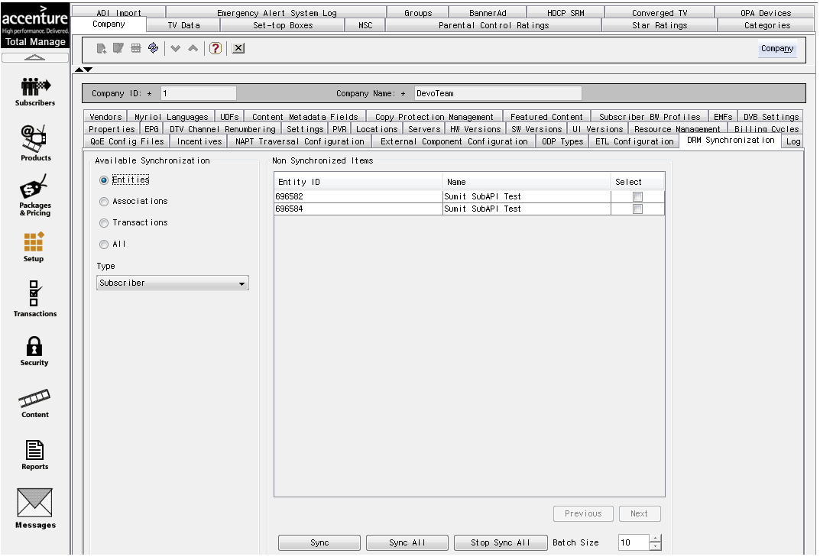

## Entity –STB

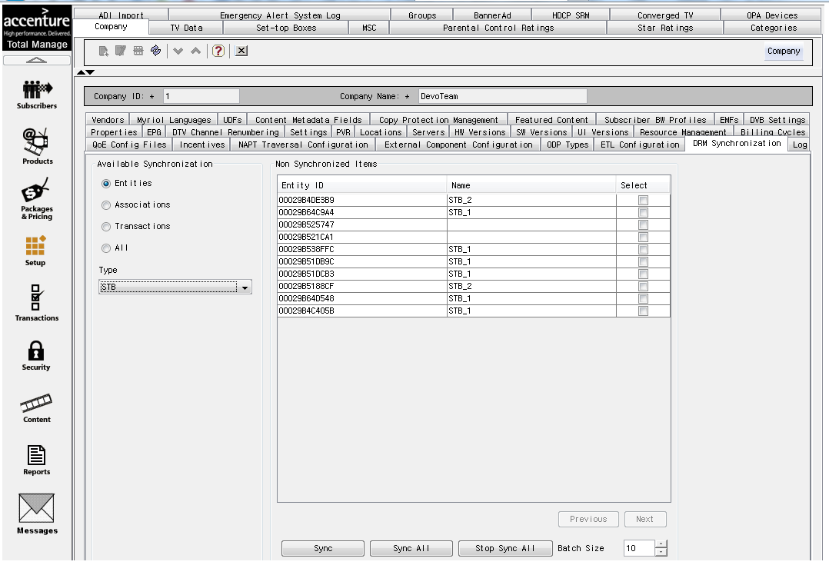

## Entity-Device

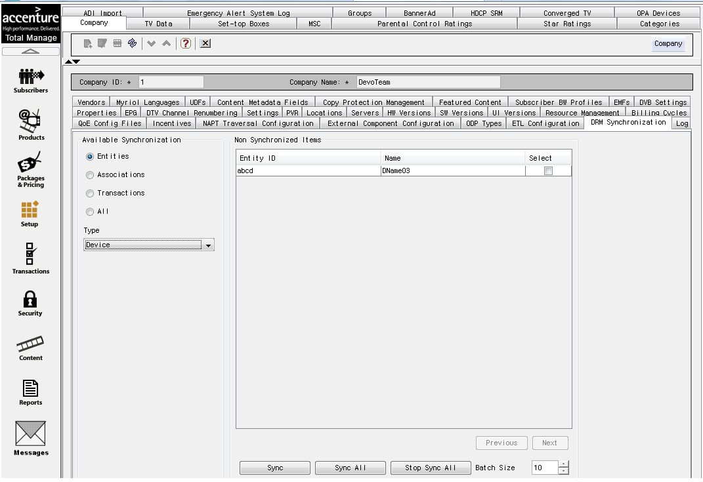

## Entity-Package

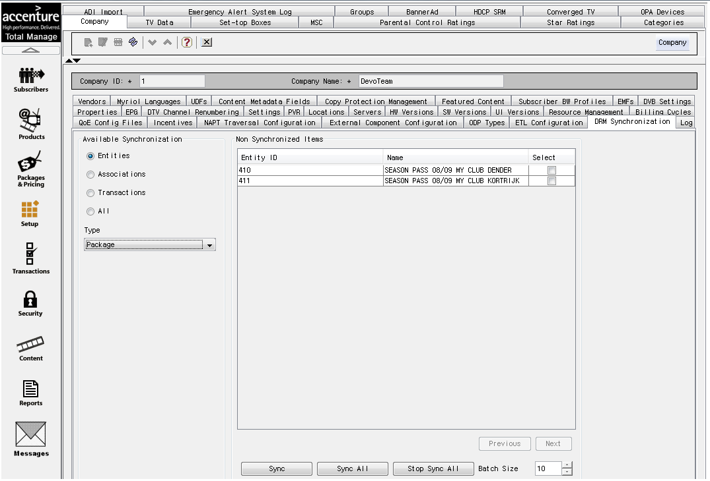

## Entity-VOD

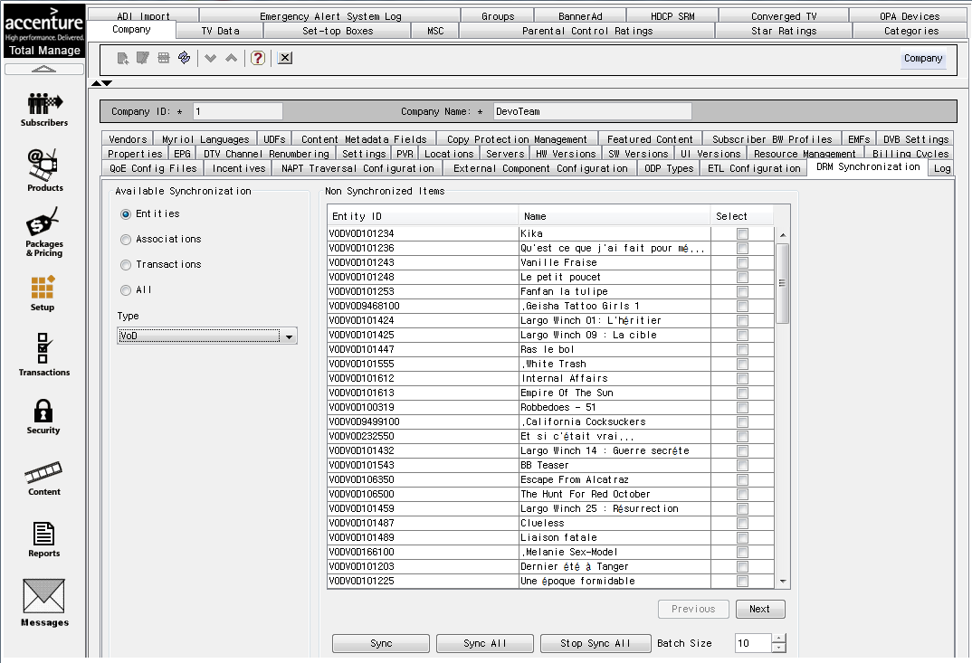

## Entity-Bundle

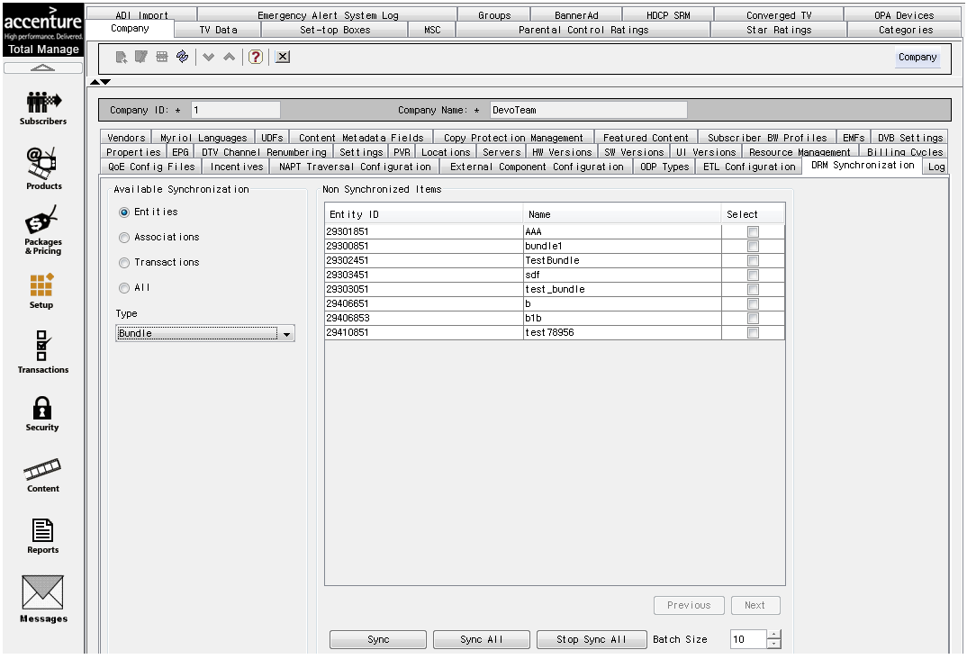

## Entity-Channel

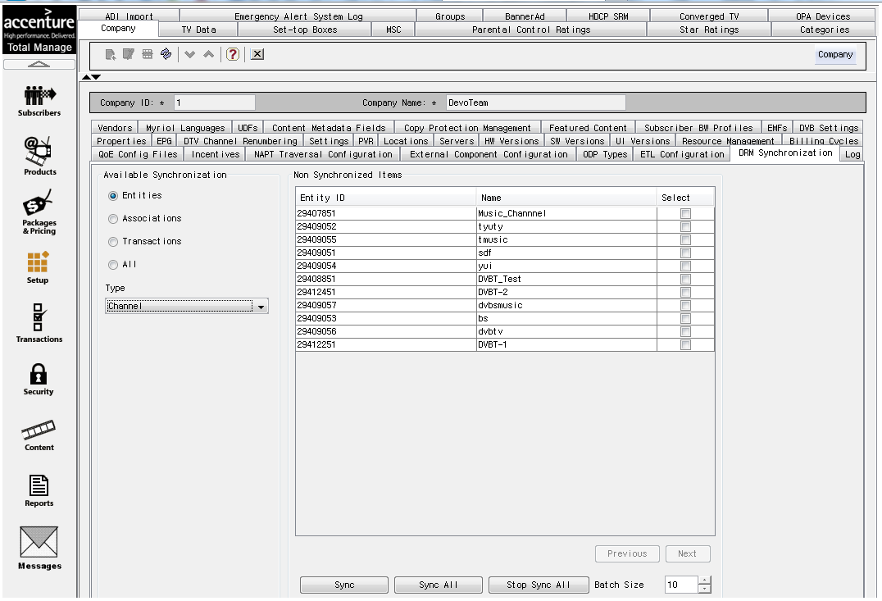

## Entity-NPVR

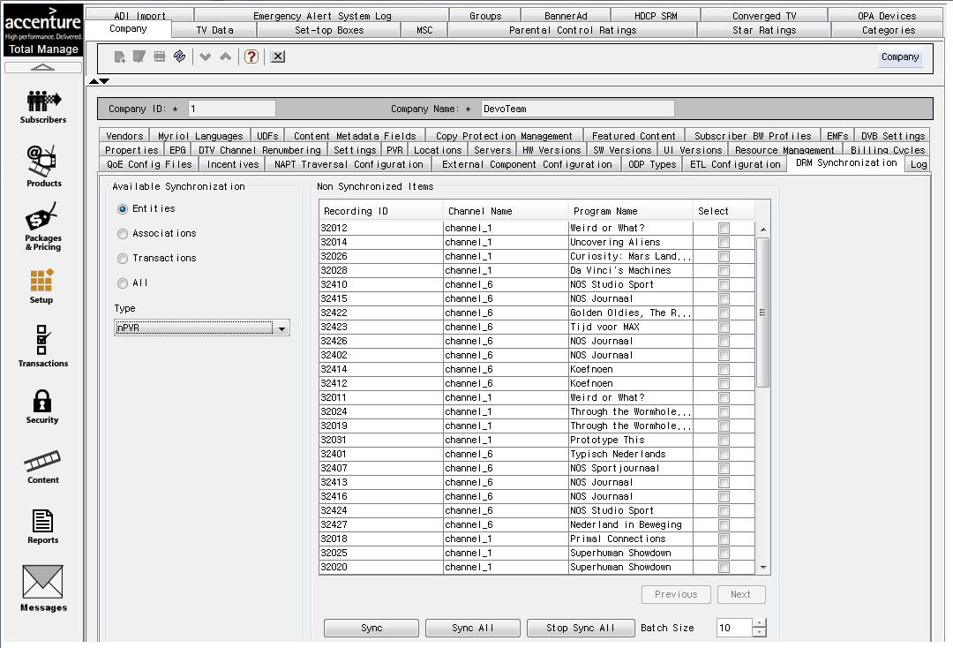

## Association : Subscriber-STB

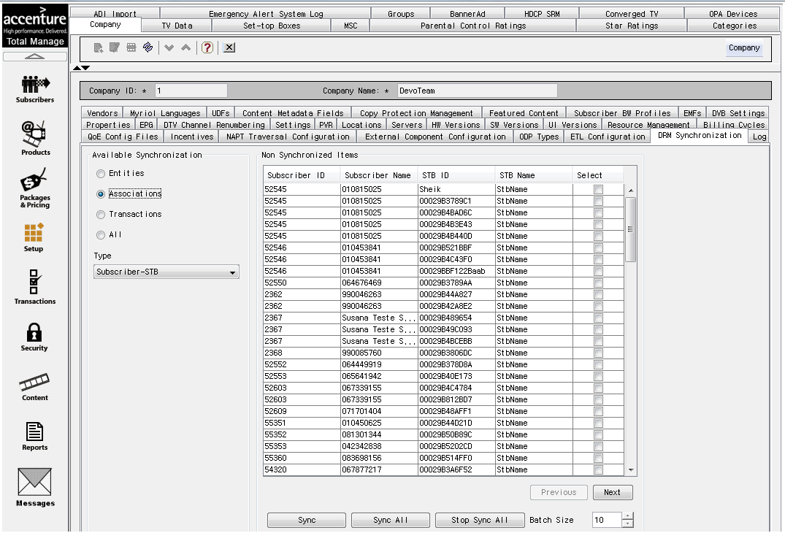

## Association : Subscriber-Devices

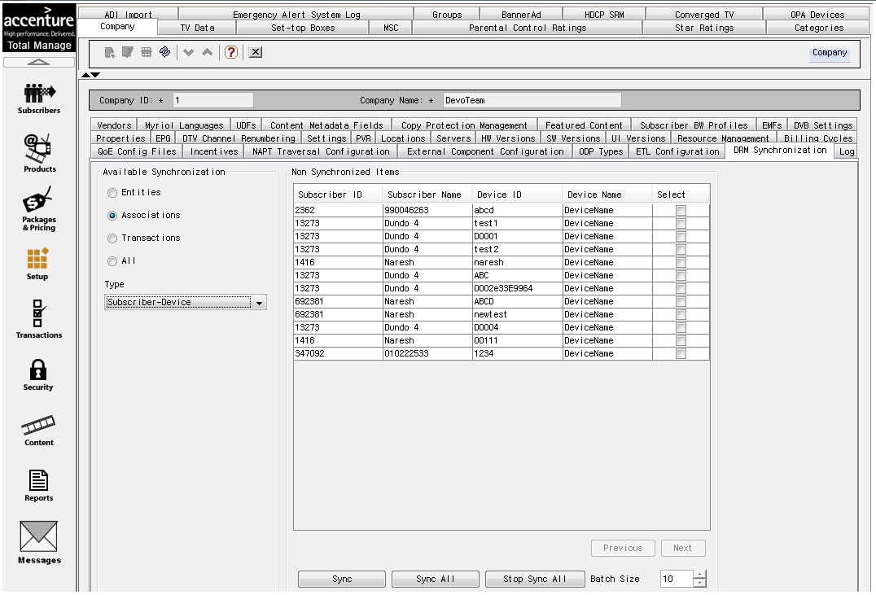

## Association : Subscriber-Packages

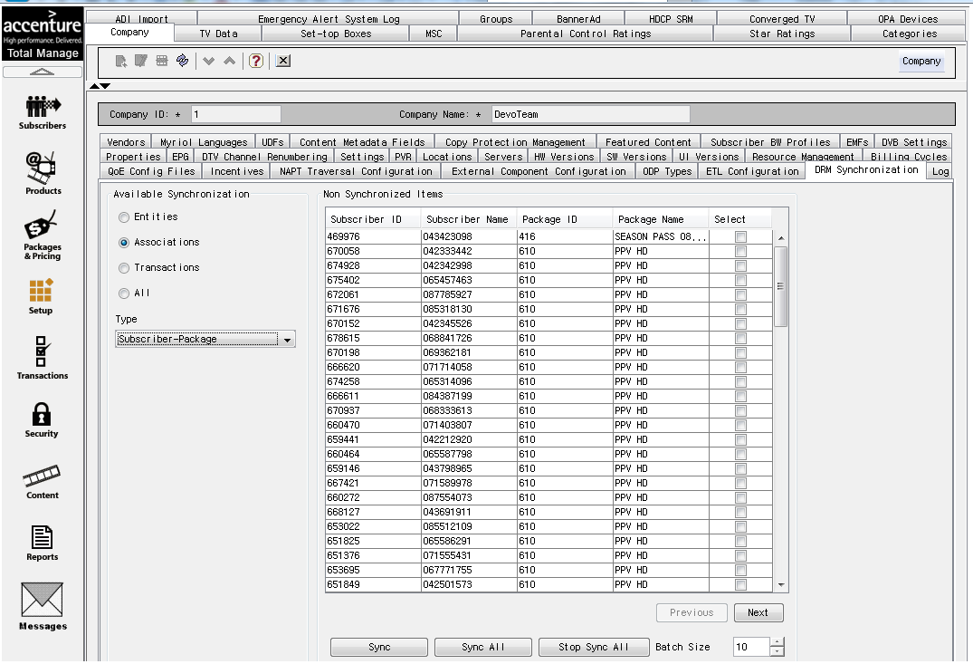

## Associations: package-VOD

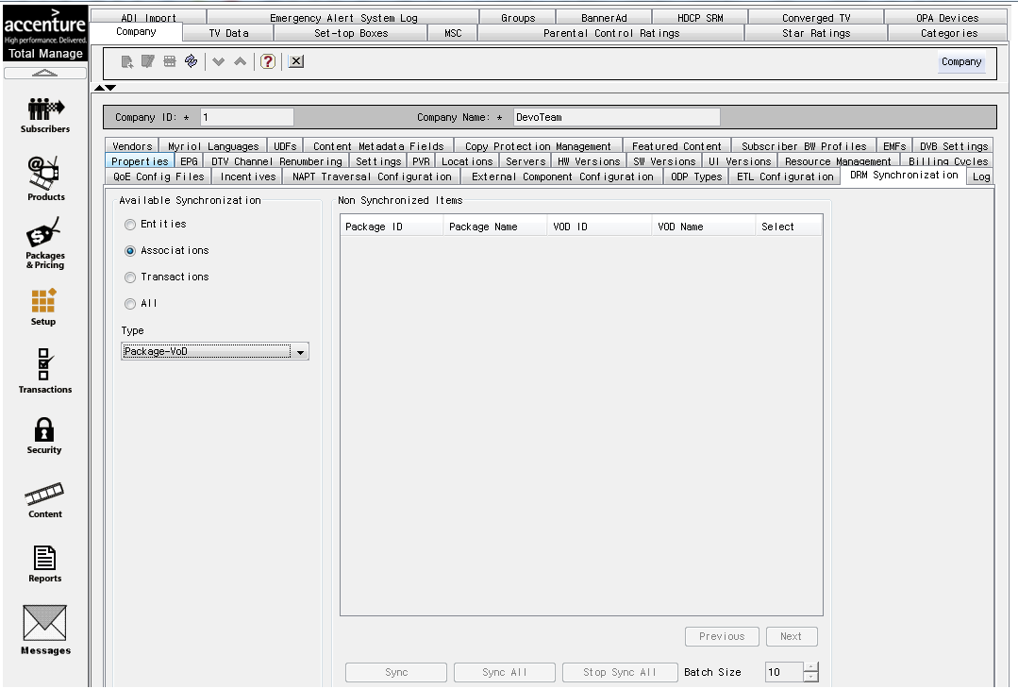

## Associations: Package-Channels

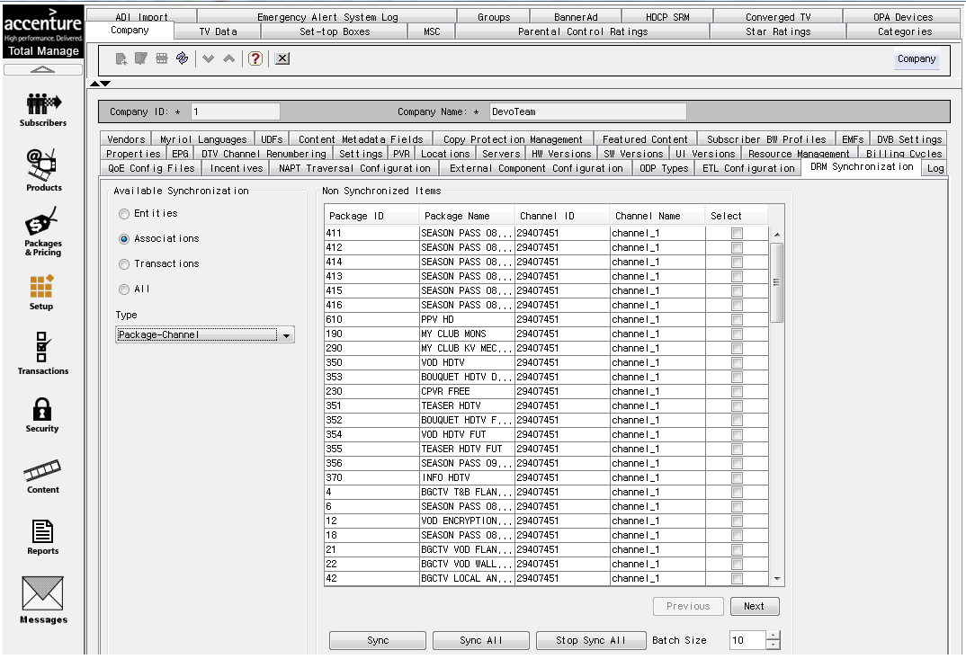

## Transactions-VOD

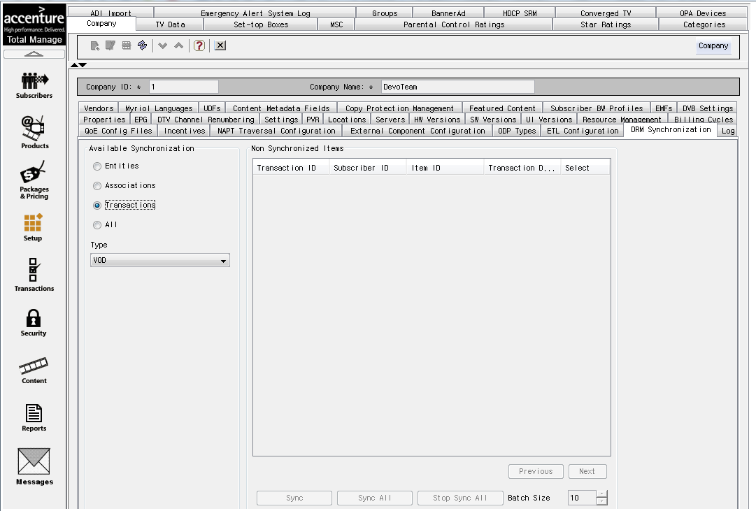

## Transactions –Bundle

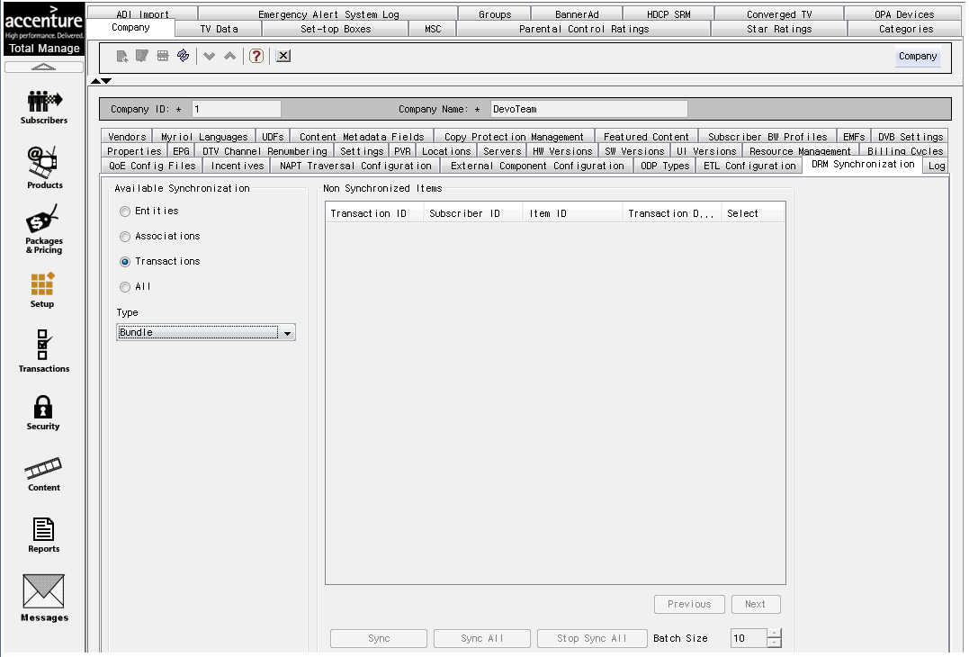

## Transaction-PPV

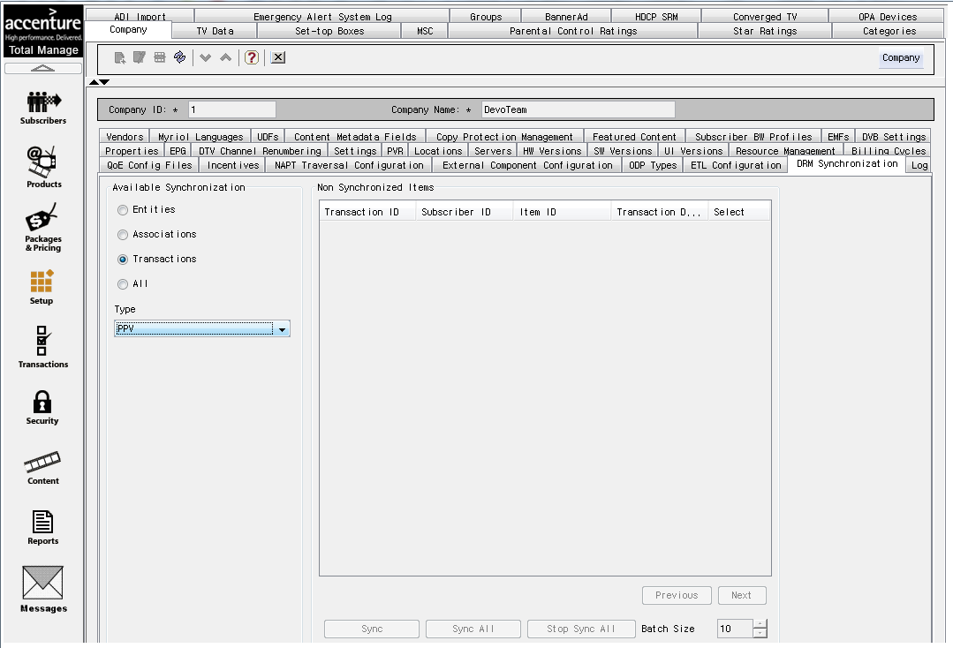

## Sync All

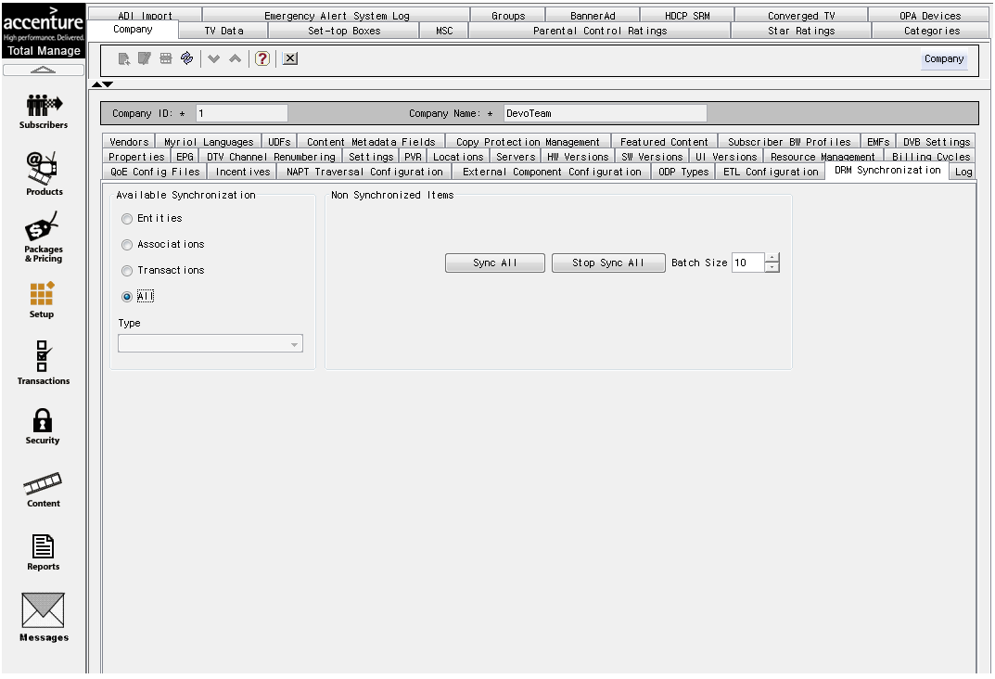

## ODS for OMI Integrator

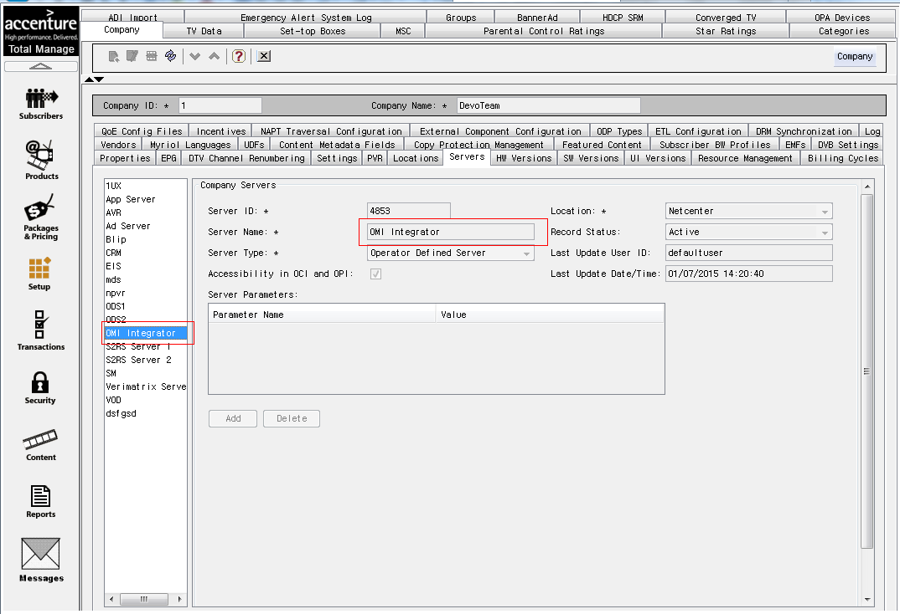

## Adding Device Type for OPA Devices:

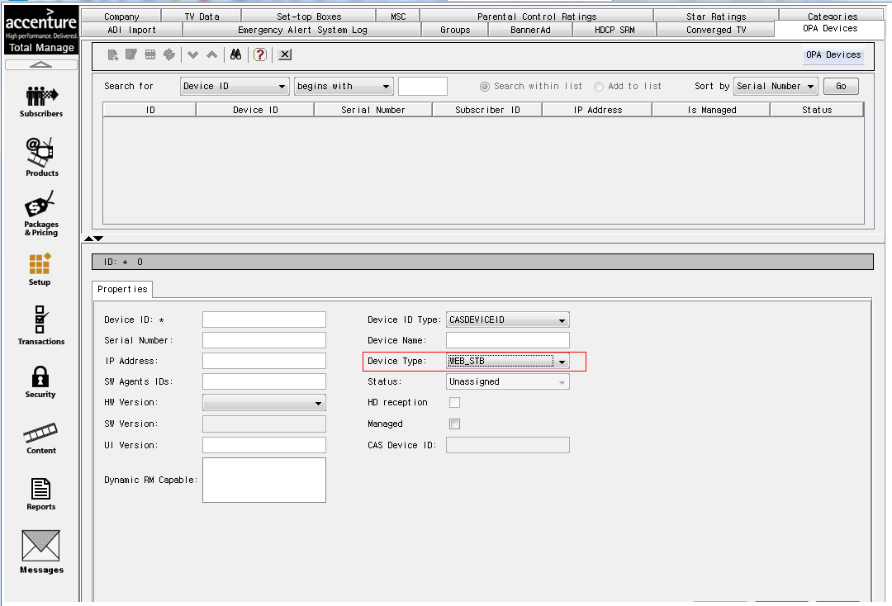

## Mandatory movieVCASID

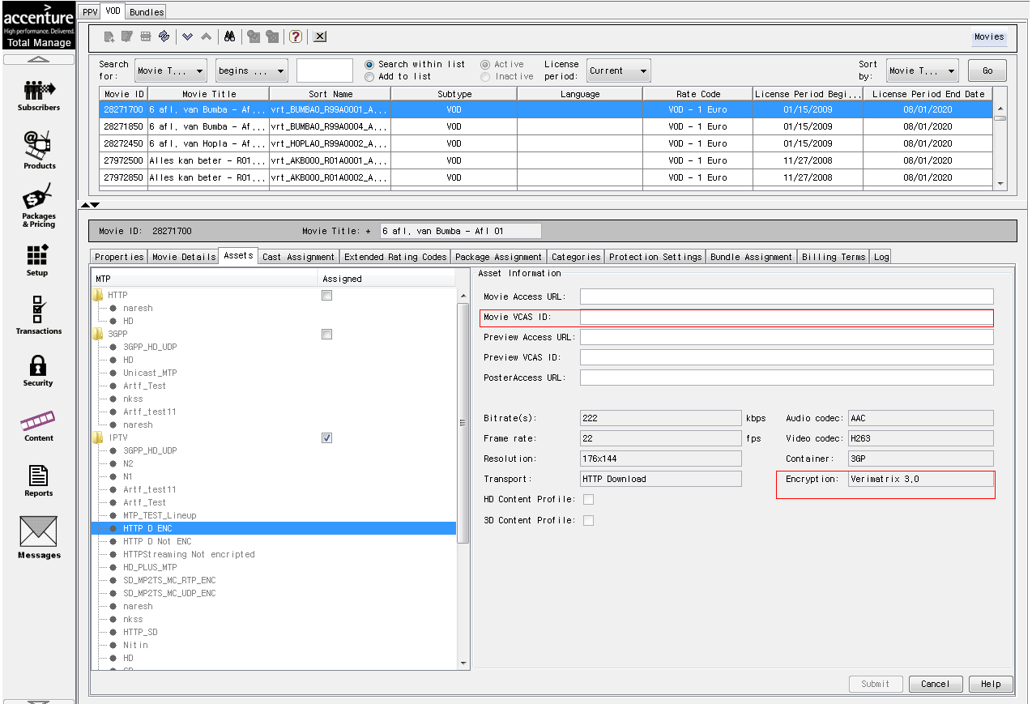

## Adding Stream Id to Channel Stream

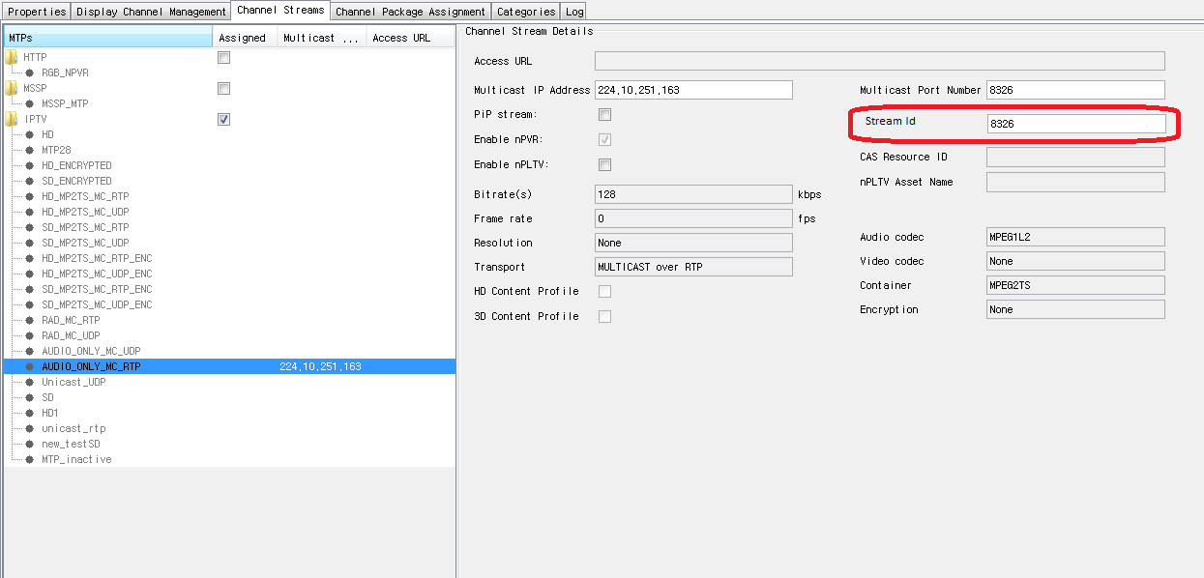

# Configuration

## Deployment Guide

All configuration changes mention in deployment guide.



# Imported Interfaces

Not Applicable

# Database Changes

## Database Patch

Added two databases patch “TMDB_HE4.3.06-oracle” and “TMDB_HE4.3.07-oracle”.

   

# Unit Tests

# Design Specification Reviewers List & Template

*********** This chapter is Mandatory ***********************

The scope of the next file is to identify specific Design Specifications mandatory and optional reviewers.



Next document refers to Review Report Template.



Review Comments:

